**USE OF PHOTODYNAMIC THERAPY FOR THE TREATMENT OF LOCALISED INFECTIONS OF ACANTHAMOEBA KERATITIS**

**AHAMUEFULA EREBOSI CHIDI**

**PhD 2020**

**USE OF PHOTODYNAMIC THERAPY FOR THE TREATMENT OF LOCALISED INFECTIONS OF ACANTHAMOEBA KERATITIS**

**AHAMUEFULA EREBOSI CHIDI**

**Department of Pharmacy and pharmaceutical sciences**

**A thesis submitted in partial fulfilment of the requirements of the University of Sunderland for the degree of Doctor of Philosophy**

**April 2020**

**ABSTRACT**

Acanthamoeba keratitis is a devastating eye disease that requires prompt diagnosis and treatment. Currently, there are no targeted antimicrobial drugs that can be used in the United Kingdom to treat *Acanthamoeba* infections. There are treatment options available but require the prolonged application of low concentrations of biocides. These biocides cause significant damage to host tissue (cornea) and are frequently the major contributor to the loss of visual acuity seen with this type of infection. In addition to this, *Acanthamoeba* trophozoites can undergo cell transformation into a cyst form as a response to stress (including biocide treatment); cysts are less sensitive to biocides. The development of new anti-amoebal drugs has been hampered by the limited interest in this rare infection by big pharma and the lack of a robust *in-vitro* susceptibility assay that can be used to assay trophozoites as well as cysts.

A novel approach that may be useful as a treatment modality for *Acanthamoeba* trophozoites and cysts is the use of antimicrobial photodynamic therapy (APDT). This approach combines light and a photo-activated drug to generate reactive oxygen species that cause cell death. Although this approach often causes host cell toxicity, these drugs can be targeted through chemical modification, the use of antibodies and via the use of precise light targeting.

The aim of the present study was to evaluate the use of photodynamic therapy for the treatment of all morphological forms of *Acanthamoeba.* The objectives are

* To asses existing assay methodologies for susceptibility testing and validate their adaptability to assay for drug activity against all morphological forms of *Acanthamoeba*.
* To identify useful photosensitisers for *Acanthamoeba* photodynamic therapy.

We were able to develop a novel optimised ATP assay that used traditional detergent-based cell lysis for trophozoites. Cysts could not be lysed using this or similar approaches thus we introduced enzymatic (lysozyme) lysis of cysts. The assay was validated using a range of clinically relevant biocides and drugs that have known *in vitro* activity against *Acanthamoeba.*

Results showed that photodynamic therapy using LED light (85 j/cm2) and cationic porphyrins (10µM), was able to inactivate more than 80% of both cysts and trophozoites. These results suggest that APDT is a promising approach for the treatment of *Acanthamoeba* infections in the eye and that it may be possible to enhance the anti-amoebic activity of porphyrins via chemical modification. We also suggest that improved targeting of these drugs could be achieved using *Acanthamoeba* specific peptides conjugated to porphyrins targeting photodynamic therapy.

**DECLARATION**

The work in this thesis was performed by the author from May 2015- May 2019, under the supervision of Professor Tim Paget and Dr Lewis Bingle in the Faculty of Pharmacy Health and Wellbeing University of Sunderland. This thesis has been submitted for a degree of Doctor of Philosophy at the University of Sunderland and has not been submitted in full or part for another degree in any other institution.

This thesis may be made available for consultation, photocopying and for use through any other lending libraries.

**NAME** AHAMUEFULA CHIDI EREBOSI

**SIGNED ……………………………………….**

**DATE ….....................................................**

**DEDICATION**

This PhD thesis is dedicated to Sir NICHOLAS AHAMUEFULA and Late PROF I .C ACHUMBA for their unending support and believe in the “dream”

# ACKNOWLEDGEMENTS

First, I would like to thank God Almighty for giving me the strength, knowledge, ability and opportunity to undertake this research study and to persevere and complete it satisfactorily.

My deepest gratitude goes to Professor Tim Paget and Dr Lewis Bingle, who relentlessly guided me through this work and who shared the excitement of 4 years with these pathogens *“Acanthamoeba*”.

I acknowledge and remain grateful for the financial assistance of Mr Stephen Emerem, Eberechukwu Emerem, Oliver Obiukwu, Stephen Ezema, Fidelis Ubeh, Franklin Ngwu, Tokunboh Dokpamu and Okey Lancaster.

To a special colleague turned to friend and Brother Mr Wisdom John Okoye. Also to Dr Samuel Oyeniyi, Dr Kwawlah Salaman and my able editor in chief Oburuche. I will not forget my able pharmacist and closest friend Emma.

Gratitude to the tireless technicians in the University of Sunderland microbiology lab. Linda Henry and Kayleigh Ironside, for their constant help and assistance around the lab.

I acknowledge and appreciate the assistance of Mrs Ann Lowry Microscopy Suite Manager and Technician Faculty of Science and the Environment University of Hull

Above ground, I am indebted to my family Lady Abigail Ahamuefula Ugomma Mbanali, Ugonna Ahamuefula, Chiamaka Ahamuefula and Chigozie Ahamuefula, whose value to me only grows with age.

|  |  |
| --- | --- |
| **LIST OF ABBREVIATIONS** | |
| ATP | Adenosine triphosphate |
| EDTA | Ethylene diamine tetraacetic acid |
| FDA | Fluorescein diacetate |
| GAE | Granulomatous Amoebic Encephalitis |
| HEWL | Hens egg white lysozyme |
| LED | Light-emitting diode |
| MBP | Mannose-binding protein |
| MDA | Malone aldehyde |
| MTT | Methyl thiazole tetrazolium |
| PCR | Polymerase chain reaction |
| aPDT | Polymerase chain reaction |
| PDT | Photodynamic therapy |
| PHMB | Polyhexamethylene biguanide |
| PVP | Polyvinyl pyrrolidone |
| RFU | Relative fluorescence unit |
| RLU | Relative light unit |
| ROS | Reactive oxygen species |

List of figures

**List of Figures Page**

Figure 1.1 published studies in the PubMed database on *Acanthamoeba …………………*...4

Figure 1.2 Scanning electron microscope image of Acanthamoeba cyst and trophozoite……5

Figure 1.3 Life cycle and pathogenesis of *Acanthamoeba spp*………………………………….5

Figure 1.4 *Acanthamoeba* infected eye vs normal eye ………………………………………… 7

Figure 1.5 Anatomy of the human cornea………………………………………………………..11

Figure 1.6 Pathogenic cascade of Acanthamoeba keratitis…………………………………. . 14

Figure 1.7 different electronic state of electrons showing their spin directions………………20

Figure 1.8 Schematic representation of the photodynamic process…………………………..21

Figure 1.9 mechanism of the free radical fix by anti-oxidants.………………… ……………..24

Figure 1.10 Electron transport chain………………………………………………………… ….25

Figure 1.11 Chemical structure of toluidine and methylene blue……………………………..34

Figure 1.12 Photosensitizers used in photodynamic therapy …………………………………35

Figure 1.13A Structure of 5, 10, 15, 20-Tetraphenyl-21H, and 23H-porphine ………………38

Figure 1.13 B Structure of 4, 4′, 4′′, 4′′′-(porphine-5, 10, 15, 20-tetrayl) tetrakis (benzene sulfonic acid) tetra sodium salt hydrate [TPPS4]………………………… …………………….38

Figure 1.13 C Structure of 4,4’,4”,4’”-( Porphine-5,10,15,20-tetrayl)tetrakis( benzoic acid). Synonym: meso-tetraphenyl porphine-4, 4, 4, 4- tetra carboxylic acid………………………39

Figure 1.13 D Structure of 5, 10, 15, 20- tetrakis (1-methyl-4-pyridinio) porphyrin tetra (p- toluene sulfonate). Synonym; meso-tetra (n-methyl-4-pyridyl) porphine tetratosylate salt…39

Figure 1.14 Different spectrum of visible light and their wavelengths………………………..43

Figure 1.15 MTT assay reaction ………………………………………………………………….47

Figure 1.16 Hydrolysis of fluorescein diacetate to fluorescein by mitochondria enzyme……48

Figure 1.17 Hydrolysis of resazurin to fluorescent resorufin……………………………………49

Figure 1.18 Adenosine triphosphate assay reaction pathway………………………………….51

Figure 1.19 Structure of povidone-iodine complex……………………………………………..56

Figure 1.20 Structure of caspofungin……………………………………………………………. 58

Figure 1.21 Chemical structure of Amphotericin B………………………………………………59

Figure 1.22 Chemical structure of miltefosine…………………………………………………...61

Figure 2.1 Sample injection point of a haemocytometer………………………………………..75

Figure 2.2 General process for Acanthamoeba photodynamic therapy …………………......82

Figure 2.3 diagram of a flat-bottom 96 well plate showing cell count protocol……………….84

Figure 2.4 A Structure of porphyrins used for photodynamic therapy………………………..86

Figure 2.4 B Microplate layout for porphyrin uptake assay…………………………………….86

Figure 2.5 Microplate setup for all PDT assay…………………………………………………..88

Figure 2.6 Photo showing red light photodynamic therapy…………………………………….89

Figure 2.7 digital lux meter ………………………………………………………………………..89

Figure 3.1 *Acanthamoeba* growth curve…………………………………………………………93

Figure 3.2 Percentage cyst chat from growth curve…………………………………………….93

Figure 3.3 Gel electrophoresis of five *Acanthamoeba* isolates………………………………..95

Figure 3.4 Multiple sequence alignment of *Acanthamoeba* DF3 fragment…………………..96

Figure 3.5 Dendrogram of Acanthamoeba isolates……………………………………………..97

Figure 3.6 Resazurin standard curve ……………………………………………………………98

Figure 3.7 Fluorescein diacetate concentration curve with *Acanthamoeba* trophozoites…..99

Figure 3.8 Inhibition of trophozoites with different concentration of hydrogen peroxide……100

Figure 3.9 Fluorescein diacetate cell concentration curve cysts…………………………….101

Figure 3.10 Toluidine blue PDT on *Acanthamoeba* trophozoites……………………………102

Figure 3.11 ATP concentration curve…………………………………………………………..104

Figure 3.12 Comparison of different lysis methods …………………………………………..105

Figure 3.13 Percentage lysis of *Acanthamoeba* cysts after incubation with lysozyme……..106

Figure 3.14 TEM image of Lysozyme degradation of *Acanthamoeba* cysts……………….107

Figure 3.15 Acanthamoeba cell concentration curve ……………………………………... . 108

Figure 3.16 Stability of ATP and luciferase enzyme after storage…………………………..109

Figure 3.17 Effect of PBS on luciferase enzyme ………………………………………………110

Figure 3.18 Amphotericin B drug assay………………………………………………………...112

Figure 3.19 Miltefosine drug assay……………………………………………………………..113

Figure 3.20 Povidone iodine drug assay……………………………………………………….114

Figure 3.21 Caspofungin drug assay……………………………………………………………115

Figure 3.22 Porphyrin excitation and emission spectrum………………………………….....118

Figure 3.23 Porphyrin calibration curve…………………………………………………………118

Figure 3.24 Uptake of porphyrin after incubation………………………………………………120

Figure 3.25 Binding of 5, 10, 15, 20-tetrakis (1-methyl-4-pyridino) porphyrin tetra (P-toluene sulfonate) ……………………………………………………………………………………........121

Figure 3.26 Binding of 5, 10, 15, 20- tetrakis (pentafluorophenyl)-21H, 23H-porphine Iron (III) chloride to *Acanthamoeba* cells after incubation………………………………………………122

Figure 3.27 Binding of 5, 10, 15, 20-Tetrakis (4-methyl phenyl)-21H23H porphine………123

Figure 3.28 Binding of 4, 4′, 4′′, 4′′′-(porphine-5, 10, 15, 20-tetrayl) tetrakis (benzene sulfonic acid) tetrasodium salt hydrate……………………………………………………………………124

Figure 3.29 Trophozoite PDT with 4,4′,4′′,4′′′-(porphine-5,10,15,20-tetrayl) tetrakis (benzenesulfonic acid) tetrasodium salt hydrate………………………………………………125

Figure 3.30 Cyst PDT with 4,4′,4′′,4′′′-(porphine-5,10,15,20-tetrayl) tetrakis (benzenesulfonic acid) tetrasodium salt hydrate……………………………………………………………………126

Figure 3.31 Trophozoite PDT with 5, 10, 15, 20-tetrakis (1-methyl-4-pyridino) porphyrin tetra (P-toluene sulfonate)……………………………………………………………………………..127

Figure 3.32 Cysts PDT with 5, 10, 15, 20-tetrakis (1-methyl-4-pyridino) porphyrin tetra (P-toluene sulfonate)…………………………………………………………………………………128

Figure 3.33 Trophozoite PDT with 5, 10, 15, 20- tetrakis (pentafluorophenyl)-21H, 23H-porphine Iron (III) chloride…………………………………………………………………….....129

Figure 3.34 Cyst PDT with 5, 10, 15, 20- tetrakis (pentafluorophenyl)-21H, 23H-porphine Iron (III) chloride………………………………………………………………………………………..130

Figure 3.35 Trophozoite PDT with 5, 10, 15, 20-Tetrakis (4-methyl phenyl)-21H23H porphine……………………………………………………………………………………………131

Figure 3.36 Cysts PDT with 5, 10, 15, 20-Tetrakis (4-methyl phenyl)-21H23H porphine…132

Figure 4.0 Structure of chitin…………………………………………………………………….142

Figure 4.1 N acetyl glucosamine showing substrate for lysozyme……………………….....143

Figure 4.2 Structure of cellulose showing target for lysozyme ………………………………143

Table of Contents

ACKNOWLEDGEMENTS VI

**LIST OF ABBREVIATIONS** VII

CHAPTER ONE 2

1.0 Introduction 2

1.1 *Acanthamoeba* biology, morphology and increasing incidence 2

1.2 Acanthamoeba Keratitis 7

1.2.1 Acanthamoeba keratitis; improper contact lens hygiene, a significant risk factor 8

1.2.2 The cornea; function and anatomy 11

1.3 Pathogenesis of Acanthamoeba keratitis. 14

1.3.1 Adhesion of *Acanthamoeba* to host cell 14

1.3.2 Extracellular proteases 15

1.3.3 Diagnosis of Acanthamoeba keratitis. 17

1.3.4 Treatment of Acanthamoeba keratitis 18

1.4 Photodynamic therapy (PDT) 22

1.4.1 Photochemistry and photophysics of PDT 23

1.4.2 A Dual pathway of Photosensitization. 26

1.4.4 The electron transport chain 29

1.4.5 Biological effects of free radical and reactive oxygen species. 31

1.4.6 Lipid peroxidation 32

1.4.7 Free radical interaction with proteins. 34

1.4.8 Free radical damage to DNA 36

1.5 Photodynamic inactivation of microbial cells: General Aspects 38

1.5.1 Photosensitizers used in photodynamic therapy 39

1.5.2 Phenothiazinium derivatives 40

1.5.3 Porphyrin-based photosensitiser. 43

1.5.4 First generation porphyrin-based photosensitizers. 43

1.5.5 Second-generation porphyrin-based photosensitizers. 45

1.5.6 Porphyrins used for the present study 45

1.5.7 Toxicity of porphyrins 51

1.5.8 Light delivery systems in PDT. 52

1.6 Susceptibility test for high-throughput drug development. 55

1.6.1 Cell viability assay 57

1.6.1.1 MTT (3-(4, 5-dimethyl thiazolyl-2)-2, 5-diphenyltetrazolium bromide) assay. 58

1.6.1.2 Fluorescein Diacetate viability assay 61

1.6.1.3 Alamar blue (resazurin) viability assay 63

1.6.1.4 The ATP bioluminescence assay 65

1.7 Cell lysis 67

1.7.1 Enzymatic lysis; Lysozyme 68

1.8.1 Povidone-iodine 71

1.8.2 Caspofungin 73

1.8.3 Amphotericin B 75

1.8.4 Miltefosine 77

2.0 Chapter overview 80

This chapter presents the materials and the protocols used for all experiment carried out in this research. 80

2.1 MATERIALS AND METHODS 81

2.1.1 Materials 81

2.1.3 Cell counting 82

2.1.4 Cryogenic preservation of *Acanthamoeba* cells. 83

2.1.5 Recovery of *Acanthamoeba* cell from cryopreservation. 83

2.1.6 *Acanthamoeba* growth curve 84

2.2 DNA extraction for polymerase chain reaction (PCR). 85

2.2.1 Use of InstaGene matrix for DNA extraction. 85

2.2.2 DNA extraction by sonication. 86

2.2.3 DNA extraction by boiling 86

2.2.4 Polymerase chain reaction. 87

2.2.5 Purification of extracted *Acanthamoeba* DNA 88

2.2.6 Sequencing of purified *Acanthamoeba* DNA 89

2.3 Viability assays. 89

2.3.1 Fluorescein diacetate (FDA) viability assay 89

2.3.2 Resazurin cell concentration curve. 90

2.3.4 Adenosine triphosphate 91

2.3.5 Lysis of *Acanthamoeba* cyst 92

2.3.5.1 Sonication of *Acanthamoeba* cysts 92

2.4.5 Lysis of *Acanthamoeba* cysts with lysozyme. 93

2.5.1 Fixation procedure 95

2.5.2 Dehydration 96

2.6 Optimisation of ATP assay 97

2.6.1 Stability of ATP after storage. 98

2.6.2 Effects of solvents on ATP and luciferase enzyme reaction. 99

2.6.3 ATP calibrations curves 99

2.7 Methods Validation (Drug assays) 100

2.7.1 Povidone-iodine drug assay 100

2.7.2 Caspofungin drug assay 101

2.7.4 Miltefosine 102

2.8.1 Toluidine blue assay 104

2.8.2 The kinetics of porphyrin accumulation in *Acanthamoeba* cells 106

2.8.3 Uptake of porphyrins by *Acanthamoeba* cells. 106

2.8.4 Excitation and emission spectrum of porphyrins. 108

2.8.3 Porphyrin concentration curve. 109

2.8.4 Photosensitizer preparation 109

2.8.5 Porphyrin PDT; Irradiation procedure 110

Chapter 3 114

3.0 Overview of the chapter. 114

3.1 Characterisation of *Acanthamoeba* 115

3.1.1 *Acanthamoeba* growth curve 115

3.1.2 *Acanthamoeba* genotyping (DNA extraction) 117

3.1.3 Agarose gel electrophoresis of the PCR amplified products of *Acanthamoeba* -DNA 118

3.1.4 Sequencing and genotyping of all five isolates of *Acanthamoeba* 119

3.2.2 Fluorescein diacetate assay (FDA) 122

3.2.4 Trypan blue viability assay with Toluidine Blue PDT 125

3.3 Adenosine triphosphate assay (ATP) 126

3.4.1 Amphotericin B Drug assay. 134

3.4.2 Miltefosine Drug assay 135

3.4.3 Povidone-iodine drug assay. 136

3.4.4 Caspofungin Drug assay. 137

3.5 Photodynamic therapy 139

3.5.1 Spectra of porphyrins used for PDT 140

3.5.2 Porphyrin uptake after incubation 141

3.6 Binding strength of porphyrins for cysts and trophozoites 143

3.6.1 Binding strength of 5, 10, 15, 20-tetrakis (1-methyl-4-pyridino) porphyrin tetra (P-toluene sulfonate), *Acanthamoeba* cells 143

3.6.2 Permeability of 5, 10, 15, 20- tetrakis (pentafluorophenyl)-21H, 23H-porphine Iron (III) chloride to *Acanthamoeba* cells 144

3.6.3 Binding strength of 5, 10, 15, 20-Tetrakis (4-methyl phenyl)-21H23H porphine to *Acanthamoeba cells* 145

3.6.4 Binding of 4, 4′, 4′′, 4′′′-(porphine-5, 10, 15, 20-tetrayl) tetrakis (benzene sulfonic acid) tetrasodium salt hydrate [TPPS4], to *Acanthamoeba* cells 146

3.7.1 PDT with 4, 4′, 4′′, 4′′′-(porphine-5, 10, 15, 20-tetrayl) tetrakis (benzene sulfonic 147

3.7.2 PDT with 5, 10, 15, 20-tetrakis (1-methyl-4-pyridino) porphyrin tetra (P-toluene sulfonate). 149

3.7.3 PDT with 5, 10, 15, 20- tetrakis (pentafluorophenyl)-21H, 23H-porphine Iron 151

3.7.4 PDT with 5, 10, 15, 20-Tetrakis (4-methyl phenyl)-21H23H porphine 153

4.0 DISCUSSION 156

4.1 Viability assays 157

4.1.1 MTT based viability assay 158

4.1.2 Alamar blue (resazurin) viability assay. 159

4.1.3 Fluorescein diacetate (FDA) assay. 160

4.1.4 The Adenosine triphosphate assay. 161

4.2 Extraction of microbial intracellular proteins 162

4.2.1 Lysozyme specificity to *Acanthamoeba* cyst cell wall 163

4.3 Activity of disinfectants and therapeutic agents measured using ATP bioluminescence assay. 169

4.4 *Acanthamoeba* photodynamic therapy Photodynamic therapy 173

4.1.1 Toluidine blue photodynamic therapy 173

4.1.2 Photodynamic therapy using porphyrins. 174

180

5.0 Conclusion 181

Novelty. 184

Future work 185

LIST OF PRESENTATIONS 186

Poster Presentations 186

Oral Presentation 186

Publications in preparation 186

**CHAPTER ONE**  
GENERAL INTRODUCTION

# CHAPTER ONE

## 1.0 Introduction

## 1.1 *Acanthamoeba* biology, morphology and increasing incidence

*Acanthamoeba* was first observed in 1957 as a contaminant in a trypsinised monkey tissue culture (Jahnes *et al*., 1957). The pathogenic potential of *Acanthamoeba* was uncovered during the development of a polio vaccine (Culbertson *et al.*, 1958). Culbertson and colleagues unintentionally inoculated a contaminated monkey-cell culture fluid infested by *Acanthamoeba* into immunosuppressed monkeys and mice, resulting in deadly encephalitis of the host within 24 hours. First, they thought the cell culture was contaminated with an unknown virus. However, after histological assessment of the animals and microscopy of the culture fluids, they confirmed *Acanthamoeba* as the contaminant. The first recorded human infection by *Acanthamoeba* came in 1972 (Jager and Stamm, 1972). A decade later, *Acanthamoeba* was characterised as an opportunistic pathogen, which affects the immunosuppressed individual (Martinez, 1980). These free-living amoebas have not evolved to parasitism such as seen in typical parasitic protozoa such as *Plasmodium* *spp.* and *Leishmania* *spp*.; hence no reported case of host-to-host transmission of *Acanthamoeba* infections. *Acanthamoeba* is extremely versatile and resistant, as shown by their ubiquitous distribution in nature and man-made environments. In soil and water sample they are reported as the most common amoeba (Page 1988) and can be seen in all water environment. *Acanthamoeba* has the ability to survive in diverse environments like extreme temperature, osmolality, pH and nutrient-depleted habitats and this can be attributed to their ability to transform to more resistant cyst formin extreme environmental situations. *Acanthamoeba* has been isolated from the public water supply, bottled water seawater, pond water, mud, freshwater, saltwater lakes, ventilation ducts, sewage, compost, the carcass of a dead animal, vegetables, contact lenses and their cases. Furthermore, *Acanthamoeba* has been isolated from dialysis units eyewash stations, human nasal cavities, lungs tissues skin lesions, cerebrospinal fluids (reviewed in Khan, 2003; Marciano-Cabral and Cabral, 2003; Schuster and Visvesvara, 2004)

The ubiquitous nature of *Acanthamoeba* means they are not reliant on hosts for transmission and spread (Khan, 2006). Remarkably, despite the opportunities offered to these amoebas by nature, Infection of humans is uncommon and limited to immunocompromised hosts (Kays, 2010). They can infect the eye and cause Acanthamoeba keratitis (AK), and they can affect the central nervous system and brain in a deadly infection known as Granulomatous Amoebic Encephalitis (GAE) (Maritschnegg et al., 2010). Until date, there are about 24 named species of *Acanthamoeba* though not all of them are pathogenic in nature (Chelkha et al., 2018). The first isolated species of *Acanthamoeba* (from dust) was *Acanthamoeba polyphaga* ( previously known as *Amoeba polyhagus*; Puschkare, 1913) a nomenclature later changed to *A. polyphaga* (Page, 1967). Another common species *A. Castellani* was isolated from a yeast culture of *Cryptococcus pararoseus* (Castellani, 1930), and was later renamed *Hartmanella castellani* (Douglas, 1930). The genus of *Acanthamoeba* was later established and distinguished from *Hartmanella,* which lead to the reclassification of *H. castellanii* to *A. castellanii* (Volkonsky, 1931). *Acanthamoeba* can occur in two morphological forms. A single cell-walled vegetative motile form known as the trophozoite and a double-walled dormant form called the cysts (Duarte et al., 2013). The trophozoites are usually 15-30µm in length with several distinguishing morphological features. Trophozoites have a cytoplasm with a large vacuole and pseudopodia often referred to as acanthopodia (Fig 1.2). The acanthopodia allow pathogenic strains to adhere to the host cell surface, aids movement and serve as a hook to capture its food (Brocious et al., 2018). *Acanthamoeba* feeds on microorganism found on surfaces of different habitats (Guimaraes et al., 2016). Food uptake by *Acanthamoeba* can be either by phagocytosis or by pinocytosis (Chrisman, Alvarez and Casadevall, 2010). Acanthamoeba engulfs bacteria, algae and smaller yeasts through its vacuole during phagocytosis. When in an axenic culture Acanthamoeba feed by taking up large volumes of solutes mostly glucose. They reproduce asexually by binary fission (Brocious et al., 2018). The trophozoites cannot survive over time in very adverse condition and will quickly transform to a more robust form the cyst. The cyst has a single nucleus and a double cell wall (endo- and ectocyst). This very resistant form has pores, which help it to monitor changes in the environment (Siddiqui, Dudley and Khan, 2012). Cysts can survive outside the host for more than 20 years (Juárez et al., 2018). When environmental factors become favourable, the cysts quickly germinate to the trophozoites and begin feeding and reproduction as illustrated in fig 1.3. Data from PubMed shows that there has been a steady increase in *Acanthamoeba* research since the discovery of pathogen in 1961 (see fig 1.1)

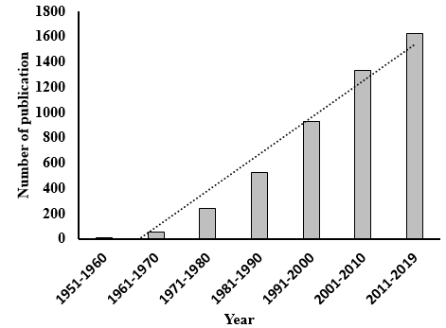

Fig 1.1 Number of published studies in the PubMed database on *Acanthamoeba* from 1960 to May 2019. Chat shows a consistent increase in *Acanthamoeba* research.

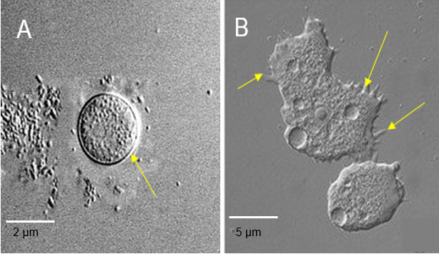

Fig 1.2 Interface contrast microscopy (magnification: X1, 000). (A) *Acanthamoeba* Cyst arrows show the double-cell wall (B). *Acanthamoeba* trophozoite. The trophozoite is typically irregular in shape with a large central nucleus and spine-like structures around the cells called the acanthopodia (yellow arrows). (Walochnik, Scheikl and Haller-Schober, 2014)

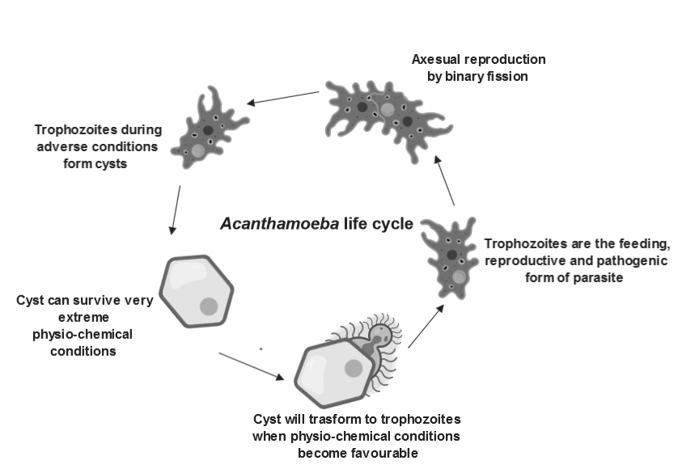

**Fig 1. 3** The life cycle and pathogenesis of *Acanthamoeba spp*. The life cycle of *Acanthamoeba spp* begins with vegetative trophozoites. Reproduction is asexual by mitosis and can occur in only the trophozoites. When the chemo-physical environment around the amoeba changes and becomes harsh they transform to cysts. The cysts are static, viable, and highly resistant. Cysts will re-transform to trophozoites when they are in optimal conditions. Updated from (Mahmud, Lim and Amir, 2017)

## 1.2 Acanthamoeba Keratitis

Keratitis is an inflammation of the cornea – the transparent, oval-shaped tissue located on the front of the eye, which covers the pupil and iris. Non-infectious keratitis is often caused by a minor abrasion on the cornea usually stimulated by foreign material or wearing a contact lens longer than required. Microorganisms like bacteria, fungi, viruses and parasites can cause infectious keratitis (Richards et al., 2015). Keratitis caused by *Acanthamoeba spp.* is often referred to as Acanthamoeba Keratitis. Acanthamoeba keratitis (AK) is an uncommon but serious eye infection that is painful and sight-threatening (Fasciani et al., 2018). As the name implies, *Acanthamoeba* causes this infection, when they invade the eye and find their way through the outer membrane of the cornea (Gonçalves, Ferreira and Guimarães, 2019). It is estimated that the annual incidence of Acanthamoeba keratitis is approximately 1.4 per million people worldwide in 2004. 80 to 90% of sufferers are contact lens users (Khan, 2015; Lorenzo-Morales, Khan and Walochnik, 2015; Maycock and Jayaswal, 2016.

In England, the incidence is reported to be 1.2-1.3 cases per million in 2010 (Trabelsi et al., 2012). Recently, it is emphasised that the awareness about Acanthamoeba keratitis a severe sight-threatening infection is still insufficient. Experimental observation in rats and mice show that infection begins with trauma in the eye (Wu, 2010). Poor contact lens hygiene is a major contributing factor to infection in humans (Brown et al., 2017).

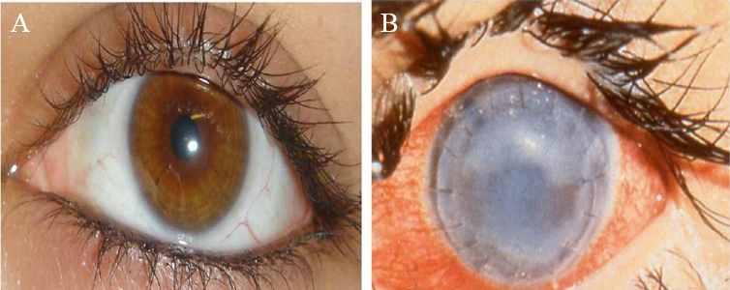

Fig 1.4 (A) Normal eye and (B) Infected eye exhibiting symptoms of Acanthamoeba keratitis*; redness* of the eye, corneal ulcer and characteristic, ring-like corneal infiltration. Adapted from (Chaidaroon and Supalaset, 2016)

## 1.2.1 Acanthamoeba keratitis; improper contact lens hygiene, a significant risk factor

Contact lenses are tin lens placed directly on the surface of the cornea in the eye. They are usually corrective devices but sometimes worn for cosmetic reasons. For a contact lens user, the fig lens sits on the cornea. Not all cornea has the same structure and size (Jester et al., 2013). Some cornea is more curved while others are flatter. It is vital to have a contact lens that fits properly onto the cornea, highlighting the importance of professional guidance before and during contact lens use. If the contact lens does not align properly on the cornea, it can cause serious problems for the user- including corneal distortion, swelling, ulceration, abrasion and inflammation (Asoklis, 2017). Corneal ulcers develop when there is a disruption of the corneal epithelium; in a normal eye, the tear films constantly lubricate the surface of the cornea, preventing corneal abrasion from friction. As seen in fig (1.6), attachment of *Acanthamoeba* trophozoites on the surface of the cornea initiates the first step of the pathogenicity of Acanthamoeba keratitis. The key role of the tear is to lubricate and supply the appropriate amount of oxygen in the cornea. This function can be affected by inappropriate contact lens use, causing several problems like dry eyes, and corneal abrasion. Studies have shown that frequent overnight use of contact lens predisposes an individual to corneal ulceration (Asoklis, 2017).

During sleep when the contact lens is in use, there is obstruction of the flow of tear and oxygen, which might lead to hypoxia and hypercapnia of the corneal epithelium, leading to ischemic necrosis (Alharbi, La Hood and Swarbrick, 2005). Alharbi and co reported that the relative risk of ischemic necrosis for overnight used of the contact lens was 5 times greater than the non-contact lens user (Abdelkader, 2014). Recall that corneal abrasion or trauma is the major anchor point of *Acanthamoeba* trophozoite and this has been demonstrated in vivo (Suryawanshi et al., 2014). The toughness of the cornea epithelium prevents this process hence it is difficult for *Acanthamoeba* to invade an intact cornea. It has been shown that corneal epithelial cells are more resistant to the cytopathic mechanism of trophozoite invasion (Omaña-Molina et al., 2013) However, because the use of contact lenses facilitates the initial mechanism of corneal invasion by increasing the chances of corneal abrasion, contact lens use is one of the primary risk factors for Acanthamoeba keratitis. The toughness of the corneal epithelium creates an important obstruction against *Acanthamoeba* invasion to the underlying structures. However, reports showed that the adherence of *Acanthamoeba* trophozoites to an intact corneal in animals also caused keratitis; suggesting that the existing trauma to the corneal surface is not a requirement for the initiation of amoebic keratitis. (Omana-Molina et al., 2004).

Ulceration of the corneal was essential for the development of Acanthamoeba keratitis in rabbits (Ortillés et al., 2017). Corneal epithelial trauma facilitates the attachment of *Acanthamoeba* on the cornea and subsequent invasion of the underlying layers of the cornea. Lacerations on the cornea expose protein-binding sites of the mannose glycoprotein. The adhesion of *Acanthamoeba* to the corneal epithelial cells is a site-specific interaction between proteins found on the acanthopodia and the corresponding mannose-binding glycol-protein. Sugar inhibition assays have shown that *Acanthamoeba* specifically binds (with high affinity) mannose saccharides and not non-mannosylated glycoproteins like galactose fructose and lactose (Cao, Jefferson and Panjwani, 1998; Huth et al., 2017). Mannose receptors on the surface of the cornea stimulate *Acanthamoeba* to release pathogenic proteases, which activates epithelium apoptosis and enhances invasion of *Acanthamoeba* into the underlying stroma (Badenoch, 1991). Therefore it is vital for contact lens users to familiarise themselves with information about proper lens care i.e. method of disinfection and most appropriate disinfectants to be used. It is a bad practice to wash the contact lens with tap water, swim or shower or use a hot tub while wearing your contact lens.Water contains viable *Acanthamoeba* cysts which when in a suitable environment can transform to trophozoites and lead to Acanthamoeba keratitis, so water should not come into contact with the contact lenses

## 1.2.2 The cornea; function and anatomy

The cornea is the peripheral layer of the eyeball see Fig 1.5. The key function of the cornea is to protect the internal structures of the eye (Luo et al., 2017). The cornea is a translucent tissue that plays a very important role in the normal functioning of the eye. Although the corneal appears empty when observed from the outside, the cornea is made of very complex structures that carry out important functions in the eye. The major component of the cornea is collagen; as well as providing robustness, the complex arrangement of the collagen, for example, the avascular arrangement of tissues, allows passage of light with limited scattering, making the cornea transparent (Meek, 2009). The intricate structure of the cornea enforces the structural function of the cornea Fig 1.5, which is to act, like a barrier that protects the inner structures of the eye like the Iris and the Pupil and also prevents the invasion of the eye by pathogenic microbes. In humans, the diameter of the cornea is approximately 11.5 mm with a thickness of about 0.5-0.6 mm in the centre and 0.6-0.8 mm at the edge. The diameter of the cornea determined using the ORBSCAN II system showed that the mean diameter of the cornea is 11.72 ± 0.47mm (Chen and Xia, 2016). There are five layers in the cornea: the epithelium which is the outermost layer, followed by the Bowmans membrane. The third layer of the cornea is the Descemet's membrane and finally, the endothelium. The most important part is the outermost layer (Epithelium) which absorbs nutrients and oxygen from tears and transports it to the other parts of the cornea.

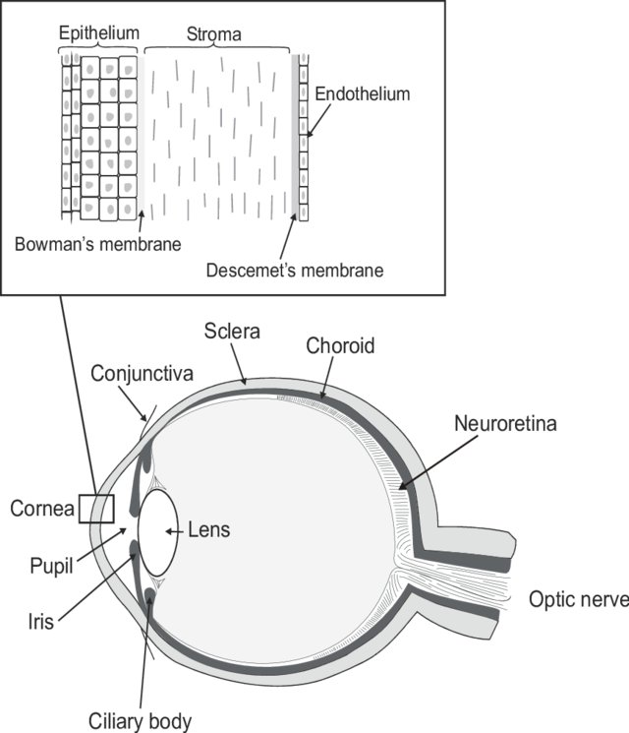

Fig 1.5. Anatomy of the cornea. The outermost layer of the cornea is epithelium which measures about 50 μm in thickness. The Bowmans membrane follows and is situated between the epithelium and the stroma. The Bowman membrane is thinner than the epithelium and varies in size (between 18-22 nm in diameter). The stroma is the middle layer of the cornea an is about 500 microns thick and constitutes about 90% of the overall cornea size. The final layer before the endothelium is the Descemet's membrane sandwiched by the stroma and the corneal endothelium, the Descemet”s membrane controls the permeability of substances through the cornea. Acanthamoeba infection does not progress past the Descemet's membrane. Image Adapted from (Huhtala et al., 2008).

## 1.3 Pathogenesis of Acanthamoeba keratitis.

The pathogenesis of *Acanthamoeba* is dependent on three factors: the host, the amoeba and the environmental conditions. The pathogenesis of *Acanthamoeba* starts with the adhesion of Amoeba to the host cell, discharge of extracellular proteases and host cell death usually by Apoptosis. Typically, a cell lysing mannose-specific protein (MIP-133), which helps in the degradation of the corneal layers and subsequent invasion of the cornea is secreted by the trophozoites (Panjwani, 2010) Fig 1.6. the first line of defence by a host to cornea invasion is the infiltration of inflammatory cells like macrophages and neutrophils (Alizadeh, Neelam and Niederkorn, 2007). Infiltration of the inflammatory cells plays an important role in the clearance of *Acanthamoeba* trophozoites (Alizadeh et al., 2014). The initial attachment and release of the MIP133 protein promote secondary events like phagocytosis and toxin production resulting in host cell death via phosphatidylinositol 3-kinase-dependent (PI3K) dependent pathways (Sissons et al., 2005). Production of P13K causes activation of proapoptotic molecules such as Bak and Bax, deactivation of mitochondrial membrane potential, production cytochrome *C*, and activation of caspases all events leading to apoptosis.

## 1.3.1 Adhesion of *Acanthamoeba* to host cell

The ability of amoeba to attach itself to the corneal epithelial cells is associated with the degree of pathogenicity of different isolates (Serrano-Luna et al., 2013). Two characteristics of amoeba that facilitates its pathogenicity are the presence of acanthopodia, and a surface adhesion protein called mannose-binding protein (MBP). These two elements are vital as non-pathogenic amoeba shows very low adhesion capacity to host cell. The number of acanthopodia is partially related to the rate of adhesion; non-pathogenic strains have fewer acanthopodia and MBP compared to the pathogenic strains (Hurt et al., 2003). The mannose-binding protein (MBP) is a 400-kDa protein containing several 130-kDa subunits. The MBP is specific to mannose, but not to a number of other similar saccharides, like manosamine and mannitol. Experiments designed to inhibit mannose resulted in reduced adhesion of *Acanthamoeba* to target cells and reduced cytotoxicity; so far no molecule has shown a similar effect (Yoo and Jung, 2012; Kim et al., 2012). Additionally, abrasions in the epithelial barrier have been shown to promote *Acanthamoeba* infection, even in non-contact lens users. Though these reports indirectly show that the adhesion of *Acanthamoeba* trophozoites to the corneal surface is facilitated by interactions between Manose-specific lectin on the surface of amoeba trophozoites and the mannose active site of glycoproteins of the corneal epithelial cells, direct evidence showing that the MBP is a virulence protein is not clearly established.

## 1.3.2 Extracellular proteases

Enzymes that have the ability to metabolise different protein substrates play an important role in various infections of bacterial, viral and protozoan origin (Lindsay, Oates and Bourdillon, 2017). *Acanthamoeba* produces several types of proteases: serine proteases, elastases cysteine proteases and metalloproteases. Serine protease is the most important enzymes associated with host cell degradation. The role of the serine proteases was shown when amoebae were incubated with phenyl methyl sulfonyl fluoride (PMSF) a known inhibitor of serine proteases (Sissons et al., 2006). Results from experiments presented by Sissons and co-scientists suggested higher levels of extracellular protease in pathogenic *Acanthamoeba* compared to non-pathogenic strains and inhibition with PMSF reduced cytopathic activities of these proteases. The serine proteases can degrade collagen, fibronectin, laminin, secretory immunoglobulin A (sIgA), immunoglobulin G, fibrinogen, bovine serum albumin (BSA), haemoglobin (Na et al., 2002). Interestingly, Type 1 collagen is a constituent in the corneal stroma and is associated with the maintenance of the cellular integrity of the cornea. Immunoglobulins in humoral immunity inhibit the adhesion of microorganisms and prevent the invasion of pathogenic microbes (Teng et al., 2017). In fact, immunoglobulins act as an immediate barrier against these pathogenic microorganisms.

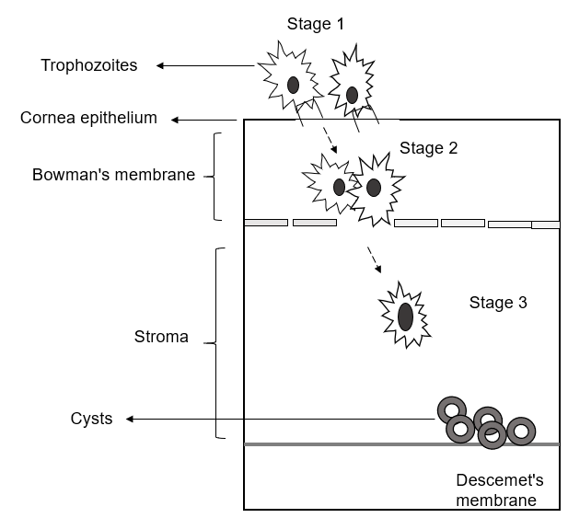

Fig 1.6. The pathogenic cascade of Acanthamoeba keratitis. In stage 1, *Acanthamoeba* trophozoites attach to the surface of the cornea epithelium a process facilitated by corneal trauma. On binding to the corneal epithelial cell *Acanthamoeba,* trophozoites release cytolytic enzyme MIP133 that degrades the corneal epithelial cell allowing the trophozoites to enter the Bowman’s membrane. In stage 2, Trophozoites produce several proteases like the mannose induced protein 113 (MIP113) and Collagenase, which affect the degradation and subsequent invasion of the stroma Trophozoites cluster around the cornea nerves causing radial keratoneutritis and extreme pain and possibly form cysts, as they do not move further into Descemet’s membrane.

## 1.3.3 Diagnosis of Acanthamoeba keratitis.

Acanthamoeba keratitis remains one of the most difficult clinical entity to diagnose (Page and Mathers, 2013). Since it has related symptoms with keratitis caused by other pathogens like bacteria, fungi and viruses it is easily misdiagnosed (Garg, Kalra and Joseph, 2017). A decent prognosis depends on early diagnoses and access to appropriate medical therapy. Prognosis worsens if the diagnosis is delayed for more than three weeks, (Alkharashi et al., 2015). To avoid this situation, *Acanthamoeba* should be suspected whenever there is corneal trauma associated with contact lens wear, contaminated water or soil. *Acanthamoeba* keratitis should also be considered when there is resistance to first-line therapy for keratitis caused by bacteria or fungi or simplex virus. The commonly used diagnostic method for Acanthamoeba keratitis is confocal microscopy (CFM), which show specificity and sensitivity up to 90% (De Craene et al., 2018). *Acanthamoeba* is present in the sample, if highly reflective round structures (10-25 µm) are seen, or if double-walled structures consistent with cysts are seen. However confocal microscopy lacks enough resolution to be the sole diagnostic tool, it is useful in predictive diagnosis, while a final diagnosis of AK can only be by culture or histology, or by DNA assay using polymerase chain reaction (PCR) which shows 84% sensitivity and 100% specificity (Tu et al., 2008).

Identification using culture technique can be either by inoculation on nutrient agar plate supplemented with *Escherichia coli* or by axenic culture using *Acanthamoeba* growth media, which was maintained at 30 °C for about 6 to seven days (Khan, 2006). Smears (immunostaining) with immunoperoxidase a polyclonal antibody for *Acanthamoeba* is proposed as a useful diagnostic tool, however, the antibody is not available commercially. Novel promising approaches are being developed. For example, the use of Matrix laser desorption ionization time-of-flight (MALDI-TOF MS) profiling has emerged as a quick, economic and HTS for identification of all microbial species and has found its application for diagnosis of Acanthamoeba keratitis (Kostrzewa and Nagy, 2016; Megha et al., 2018; Saeedi, 2018; Patel, 2019). In MALDI-TOF MS, the sample to be analysed is prepared is mixed with an energy-absorbant organic compound known as the matrix. The sample crystalises with the matrix when dried. When ionised with a laser beam, singly charged ions are generated, which travel through a flight tube from where they are separated. In MALTI-TOF analysis, the m/z ration of an ion is determined by measuring the time it takes the ion to travel through the flight tube (time of flight- TOF). The TOF data generates a spectrum called the mass fingerprint (PMF) which is distinctive for a particular sample. To identify and differentiate microbes on a specie level, a typical mass range of 2- 20kDa is used as it covers the range of masses for ribosomal proteins which are targets used to differentiate microbes on a specie level.

## 1.3.4 Treatment of Acanthamoeba keratitis

No commercially available drugs have been licenced to treat *Acanthamoeba* Keratitis in the United Kingdom (Alkharashi et al., 2015). In 2017 the United States certified the use of miltefosine for treatment of Acanthamoeba keratitis. First-line therapies include the use of biocides usually biguanide derivatives polyhexamethylene biguanide and chlorhexidine gluconate or acetate, diamidine derivatives like hexamidine isethionate and pentamidine isethionate (Carrijo-Carvalho *et al.,* 2017). Concentrations of biocides used for treatment is based on clinical reports and laboratory analyses. These biocides are formulated as an eye drop solution of 0.02% of either PHMB or CLX and 0.1% of diamidines. Although when biguanides are used in combination therapy with chlorhexidine and polyhexamethylene, they improved treatment outcome (Ferrari, Matuska and Rama, 2011). However, the side effects associated with its use in several reported cases has caused severe post-therapeutic outcomes like cataract, iris atrophy and corneal ulceration (Murthy, Hawksworth and Cree, 2002). There are other chemotherapeutic approaches like the use of, topical or oral voriconazole which is considered a second-line therapy in patients that are unresponsive to conventional approaches and requires constant supervision for side effects (Cabello-Vílchez et al., 2013).

In view of the systemic side effects, topical use of voriconazole is favoured; however, additional studies are needed to support voriconazole use as a monotherapy or in combination with biguanide and diamidines. Although a published study has shown evidence of clinical improvement with voriconazole in patients with AK, only a few cases were evaluated with limited therapeutic relevance for the cysts (Gueudry et al., 2018). The use of steroidal anti-inflammatory drugs to treat AK remains contentious and a very serious issue in clinical practise (Chomicz et al., 2016). Several complications based on clinical investigations into the effects of topical steroids on the metabolism of the protozoan and in the inflammatory cascade of the patient have been previously reported (Liesegang, 2002). Available synthetic steroids in ophthalmology used to manage severe inflammation caused by AK are prednisolone, hydrocortisone, dexamethasone and fluorometholone (Carnt et al., 2016). A study has reported the use of prednisolone acetate to treat AK (Liesegang, 2002). The use of these steroids to minimize inflammation caused by AK infection is controversial as it might increase *Acanthamoeba* pathogenicity, and be associated with worse disease outcome. Considering the current knowledge about the safety and efficacy of the available therapeutic compounds for the treatment of Acanthamoeba keratitis, the biguanides are still the first option; although the benefit of choosing between the two most used biguanide( poly hexamethylene and chlorhexidine), remains unclear.

The biguanides molecular weight affects permeability through the cornea, which explains better clinical outcome using chlorhexidine. Shown in Table 1.1 are drugs and antimicrobial compounds that have shown the significant therapeutic effect on *Acanthamoeba* and their minimal inhibitory concentrations. Among them is Miltefosine a drug originally formulated as an anti-parasitic drug but now have gained orphan drug profile for the treatment of *Acanthamoeba* infections in the United States.

Table 1.1 Minimal amoebicidal concentrations of compounds investigated against cysts and trophozoite of Acanthamoeba spp. (nd) means no data. The US FDA in 2017 accepted Miltefosine for treatment of AK in 2016 and has to treat a resistant case of keratitis in England in 2017

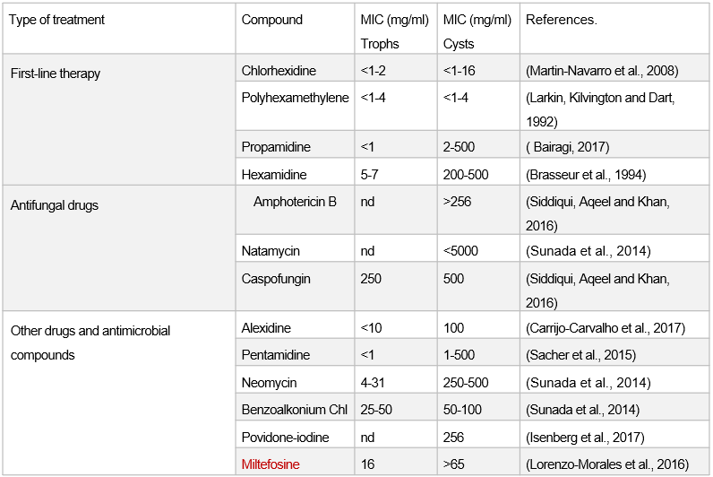

## 

## 1.4 Photodynamic therapy (PDT)

Photodynamic therapy (PDT) uses the combination of a photoactive compound, in the presence of a sufficient amount of oxygen and light of appropriate wavelength to cause targeted damage to a specific tissue or microorganism. Early experiments by Oscar Raab stirred the interest in photodynamic therapy as a therapeutic modality. Although there are several reports of the use of photosensitisation reactions by Chinese, Indian and Egyptian scientists 30 centuries ago, the use of PDT in the contemporary period has been recognised to start 1900 (Sorbellini, Rucco and Rinaldi, 2018). Oscar Raab studied medicine under the supervision of Hermann von Tappeiner at the Ludwig-Maximillian University in Munich. Raab while investigating the toxicity of acridine on paramecia, discovered that the response of paramecia to acridine differs depending on the time of the day. The toxicity around midday was greatest. Raab noticed that the amount of light entering the laboratory where he worked as an important variable. He subsequently demonstrated that the paramecium, when incubated with acridine solution, were inactivated more efficiently when exposed to light than when in the dark. This result was published in 1900, giving rise to increased interest in photochemistry as a possible therapeutic modality.

The interaction between light and the photosensitiser (PS) generates reactive oxygen species (ROS), e.g. singlet oxygen (1O2).

Photodynamic therapy has been accepted as a therapeutic method of management of several kinds of cancers (Akimoto et al., 2019). The use of PDT as a treatment for cancer is particularly interesting because of its specificity and selectivity. This is because the PS usually concentrates on the malignant tissue (cellular mechanisms which remove foreign materials from malignant cells are not functional). and when illuminated, there is the selective destruction of cells limiting adverse effects due to damage to normal cells. For this reason, PDT has become a subject of intense investigation as a potential treatment for localised infections of microbial origin.

## 1.4.1 Photochemistry and photophysics of PDT

The two most important aspects of PDT are the mechanism of light absorption and energy transfer see Fig 1.8. A photosensitizer in its ground state has two electrons with an opposite spin in a low energy molecular orbit; this is called the singlet state. Following the absorption of light energy (photons), one of the electron pairs is elevated to a high –energy orbit while maintaining its spin from the singlet state. This singlet-excited state is transitory and loses its energy by fluorescence emission or by internal conversion to heat.

This excited singlet state photosensitiser can also experience what is known as intersystem crossing where the spin of the excited electron reverses to give rise to a long-lived triplet excited state with electrons that spin in the same direction (Fig 1.7)

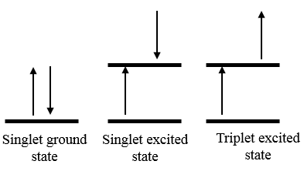

Fig 1.7 Spin direction of electrons from the ground state to singlet excited state then to the triplet-excited state.

The triplet-excited state can undergo two different reactions as shown in fig (1.8). Firstly, in a reaction known as the type I rxn, the triplet state PS can react directly with a substrate like a cell membrane or a molecule by transferring a proton or electron to form a radical anion or cation (Martinez De Pinillos Bayona et al., 2017). These radicals can then react with oxygen-generating reactive oxygen species (ROS) (Zorov, Juhaszova and Sollott, 2014). Alternatively, in the type II rxn, the triplet state PS can transfer its energy to molecular oxygen to produce an excited state singlet oxygen see fig 1.8. Both the type I and the type II reaction can happen at the same time and the ration between the two depends on the type of PS used the concentration of substrate and amount of oxygen involved (Huang et al., 2012).

Singlet oxygen, are highly reactive and can react with membranes or any biomolecule to induce cell death through oxidative damage.

Generally, an ideal PS used in aPDT should have the following features; High 1O2 quantum yield (Zhang et al., 2018), high binding affinity for target microbial cell wall, low binding affinity to mammalian cells (Rovaldi et al., 2000) and low chemical toxicity and mutagenicity (Castano, Demidova and Hamblin, 2004)

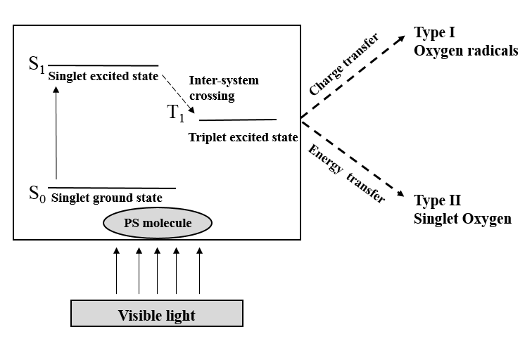

Fig (1.8) The Type I and Type II processes of photodynamic therapy. Visible light of the required wavelength is absorbed by the PS molecule, causing the molecule to change from its ground state (SO) to an energetically excited-state (S1). Here the Ps is able to transform from a singlet excited state to a triplet state (T1) (ISC). This T1 is long-lived and can transfer energy (type II) or transfer charge (type I) to surrounding molecules like oxygen radicals or singlet oxygen.

## 1.4.2 A Dual pathway of Photosensitization.

As stated earlier, the PDT process occurs by two competitive pathways, both of which require the long-lived excited triplet oxygen state of the PS molecule as the reactive intermediate (3PS). The type I pathway includes an electron transfer step between the triplet PS molecule and a surrounding substrate (Sub), by the generation of radical oxygen species, the substrates react with ground state oxygen giving out oxidised products (Ding et al., 2011). Below is a typical representation of a type I reaction in PDT

Type I reaction



However, the direction of the electron transfers between the PS and the substrate regulated by the redox potentials between the PS and the substrate. This means that the forward reaction is affected by the equilibrium of the reacting pair.

Alternatively, in the second pathway the type II reaction, there is energy transfer from the PS directly to any suitable acceptor, which is often ground state oxygen which will then be excited to the most reactive triplet excited state (1O2), which can attack surrounding biomolecules (Baptista et al., 2017).

Type II reaction



In any of the pathways, the phot oxidation process is of electrophilic nature and is specific to biomolecules like lipids, amino acid proteins and DNA as discussed earlier. It is a general belief that porphyrin and phenothiazine-based PS operates via the type II pathway which is the predominantly the common process of photosensitization.

**1.4.3 Reactive oxygen species**

A radical usually called a free radical is an atom or group of atoms that contains one or more unpaired electrons (Lobo et al., 2010). Radicals can be negatively or positively charged or have a neutral charge. The valence electrons in the orbit make free radicals very reactive, this is because they must pair with surrounding molecules to be in the most stable state (octet state). They are intermediates in different biochemical reactions, but when the production is not optimised in a biological system, radicals can cause damage to cells or microorganism (Oberkampf et al., 2018). There are different types of radical; however, those usually studied are those from oxygen (oxygen free radicals). Oxygen has two unpaired electrons in two different orbitals in the outermost shell see fig 1.9. This gives oxygen a higher potential to form radicals. Sequential reduction of molecular oxygen causes the production of a group of reactive oxygen species: superoxide anion, peroxide (hydrogen peroxide) and hydroxyl radical. The most important form of oxygen radical in photodynamic therapy is singlet oxygen. Singlet oxygen is the lowest excited state of molecular oxygen; it is an interesting specie in many ways. Its chemical behaviour is different from its ground state triplet oxygen. Singlet oxygen can travel through cellular environments and can cause serious damage to biomolecules (Koh and Fluhr, 2016).

In biomolecules, the lifespan of singlet oxygen varies and this is because of the presence of antioxidants and quenchers. In human plasma, which contains a lot of antioxidants, the lifetime of singlet oxygen is about 1µs (Sharma et al., 2012). Singlet oxygen acts as an electrophile in solution and reacts with biomolecules having regions of high electron density example guanine in DNA (Petrou et al., 2018).

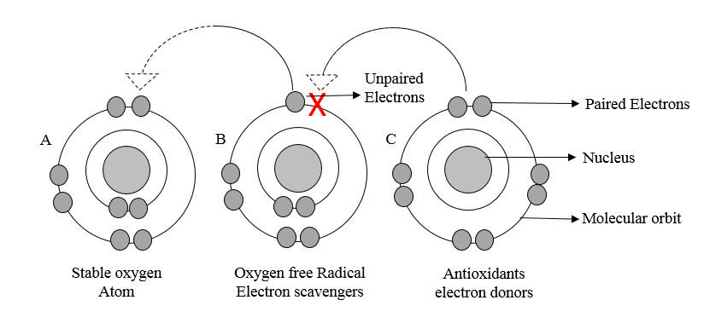

Fig 1.9 Molecular representation of (a) stable molecular oxygen (b) oxygen free radical with the unpaired electron shown as X and (c) antioxidants which are characteristically electron donors.

## 1.4.4 Biological effects of free radical and reactive oxygen species.

Oxygen-free radicals are produced in a number of reaction important in life, including in the production of ATP. They are also produced during the controlled destruction of antigens; phagocytic cells generate radicals that enable them to mop up invading pathogens (Rea et al., 2018). Radicals are key players in intracellular and intercellular signalling (Ray, Huang and Tsuji, 2012). For example, the introduction of superoxide or peroxide to some cultured cells stimulates the elevated rate of DNA replication and cell proliferation- in other words, these radicals are important mitogens (Hishikawa et al., 1997). Regardless of these important biochemical functions of radicals, they can be toxic to cells. As shown in fig (1.9) the unpaired electrons in the outermost shell of the radicals make them highly reactive to almost every biomolecule. They have a very strong affinity to lipids, proteins and nucleic acids (Koh et al., 2016). One of the most common toxic effects of these radicals to cellular membranes is lipid peroxidation (Yin, Xu and Porter, 2011).

## 1.4.5 Lipid peroxidation

The main target for peroxidation is unsaturated fatty acids seen in membrane phospholipids. When there is an elevated level of ROS in the cell beyond the cells antioxidant capacity, lipid peroxidation occurs (Ayala, Muñoz and Argüelles, 2014). Lipid peroxidation intensifies oxidative stress by the production of lipid-derived radicals, which have a strong affinity to proteins and DNA. Quantification of peroxidation in cells undergoing oxidative stress can be used to detect ROS in these cells (Niki, 2008; Griendling et al., 2016). Increased peroxidation under stress conditions is proportional to increased production of ROS. The two most common specific sites to ROS on the phospholipid molecule are the ester linkage between glycerol and fatty acid and the unsaturated bond between carbon atoms fig 1.10 (Saravanakumar, Kim and Kim, 2016). Polyunsaturated fatty acids in cell membranes are the principal target of ROS (Das and Roychoudhury, 2014). A single hydroxyl radical (•OH) can cause the peroxidation of several polyunsaturated fatty acids as the reaction involved is a cyclic chain reaction. Peroxidation of membrane lipids significantly alters the lipid bilayers, particularly distorting lipid-lipid interactions, ion gradients, membrane fluidity and permeability leading to cell death (Wong-ekkabut et al., 2007). Modelled molecular dynamics showed that peroxidised phospholipids rearranged themselves in a bilayer such that the oxidised chain moved toward the water/lipid interphase, decreasing membrane thickness and strength (Lis et al., 2011).

Subsequent evidence showed that the entire oxidized chain could float unto the aqueous phase, becoming targets for macrophages (Remmerie and Scott, 2018). Lipid peroxides produce metabolites that exhibit additional toxicity. For example, ferrous iron can react with lipid peroxide to produce a corresponding alkoxy radical, which potentially stimulates new peroxidation reactions. Furthermore, products like 4-HNE (4- Hydroxylnonenal) and [Malonaldehyde](https://www.sciencedirect.com/topics/medicine-and-dentistry/malonaldehyde) (MDA), formed by the degradation of aldehydes are toxic to cells. MDA is a dialdehyde capable of crosslinking primary amines and proteins. Similarly, 4-HNE is also a Michael acceptor and can attach to the side chains of nucleophilic amino acids (Pizzimenti et al., 2013). These covalent modifications carried out by these secondary by-products of lipid peroxidation modify the functions, structure of proteins and nucleic acids, and are responsible for the cytotoxic effect seen by free radical-induced damage (Gaschler and Stockwell, 2017).

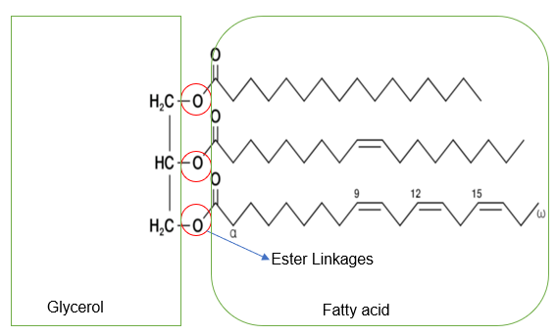

Fig 1.10 Lipid molecule showing ester linkages (red rings) which is the main target of reactive oxygen species.

## 1.4.6 Free radical interaction with proteins.

Free radical attack on proteins results in the modification of proteins, and this can occur in a direct or indirect manner. Direct modification of a protein includes modulation of the activity of the protein through nitrosylation, carbonylation, the formation of disulphide bonds and glutathionylation. Protein is also modified indirectly through conjugation with by-products of fatty acid peroxidation (Barrera, 2012).

As consequences of an attack by ROS, site-specific modification of amino acid, the break-up of the peptide chain, aggregation of cross-linked reaction products, changed electric charge and elevated susceptibility of protein to proteolysis occur (Wall et al., 2012). The reaction of singlet oxygen with proteins is more selective. Some amino acids are more reactive to singlet oxygen, for example, histidine, tryptophan, methionine and tyrosine (Klotz, Kröncke and Sies, 2003). Oxidation of these amino acids produces endoperoxides and sulphoxides, which are toxic by-products. When singlet oxygen is released in solution, it sometimes causes non-specific or global protein damage, which can be estimated by evaluating protein carbonyl (Augustyniak *et al*., 2015). The oxidation of proteins is associated with the process of ageing and the onset of certain diseases (Reeg and Grune, 2015).

Lipofuscin, a by-product of peroxidised lipid and proteins, is found accumulated in the lysosomes, of aged cells and brain cells of patients with Alzheimer’s disease and found localised in iron-overloaded hepatocytes (Grimm et al., 2010). The oxidative inhibition of several enzymes is associated with ageing and in the onset of certain disease conditions like ischemia-reperfusion. Oxidation of cysteinyl residues by singlet oxygen causes inactivation of different enzyme-like tyrosine phosphatases (Bheri and Pandey, 2018). Tyrosine phosphatases are enzymes that detach the phosphate group from phosphorylated tyrosine residues on proteins (Elson, 2018). Phosphorylation is a post-translational modification that creates new recognisable modifications that allow for protein-protein interactions. When tyrosine phosphatases are inactivated, protein stability and enzyme activity are affected (Ardito et al., 2017); this, in turn, affects various metabolic processes like cell growth, differentiation, and transformation. Furthermore, oxidation of histidylbysinglet oxygen is believed to have stimulated the inactivation of mitochondrial permeabilitytransition pore. The mitochondrial permeability pore was shown to be unresponsive to Ca+ after photodynamic inactivation by hematoporphyrin (Ricchelli, Šileikytė and Bernardi, 2011). In summary, various signalling proteins are inactivated by singlet oxygen-mediated oxidation of amino acid side chain.

## 1.4.7 Free radical damage to DNA

Reactive oxygen species are the main initiators of DNA damage (Srinivas et al., 2018). The primary targets of ROS are intracellular organelles mostly mitochondria. DNA is the genetic material of the cell and any injury on the DNA will lead to changes of the encoded proteins, which will result in malfunction and inactivation of the encoded protein. Oxidative attack on the DNA effects deoxyribose oxidation, fragmentation of DNA strands, deletion of nucleotides, changes in the organic base of the nucleotides, and crosslinking of DNA (Cadet and Wagner, 2013). DNA mutation can occur especially when there are changes in the nucleotide of one strand, causing a mismatch in the corresponding strand (Liu et al., 2016). Oxidative damage to DNA typically involves the addition of hydroxyl radical to double bonds, while distortion of the DNA sugar base occurs from hydrogen abstraction from the deoxyribose (Markkanen, 2017). The hydroxyl radical has the ability to react with all the purine and pyrimidine bases, even the deoxyribose backbone (Terzidis et al., 2016). Attack by hydroxyl radical cause the formation of products like hydroxyl methyl urea, urea, thymine glycol and other saturated products (Evans, Dizdaroglu and Cooke, 2004). ROS induced damage to DNA causes different mutagenic alterations which can lead to the development of cancers (Mu and Liu, 2017).

For example, the mutation caused by the selective alteration of G: C sites, typically shows an attack by reactive oxygen species (Bandyopadhyayet et al., 1999).

Attack by reactive oxygen species to the sugar moiety of the DNA can result in a broken DNA strand (Caldecott, 2003). Mitochondrial DNA is susceptible to attack by ROS probably because of the fact that mitochondria already generates ROS via oxidative phosphorylation (Kalogeris, Bao and Korthuis, 2014). Although there are repair systems in place from damage DNA, too much alteration by ROS causes irreversible damage to DNA with possible detrimental effects on the cell (Patel et al., 2018).

## 1.5 Photodynamic inactivation of microbial cells: General Aspects

Microbial cells display a huge variation in size, subcellular and biochemical contents (Brehm-Stecher and Johnson, 2004); as a result, the susceptibility to photodynamic therapy can be hugely different for various types of organisms or forms of a cell. Microbial cell walls can be likened either to gram-positive characteristics or to a gram-negative type (Mai-Prochnow et al., 2016). The gram-positive cell wall is often surrounded by an external wall which is separated from the cell membrane by a periplasmic space. This space typically ranging from 20 nm – 80 nm is a protective lattice chiefly comprising of peptidoglycan layers, which intercalate diagonally beside negatively charged lipoteichoic and teichuronic acids anchored inside the cell membrane (Kleanthous and Armitage, 2015). This type of special arrangement is not particularly robust as a barrier, hence the ability of several macromolecules with relatively large mass (60, 000Da) to diffuse and permeate the inner membrane (Foster, 2015). Any PS molecules with a weight typically not greater than 1500Da, can freely cross the outer wall into these cells hence their susceptibility to anti-microbial photodynamic therapy are known to be high (Schastak et al., 2010). On the other hand, the gram-negative bacterial usually have an extra 10-15 nm thick cell wall element which is external to the peptidoglycan network.

The peptidoglycan of these bacteria are also chemically different, containing teichoic and lipoteichoic acids which provide the outer membrane with a net negative charge: this sophisticated cell wall system inhibits the cell wall penetration of macromolecules with a molecular weight larger than 600-700Da (Miller and Salama, 2018).

The pathogenic protozoa like *Acanthamoeba* also represent a group of structurally diverse organism, which has the ability to transform into a more robust form in severe conditions. The complex life cycle of these protozoa like *Entamoeba histolytica*, *Giardia* and *Acanthamoeba spp* represents why they are therapeutically difficult to handle (Smith and Evans, 2009). By their complex life cycle, it appears that Gram-negative bacteria and the cysts of *Acanthamoeba spp* represent the most challenging targets for antimicrobial PDT or any form of chemotherapy.

## 1.5.1 Photosensitizers used in photodynamic therapy

Several photosensitizers have been tested in *in-vivo* and *in-vitro* experiments against microbial and mammalian cells, though few of them have exhibited ideal therapeutic properties (Hosseinzadeh and Khorsandi, 2017; Morton, 2018; Tampa et al., 2019). As a result, studies have focused on developing PS with desired properties which increase the efficacy of the photodynamic therapy (Garland et al., 2009; Celik and Saydan, 2011 Ansari et al., 2011; Kwiatkowski et al., 2018; Xu et al., 2018). The prerequisite for a potent PS are chemical purity, selectivity to target tissue, chemical and physical stability, shortest possible interval between administration and accumulation to the target tissue, activation at a wavelength with peak tissue penetration and above all rapid removal from the body (Robertson, Evans and Abrahamse, 2009) see table 2 (page 39). There are four main classes of photosensitizers used in PDT. They are the porphyrin derivatives, chlorins, phthalocyanines, and porphycenes (Ormond and Freeman, 2013). The efficacy of several PS molecules has been investigated for their ability to inactivate microbial biofilms *in vitro*. Among the most commonly, used dyes are the phenothiazinium derivatives, like Methylene Blue (Dos Santos et al., 2017) and Toluidine Blue (Oruba et al., 2017), tetrapyrrolic macrocycles like porphyrins (e.g., TMPyP) or the xanthene dyes like erythrosine and Rose Bengal (RB) (Amescua et al., 2017). Furthermore, dyes like fullerenes and curcumin have been reported (Mizuno et al., 2011; Araujo et al 2014). Recently a dye known as SAPYR was introduced, which has a perinaphthenone structure (Cieplik et al., 2013).

|  |  |
| --- | --- |
| **Required features** | **Details** |
| Purity | Must be a substance of known composition and should be stable at room temperature |
| Toxicity overdosage and side effects | * Should have minimal or no toxicity in the absence of light. * Cytotoxic in the presence of the light of a specific wavelength * Should have non-toxic metabolites and minimal side effects |
| Absorption, distribution, metabolism and excretion (ADME) | Should have optimal ADME characteristics especially clearance from cells. |
| Activation and wavelength | Should be activated in a photo-therapeutically window  ( 600- 850nm) |
| Singlet oxygen quantum yield. | Should have a high singlet oxygen quantum yield (0.99⪕ΦΔ⪕ 1.00) |
| Cost and availability | Low-cost Commercially obtainable to allow extensive utilization |
| Selectivity | * Good tumour/target cell/healthy tissue localization ratio * Favourable subcellular localization to induce an apoptotic rather than a necrotic pathway to cell death. |
| Mutagenicity/Carcinogenicity | Must be non-carcinogenic or mutagenic |
| carriers | Can be formulated with different conveyors and carriers. |
| Upgradable chemical structures | The structure should be adaptable to synthesis to get desired chemical/ physical properties |

## Table 2: Required features for an efficient photosensitiser

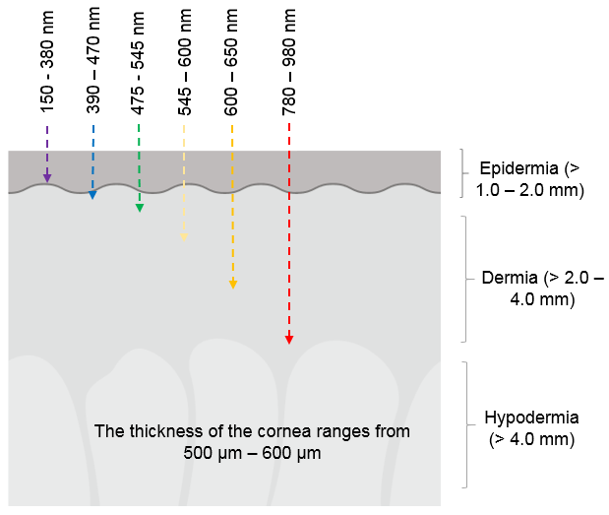

Fig 1.11 Penetration of different spectrum of light through the human skin. (Barolet, 2008)

## 1.5.2 Phenothiazinium derivatives

Methylene blue the first phenothiazinium dye- whose synthesis blueprint was patented by Heinrich Caro in the 1870s. In addition to its use as anti-malarial and antipsychotic agents, phenothiazinium derivatives were also used as potent PS due to its strong absorption in the red spectral region (Felgentrager et al., 2013). The series of phenothiazine (thionine, methylene blue, azure A and B derivatives (Fig 1.11) positively charged dyes and are commonly used as PS in PDT. The intersystem cross quantum yield and singlet oxygen generated during PDT with methylene blue MB are 0.52 (Schaefer, and Schmidt 1980), the triplet lifespan is higher; about 3.0 µs, in air-saturated solution and about 5.0 µs in aqueous solutions saturated by Nitrogen. The singlet-excited state exhibits a lesser life span of approximately 1400ps. Furthermore, MB and its derivatives used in photodynamic therapy as PS showed remarkable biocompatibility *in vitro* to inhibit vital cell organelles (Wainwright, 2007). Numerous studies have shown the efficacy of MD as a PS molecule. Fontana et al. have reported its efficacy on *ex vivo* polymicrobial biofilms sampled from patients with chronic periodontitis. After 7-day cultivation, the biofilms were incubated with MB in concentrations of 25 µg or 50 µg for 5mins and irradiated using a diode laser delivering energy of about 30 j/cm2, which resulted in a 32% CFU only. The authors, however, concluded that optimised delivery and targeting approaches could enhance efficacy. In a similar study, Rossoni et al. (2014) after incubating two different serotype (A and B) of *Candida albicans* with 300 µM MB and delivering a total energy of 26.3 j/cm2 using a gallium aluminium-arsenide laser, resulted in inhibition of less than 1 log10 for serotype A and about 2 log10 for the serotype B.

The authors described that the difference inactivation rate in serotype A and B is because of morphological variation in their cell wall structure. Rossoni et al. further explained that difference in sensitivity of A and B serotypes may be due to ultrastructural differences in their EPS composition (Rossoni et al., 2014). Using toluidine blue (TBO) as a PS a group of Brazilian scientists carried out a number of studies (Zanin et al., 2005, 2006; Teixeira et al., 2012). In their studies, they examined antimicrobial efficacy of using TBO in combination with either a helium or a neon gas laser (32 mW; 632.8 nm) or a led emitting diode (LED; 32 MW; 620-660 nm) on *Staphylococcus mutans* biofilms. *S. mutans* biofilm was incubated with 100mg/l of TBO for 5mins and irradiated at different time intervals delivering a light dose of 49, 147, or 294 j/cm2). This resulted in variations in susceptibility that is dependent on the light source and irradiation period (Zanin et al., 2005). Until date, the Phenothiazinium derivatives are the studied dyes for biofilm inactivation (Voos et al., 2014).



Fig 1.12 Chemical structure of (A) toluidine blue O and (B) methylene blue. Both dyes are phenothiazinium cationic dye with the same mother structure. The difference is methylene blue has a quaternary ammonium salt while toluidine blue has an amine group

## 1.5.3 Porphyrin-based photosensitiser.

Porphyrins are a class of tetrapyrroles and are a major component of Haemoglobin and myoglobin, two O2 binding proteins in the blood (Vicente and Smith, 2014). They are essential for the biological activities of all living organisms. Porphyrins have a highly conjugated heterocyclic macrocycle and sometimes may contain a central metallic atom-like ferrous ion and magnesium. The 22 *π* electron system gives them a characteristic long absorption wavelength. These properties have made porphyrins the most studied compound in photodynamic therapy. There are different classes of porphyrins which primary function in nature is to optimise oxido-reduction processes (Samajdar et al., 2018). They are classified into the first generation, for example, the hematoporphyrin and second-generation PS. Figure (1.13) illustrates the first and second-generation PS and their types. The hematoporphyrin fig 1.12 (a) derivatives have shown greater efficacy in cancer photodynamic therapy. However, these porphyrins are limited by significant impurity, poor light absorption. The second-generation photosensitisers like the chlorins, bacteriochlorins and phthalocyanine were synthesised to resolve some of the limitations of the first generation sensitisers (O’Connor, et al., 2009; McCarthy et al., 2009).

## 1.5.4 First generation porphyrin-based photosensitizers.

Photofrin, synonym Porfimer sodium and di-hematoporphyrin ether are purified types of hematoporphyrin with maximum absorption of 630nm. They have a low molar extinction coefficient of about 1170 M- cm-1 (O’Connor, Gallagher and Byrne, 2009). This low molar extinction coefficient entails that a higher amount of light and high concentration of PS is required for effective PDT. Photofrin has been reported to have a long half-life of 452 hrs giving this PS remarkably long-lasting photosensitivity (Bellnier et al., 2006). In cancer therapy, Photofrin PDT involves intravenous administration of photosensitizer and subsequent irradiation with light after 24 - 48hrs. During this incubation period, systemic clearance is faster in normal cells compared to tumour cells. However, clearance of Photofrin from some tissue like the reticuloendothelial system and skin tissue is slower (Jones, Vernon and Brown, 2003). After irradiation, tumour cell death is caused by the generation of ROS. Photofrin was approved for the treatment of early and late-stage lung, oesophageal, bladder and malignant and non-malignant skin diseases (Dougherty et al., 1998). Photofrin also has shown significant importance as an antimicrobial PS. Photofrin mediated PDT significantly reduced *M. Catarrhalis* viability (Luke-Marshall et al., 2014). Both biofilms were grown and plankton grown bacteria showed a statistically significant reduction in viability (5-6log kill and 3-4 log) kill respectively.

Bacteria treated with Photofrin showed prominent morphological changes with visibly compromised cell membranes (Luke-Marshall et al., 2014). However, While, Photofrin is one of the commonest PS and has a “gold standard” status, in oncology its application to aPDT is hampered by the synthesis of the second-generation photosensitizers, which have desirable physio-chemical properties.

## 1.5.5 Second-generation porphyrin-based photosensitizers.

Though no single photosensitizer has been developed which can be considered the ideal PS in cancer therapy and antimicrobial PDT, several porphyrin-based P have been synthesised to overcome the inadequacies of the first generation PS. However, though the second-generation PS show enhances use in PDT the newer types of conjugated porphyrins allow for better photoactivation with minimal side effects. Recently, there is more research on the electrostatic interaction between the PS molecule and the target bacterial cell wall. It has been suggested, that the number of charges and their distribution in the porphyrin macrocycle has a key role to play in the efficiency of PDI on pathogens with the more robust cell wall (Simões et al., 2016). In *E. coli* cells, the efficiency of photodynamic inactivation (PDI) increased proportional to the number of charges, with porphyrins having three or more positive charge (Hurst et al., 2019).

## 1.5.6 Porphyrins used for the present study

The distribution of functional groups in a porphyrin modifies its amphiphilic characteristics and consequently its efficacy (Nyman and Hynninen, 2004). As regards the transport across cell membranes, the lipid bilayer of the membrane allows passive transport of hydrophobic molecules. If the porphyrin is synthesis to have a hydrophobic functional group, the efficiency of the PDI is enhanced. However, since the PS is expected to be in solution they must exhibit some form of hydrophobic character. Therefore, the ideal PS will have both hydrophobic and hydrophilic characteristics and the way to achieve this is the combination of a hydrophobic and hydrophilic functional group to the porphyrin molecule (Banfi *et al*., 2006)). A slight increase in the hydrophobicity of the photosensitiser improves its affinity to cell walls hence stimulating a more prolific photoinactivation (Niikura et al., 2010).

The synthetic photosensitiser used in this study is the meso-substituted porphyrins. The popularity of meso-substituted porphyrin is because their synthesis involves one-flask or two-step one-flask procedure. The availability of different aldehydes gives rise to porphyrin synthesised with different aryl and hetaryl substituents at their meso positions as seen in Fig 1.14a-d. Porphyrins have shown significant broad-spectrum activity against both gram-positive and gram-negative cell walls at optimal concentrations (0.1-0.5 µM).

The following unique properties make porphyrins most preferred PS for photodynamic therapy. Porphyrins have shown remarkable low toxicity compared to other photosensitisers and can be synthesised to be soluble or insoluble in water (Mondal and Bera, 2014). They have a quick clearance time from the body which reduces the possibility of photosensitive reactions after treatment. (Macdonald and Dougherty, 2001). Furthermore, porphyrins possess proficient amphiphilicity and can be chemically modified to have the desired chemical properties (Lammer et al., 2015). Porphyrins compared to most photosensitisers have high quantum yield (above 0.70) for 1O2 generation and the exhibit one-photon absorption coefficient (≈500,000 M−1cm−1). Porphyrins also have high binding affinity to biomolecules (Nyman and Hynninen, 2004; Kou, Dou and Yang, 2017). Lastly, porphyrins have a therapeutic window, which is capable of killing even multi-drug resistant bacteria with limited toxicity to cultured human cells (Singh et al., 2015; Hamblin, 2016).

Fig 1.13 Porphyrin based photosensitizers are classified as belonging to the first, second or third generation of photosensitizers, or depending on the platform to which they belong (porphyrin, chlorophyll, dyes) (Allison et al., 2004). The first-generation photosensitizers comprise of the only hematoporphyrin derivatives and were developed in the ’70s. The second-generation sensitizers are the porphyrin derivatives synthesised during the ‘80s. Image adapted from (Socoteanu et al., 2011)

|  |
| --- |
|  |
| 5, 10, 15, 20-Tetraphenyl-21H, 23H-porphine (meso-tetra phynylporphyrin) |

Fig 1.14 A Benzylic group attached to the nitrogen atoms of the pyridyl residues located at the mesoporphyrin positions. Attached to the mother porphyrin molecule is a non-polar benzene ring.

|  |
| --- |
|  |
| 5, 10, 15, 20- tetrakis (pentafluorophenyl)-21H, 23H-porphine Iron (III) chloride]. |

Fig1.14 B An iron-containing porphyrin with the R groups having fluorine molecules.

|  |
| --- |
|  |
| 4,4’,4”,4’”-( Porphine-5,10,15,20-tetrayl)tetrakis( benzoic acid). Synonym: meso-tetraphenylporpphine-4, 4, 4, 4- tetra carboxylic acid. |

Fig 1.14 C Chemical structure of 4,4’,4”,4’”-( Porphine-5,10,15,20-tetrayl)tetrakis( benzoic acid). Synonym: meso-tetraphenylporpphine-4, 4, 4, 4- tetra carboxylic acid

|  |
| --- |
|  |
| 5, 10, 15, 20- tetrakis (1-methyl-4-pyridinio) porphyrin tetra (p- toluene sulfonate).. |

Fig 1.14 D Cationic-meso substituted porphyrin with a methyl and sulfonate polar side chain.

## 1.5.7 Toxicity of porphyrins

*In-vitro* and *in-vivo* antimicrobial photodynamic therapy showed that overall there is no toxicity recorded when porphyrin dyes are used at concentrations that can inhibit the growth of microbes (Di Poto et al., 2009; Collins et al., 2010; Gonzales et al., 2013; Hanakova et al., 2014). Porphyrins also did not affect the viability of blood cells and other mammalian cells (Lutton et al., 1997). A cationic poly-L-lysine e6 conjugate showed efficacy in killing *Actinomyces viscosus* without affecting the viability of epithelial cells (Soukos et al., 1998). Casteel et al, 2004 showed that porphyrins, cationic, anionic and amphiphilic were not mutagenic using the Ames assay. Photoinactivation of microorganisms takes place at the concentration found to be lower than those cytotoxic to the host cell. The cytotoxicity of water-soluble porphyrin and its metal complexes (Zn (II), Cu (II), Fe (III) and Mn (III) was monitored in Madin-Darby canine kidney cells and Vero cells and the results showed that the inhibition of influenza virus types A and B and herpes simplex virus was seen at concentrations lower than those seen to be toxic to eukaryotic cells (Liu et al., 2005). A study evaluating the cytotoxicity of porphyrins to basic blood cells and neutrophils discovered that antimicrobial PDT does not affect their viability (Hamblin and Juri, 2016). Hurst et al., 2019 in a recent study tested the dark toxicity of cationic porphyrin derivatives on *E. coli*.

The toxic effect of PS was calculated based on viable CFU per mL in comparison with a control that was not incubated with cationic porphyrin. His result shows that the cationic porphyrin derivatives showed minimum dark toxicity to *E. coli* at concentrations less than 1μM. Therefore, when used in optimal concentrations porphyrins are not significantly toxic to the bacteria or mammalian cells when not activated by light.

## 1.5.8 Light delivery systems in PDT.

The efficacy of PDT is in part affected by the amount of light that reaches the target tissue where the PS is localised (van Straten et al., 2017). In PDT it is important to know the excitation and the emission spectra of the PS used. This will enable the operator to know what type and wavelength of light that will effectively excite the PS molecule. Every photosensitive molecule has an excitation and emission wavelength, which corresponds to the region of the visible spectrum of light that is suitable for its excitation see fig (1.14). For irradiation of a PS, three major light sources are often used, they are Lasers (e.g., diode, argon or neodymium-doped yttrium, aluminium and garnet lasers), light-emitting diodes (LEDs) and other gas discharge lamps like the quartz-tungsten-halogen lamp or the xenon-discharge lamp.

Lasers are mainly used because they produce a single wavelength of light (monochromacy) which allows the laser beam to produce a coherent parallel beam of light with narrow special intensity. This makes it easy for the laser to be coupled into a mono-optical fibre and then connected to different light delivery devices. In comparison with lasers, LEDs deliver a wider emission spectrum and are cost-effective (Wilson and Patterson 2008). Unlike the lasers and the LEDs, the halogen lamps have more advantage as they can be optimised to match any PS; but the halogens are often not used as they cannot be effectively attached into an optical fibre and then they produce more heat compared to the lasers and the LEDs (Lerche et al., 2016)

Depending on the irradiation period and the type of light source, the amount of energy applied can cause a significant increase in temperature and potentially causing irritation or tissue damage during PDT and these needs to be considered (Spranly et al 2012). For example, Namomour and co-workers reported that thermal irritation can damage or cause changes in the pulp tissue (Nammour et al 2010). Generally, for irradiation of a given PS, the light intensity, mode of delivery, (via optical fibre or directly) play a major role than the type of light source used, e.g. Laser, LED or halogen lamps (Novak et al., 2016). Table (3) shows some commonly used light source, incubation period, irradiation time and the overall photodynamic efficacy of some photosensitizers used in photodynamic therapy

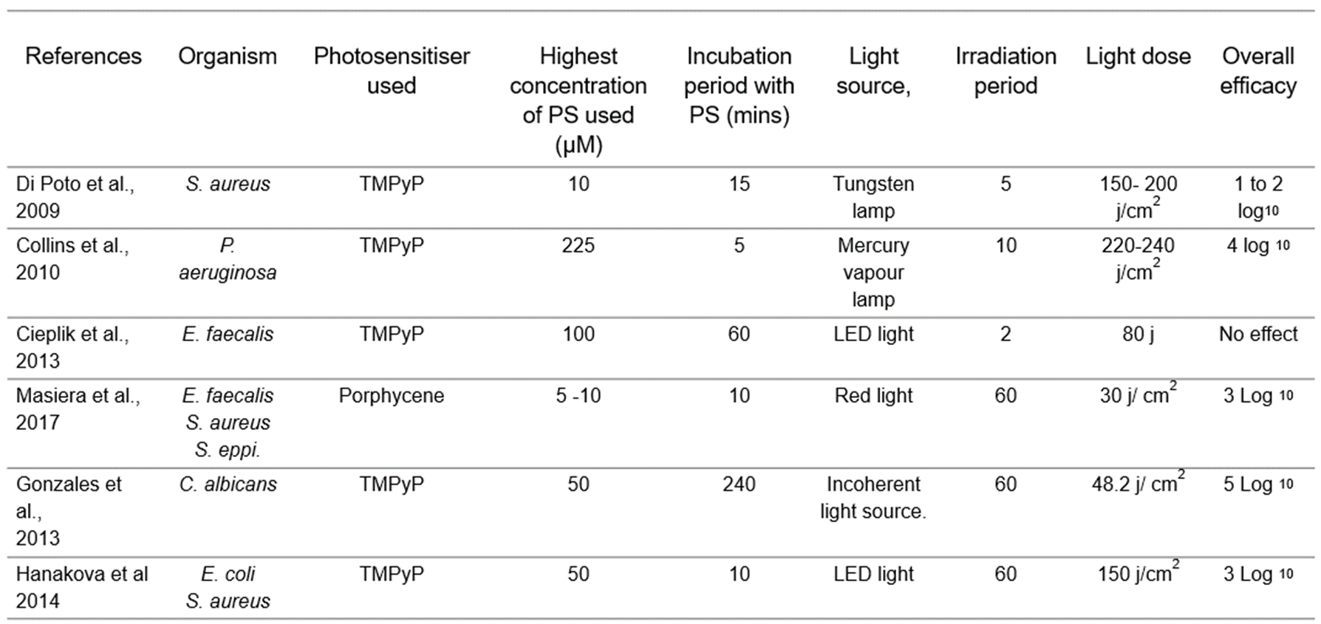

Table 3 . Examples of photosensitisers used in photodynamic therapy , their concentrations, incubation period, light source used to activate the PS and the overall PDT efficacy

## 1.6 Susceptibility test for high-throughput drug development.

Today’s drug development industries are confronted with the unique problem of managing the process of screening an increasingly bunch of molecular target, and novel APIs needed to discover and develop new drugs and treatment approaches. Developing a new drug compound or treatment method requires susceptibility testing system that shows the effect of compound or therapy to target organism.

During the past decade, susceptibility assays have evolved from very slow to high throughput systems (Chai, Goktug and Chen, 2015). For example, 20 years ago it would have been a very difficult task to screen several million compounds during susceptibility testing; an average susceptibility assay would have taken at least 48 hours. Today the same number of compounds using available screening systems would be screened in less than a few hours. This extraordinary progress is now possible through assay miniaturisation and innovations in hardware used for assay technologies. It is now a common practice to confirm the response of mammalian, Fungi, protozoa, and bacteria cells to new therapeutics through enzyme assays optimised to be adaptable to 150 x 384- well microplates in a single day using high-throughput screening. The most available susceptibility testing system use fluorescence, absorbance and bioluminescence detection systems (Tung et al., 2016). These systems provide significant sensitivity and facilitate ultra-high-speed measurements (using luminescence and fluorescence imaging devices).

There is a strong movement within the drug development sector towards an increased emphasis on cell-based assays (Szymański, Markowicz and Mikiciuk-Olasik, 2011). This shows the need for functional screens to uncover what happens within the cell when a molecule interacts with a target. The complexity of the screening process can be compounded when a particular microbial cell exhibits different behaviours in terms of morphological and biochemical presentation.

For these reasons, scientists in the drug development industries are seeking out specific biomarkers that are consistent regardless of variations in the physical and biochemical presentation of a particular cell.

## 1.6.1 Cell viability assay

Part of method development for this project was to develop an assay to measure the cytotoxicity of photodynamic therapy to *Acanthamoeba spp* (all morphological forms). A variety of viability assay can be used for this purpose, but the suitable choice of assay method will depend on a lot of factors most importantly in the case of *Acanthamoeba* is the morphology of the cysts. Different viability assay methods have been developed to show the efficacy of different anti-amoebic agents against *Acanthamoeba spp*. Studies have used microscopy; the manual counting using the haemocytometer (Mafra et al., 2013). There are other methods like flow cytometry analysis using fluorescence dyes (Imayasu, Tchedre and Cavanagh, 2013), MTT assay (Ortega-Rivas et al., 2016), Resazurin assay (McBride et al., 2005), lactate dehydrogenase assay (Sifaoui et al., 2017). These viability assays are dependent on the reaction between intracellular mitochondria enzymes and certain dyes, leading to colour change or increased absorbance, which is proportional to the viability of the cells in a given population.

More recently, the focus has turned to fluorescence and bioluminescent endpoints as they have shown remarkable sensitivity and reproducibility (Balouiri, Sadiki and Ibnsouda, 2016). The commonly used viability assays in drug development and their mode of action are summarised is the sub-headings below.

## 1.6.1.1 MTT (3-(4, 5-dimethyl thiazolyl-2)-2, 5-diphenyltetrazolium bromide) assay.

Different tetrazolium compounds have been used to detect viable cells after exposure to cytotoxic compounds. The MTT (3-(4, 5- dimethylthiazol-2, 5-diphenyltetrazolium bromide) was the first homogeneous cell viability assay developed that was adaptable for 96-well plate and HTS (Mosmann, 1983). The mechanism of this assay is the reduction of MTT salts by mitochondria reductase enzymes in viable cells to a coloured formazan (Jo et al., 2015). The commonly used tetrazolium-based compounds are MTT, MTS, XTT, and WST-1. These compounds can be categorised into two based on charge. The MTT assay salt is positively charged and based on charge difference with eukaryotic cell wall can readily penetrate viable eukaryotic cells (Tachon et al., 2009).

The second group like the MTS, XTT and WST-1 are negatively charged and must be incorporated into an intermediate electron acceptor, which can transfer electrons from the cytoplasm to facilitate the reduction of the tetrazolium to coloured formazan (Berridge, Herst and Tan, 2005). Usually, the MTT substrate is prepared in a physiologically balanced solution, and then added to cells in solution at a final concentration of about 0.2- 0.5 mg/ml and then incubated for about 1 to 4 hours. The amount of reduced formazan present in a population of test cells is often measured at 570 nm using a spectrophotometer. Some limitations to MTT assay is the interference from reducing compounds.

Compounds like ascorbic acids or sulfhydryl-containing compounds, coenzyme A and dithiothreitol can non-enzymatically reduce tetrazolium salts thereby increasing the absorbance (Menyhárt et al., 2016). Furthermore, changes in the pH in culture medium has the potential to accelerate the reduction of tetrazolium salts causing increased background absorbance readings (Śliwka et al., 2016). Several culture conditions can also alter the metabolism of the cell and thus affect the rate of MTT reduction to formazan. For example, when adherent cells go beyond the log phase growth becomes contact inhibited, slowing down metabolism and affecting the overall reducing process (Wright Muelas et al., 2018).

|  |
| --- |
| **MTT**  Mitochondria reductase    **Formazan** |
|  |

Fig 1.15 Reduction of MTT to formazan by mitochondria reductase enzyme.

## 1.6.1.2 Fluorescein Diacetate viability assay

Similar to the MTT assay, the fluorescein diacetate assay (FDA) are mitochondrial permeability dependent assays. Fluorescein diacetate is a no-fluorescent dye but can become fluorescent after hydrolysis by mitochondria reductase enzymes (proteases, lipases and esterase) which converts it to the more fluorescent fluorescein (Armour, Powell and Boyce, 2008). Fluorescein can be virtualised inside the cell by either fluorescent microscopy or fluorescence spectroscopy. The advantages of using the FDA is adaptability. FDA can be optimised to be adaptable for use with different detection methods i.e. fluorescence microscopy or spectroscopy. However, the limitation of the FDA is similar to MTT. It has been reported that common microbial media components like tryptone, peptone and yeast extract all stimulate the hydrolysis of FDA in the absence of viable cells, as do commonly used solvents like phosphate buffers. As a result, most microbial media promote hydrolysis of FDA in the absence of viable cells (Clarke et al., 2001).

|  |
| --- |
| Fluorescein diacetate  Mitochondria enzymes  Fluorescein |
|  |

Fig 1.16 Hydrolysis of fluorescein diacetate to fluorescein by mitochondria enzyme.

## 1.6.1.3 Alamar blue (resazurin) viability assay

Resazurin cell viability assay is relatively simple, sensitive and economical. In resazurin assay, viable cells which are metabolically active are able to hydrolyse (via mitochondria reductase enzyme systems), resazurin which is a non-fluorescent dye to a fluorescent resorufin (Czekanska, 2011). The fluorescence intensity is directly proportional to the number or viability of cells present in a population. Spectrophotometer, spectrofluorometric or spectrophotometric microplate reader can carry out viability detection with Alamar blue. The main advantages of the Alamar blue assay are that it is cost-effective and more sensitive than MTT assay (Aslantürk, 2018). Furthermore, Alamar blue assay can be multiplexed with other assay techniques like caspase assay to get more insight about the mechanism leading to cell death (Ren et al., 2015). Some limitation of Alamar blue assay is that microbial contamination can result in false-positive signals, therefore, Alamar blue assay must be carried out in an aseptic environment (Neufeld et al., 2018). A report has shown that an increased number of cells and prolonged assay times may cause a reduced rate of reduction process (Uzarski et al., 2017). Although the reduction of resazurin to resorufin is an irreversible, an important and often disregarded by-product might be produced from secondary reactions, which depletes resorufin to a non-fluorescent and colourless hydro-resorufin (O'Brien et al., 2000). These factors may cause underestimation of the number of viable cells when using resazurin assay. Spectrophotometric absorbance is taken at 570 and 600 nm. Absorbance values can vary depending on the type of microplate used (flat or round bottom). The fluorescence signal is measured at 530 – 560 while the emission wavelength at 590 nm.

|  |
| --- |
| Resazurin  Mitochondria reductase enzymes    Resorufin |
|  |

Fig 1.17 Hydrolysis of non-fluorescent resazurin by mitochondria reductase enzymes to fluorescent resorufin

## 1.6.1.4 The ATP bioluminescence assay

Adenosine triphosphate (9- β-D- ribofuranosyl adenine-5” –triphosphate or - β-D- ribofuranosyl-6-amino purine- 5”-triphosphate) - a nucleotide, and an adenosine triphosphate ester derived from adenine and ribose – is the main energy molecule in the cells of all living things (Wang et al., 2016). The division of one or two phosphate groups during the hydrolysis of ATP is followed by the release of energy. In living things, ATP transfers energy to other biomolecules after hydrolysis to its low-energy analogues (ADP and AMP), which in turn gain energy by phosphorylation and subsequent re-transformation to ATP (Rajendran et al., 2016). The intracellular content of ATP in cells is the major indicator of cell viability (Bajerski et al., 2018). When cells die, the synthesis of ATP is inhibited. Though its hydrolysis can continue for a while, hence the intracellular content of ATP of a dead cell drops quickly to zero (Verrax et al., 2011). The amount of ATP in the cell of microorganisms is quite high and ranges from 500 to 10,000 µg /g of dry biomass or around 10-19 to 10-15 mole of ATP per cell (Lomakina, Modestova and Ugarova, 2015). This can vary depending on the type of cell, the size and physiological conditions encountered by the cell. Cellular response to chemo-physiological stress ultimately changes the levels of intracellular ATP. The ATP assay is different from the mitochondria reductase-dependent assay because of the high specificity of ATP to its substrate, luciferase enzyme.

|  |
| --- |
| ATP  +  Luciferin      Luciferase + mg++  O2  Adenyl-luciferin  Luminescence  + PPI    + H2O + CO2  Oxyluciferin |

Fig 1.18 Adenosine triphosphate assay reaction. ATP is hydrolysed and light is emitted when firefly luciferase catalyses the oxidation of D-luciferin in a reversible reaction. In the second reaction ATP is the rate-limiting enzyme, the light produced is directly proportional to ATP produced.

## 1.7 Cell lysis

Intracellular ATP is not accessible to the luciferase enzyme because luciferase cannot penetrate microbial cell walls (Kato et al., 2011). Reagents that increase permeability or disrupt the cell wall of these microbes are required. The type of cell analysed and the requirements of a particular analysis primarily determine the choice of lysis approach. There are several methods of extracting intracellular proteins from cells. These methods are grouped into three: physical methods (sonication) chemical methods (detergent and acid lysis) and the enzymatic methods (Brown and Audet, 2008). Some assay methods require controlled lysis, especially if target intracellular protein or enzyme must be extracted intact. In ATP assay, for example, ATP must be released in a controlled manner to preserve its activity. An ideal extractant or lysis reagents used for ATP assay should rapidly extract ATP, be able to inactivate enzymes that participate in the interconversion of adenine nucleotide inside the cell, should maintain the original ATP level upon extraction, during storage and analysis should not exhibit an inhibitory effect on luciferase enzyme during measurement of ATP (Henderson, 2018). Different compounds and methods are used to extract ATP from microbial cells example Chemical lysis: detergents, strong acids (perchloric acid and trichloroacetic acid), organic solvents (butanol, DMSO, chloroform) (Shehadul Islam, Aryasomayajula and Selvaganapathy, 2017). Mechanical lysis using ultrasonic vibrations that burst microbial cell wall (sonication). The choice of these methods will depend on their characteristic as listed above and the strength of the target cell wall but most importantly the reaction of the extractant with luciferase enzyme.

## 1.7.1 Enzymatic lysis; Lysozyme

The use of enzyme systems, which offers biological specificity to the process of cell lysis, has shown remarkable promise as a method of controlled cell lysis and selective product release (Salazar and Asenjo, 2019). Lysozyme is a globular protein with a molecular weight of about 14.4kDa. Lysozyme is a bacteriolytic enzyme because of its ability to lyse certain bacteria cells (Levashov et al., 2019). The bacteriostatic and bacteriolytic characteristics of lysozyme have made it an interesting enzyme in medicine, pharmaceutics and agriculture. Lysozyme finds its key application as an antimicrobial enzyme in cheese, also used as an antibiotic in poultry (Abdel-Latif et al., 2017). It has been reported, the ability of lysozyme to inhibit HIV in-vitro (Lee-Huang et al., 1999). Hen’s egg-white lysozyme (HEWL) is the main commercially manufactured type of lysozyme not particularly because of its abundance in hen’s egg white but because it is easily purified from, hens egg white in a cost-effective way (Dekina, 2015). Lysozyme is stable at optimal physiochemical environments were most proteins and enzymes remain stable (James and McManus, 2012). At a pH range of 5.2 to 7.0 and temperatures not exceeding 50oC most enzymes and proteins are not denatured.

Reports suggest that lysozyme is most stable at 5.2 pH and its activity is significantly affected at lower pH (Venkataramani, Truntzer and Coleman, 2013).

Lysozyme is found in bodily fluid and tissues of humans and animals such as saliva, mucus, human milk, cytoplasmic granules of macrophages and in polymorphonuclear neutrophils (PMNs). Lysozyme is also a major component of the human tear (McDermott, 2013). The mean concentration of lysozyme in the eye is about 0.5 to 1.4 mg/ml.

Though it is a general, believe lysozyme in the human eye protects the eye against microbial infections; its role in eye disease has not been established (Meyer et al 1948). Studies have shown that there is no significant difference in the levels of lysozyme found in the tears of individuals with bacteria, viral or fungi keratitis with normal subjects (Sen and Sarin, 1982).

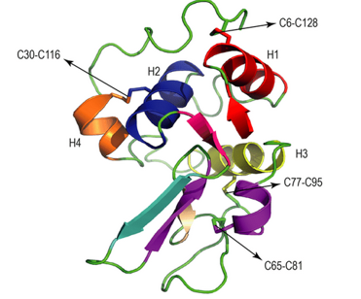

Fig 1.19. The tertiary structure of the human lysozyme.The α – helix structure is represented with the letter H and C6 – C188, C30 – C116, C65 – C81 and C77 – C95 shows the disulphide bonds. Image adapted from (Jafari and Mehrnejad, 2016)

**1.7.2 Lysis of *Acanthamoeba* cysts. Lysozyme?**

The ability of lysosome to lyse *Acanthamoeba* cyst cell wall could be because of its specificity to the cell wall components of the cysts. It is established that the cell wall of *Acanthamoeba* contains polysaccharides like galactose cellulose, chitin and other sugars. (Murti, 1973; Dudley, Alsam and Khan, 2007; Lorenzo-Morales et al., 2008; Anwar, Khan and Siddiqui, 2018; Garajová et al., 2019). Lysozyme is a muramidase and specifically hydrolyse β- 1-4 linkages between *N-acetyl glucosamine* (*NAG*) and *N- acetyl muramic* acid (*NAM*). This β- 1-4 linkages are present in polysaccharide sugars like cellulose chitin, galactose and other sugars and are expected to be the substrate for lysozyme. The structural resemblance of lysozyme to chitinases have been reported and this structural resemblance gives some lysozyme the capacity to hydrolyse chitins. (Wohlkönig et al., 2010). Other reports have suggested the specificity of lysozyme to glucose-glucose linkages (Zehavi et al., 1968; Alcorlo et al., 2017).

Zehavi et al (1968) reported that the active site of lysozyme can accommodate six sugars and that the hydrolysis of the glycose-glucose bond is 50 times slower compared to NAG and NAM. We assume that the reason behind lysozymes ability to hydrolyse *Acanthamoeba* cyst cell wall is its specificity to β- 1-4 linkages which are found in chitin and cellulose the major polysaccharides found in *Acanthamoeba* cysts cell wall. Future scientific work will be needed to verify this hypothesis.

**1.8 Drugs and compound for susceptibility assays.**

The response of *Acanthamoeba* to different compounds has been studied and reported see page 21. Typically, most susceptibility assay reports with *Acanthamoeba* rely on the terminal sub-culturing of cyst cells expose to test compounds to determine its viability, otherwise known as regrowth assay (Baig, Iqbal and Khan, 2013). Though effective, it lacks statistical information regarding the response pattern of an amoeba to these drugs. As explained earlier not all viability assay method can be adaptable for both morphological form and because of this, the response kinetics of potential active therapeutic compounds against *Acanthamoeba* cysts have not been established. To close these gaps, it was important to develop a susceptibility assay method which not only shows, cytotoxicity but also presents its kinetics. Four anti-microbial compounds were used as a test: povidone-iodine, caspofungin, miltefosine and amphotericin B. These compounds were selected considering they all exhibit a different mode of action, hence validates and shows reproducibility of assay during different biochemical reactions.

## 1.8.1 Povidone-iodine

Povidone-iodine is a compound containing an iodine complex and a water-soluble polymer called polyvinylpyrrolidone. It is an ionophore because it is a carrier of iodine. Iodine is an active molecule that causes antimicrobial effects. The povidone-iodine complex is a powerful antimicrobial disinfectant, which has shown strong anti-amoebic properties in *in-vitro* experiments (Padzik et al., 2018). The antimicrobial action of povidone ensues after the dissociation of iodine from the povidone-iodine complex. When in its free form, iodine rapidly penetrates the cell wall of microbes and interacts with the nucleotides, proteins and fatty acids in the cytoplasm. This interaction results in the disruption of the structure and the synthesis of nucleic acid. Thought the exact interaction mechanism is not particularly clear, iodine thought to cause the oxidation of nucleotides fatty acids in the cell membranes of microbe. Additionally, free iodine from the PVP-complex interrupts the functions of the key metabolic enzymes in the respiratory chain, causing them to become denatured and neutralised. The antimicrobial effects of povidone against *Acanthamoeba* have been reported (Gatti et al., 1998; Marcin *et al*., 2018). Marcin et al (2018) exposed Axenically cultivated *Acanthamoeba castellanii*, to different concentrations of povidone-iodine, chlorhexidine digluconate or toyocamycin. The In-vitro population dynamics of the different strains of amoeba were monitored and compared to those of control cultures via microscopy and cell count.

The results showed that the amoebicidal efficacy of povidone on both the cyst and trophozoites was higher when compared to chlorhexidine. Gatti et al (1998), showed that unlike chlorhexidine, there were no strain-dependent variations to response to 250 mg/L povidone-iodine on tested *Acanthamoeba* strains. In another report, and in agreement with previous studies (Carrijo-Carvalho *et al*., 2017) confirm the minimum inhibitory concentration of *Acanthamoeba* cyst to be within the range reported by (Gatti et al., 1998). Though povidone has shown excellent importance as an antimicrobial disinfectant, its use as a drug is curtailed by its toxicology profile (Sato et al., 2013). Sato and co-workers showed that 24hours exposure of HeLa cells as (a model of epithelial cells and rat oral mucosa), caused toxicity at a sub-clinical concentration

|  |
| --- |
|  |
| Povidone-iodine complex |

Fig 1.20 Structure of the povidone-iodine complex. Chemical formulas: 2-pyrrolidinone, 1- ethenyl-, homopolymer, a compound with iodine; 1-vinyl-2-pyrrolidinone polymer, compound with iodine.

## 1.8.2 Caspofungin

Caspofungin (brand name Cancidas worldwide) is among the newest class of antifungal drugs manufactured by Merck & CO., Inc. James Balkovec, Regina Black and Frances A. Bouffard discovered Caspofungin. It is a class of antifungal drug known as the echinocandins (Grover, 2010). Caspofungin inhibits the synthesis of β (1, 3)-d-glucan found in the fungal cell wall, by non-competitive inhibition of (1, 3)-d-glucan synthase (McCormack and Perry, 2005). The (1, 3)-d-glucan in the fungal cell wall forms a solid three-dimensional matrix, which maintains the mechanical straight and shape of the cell wall. Blocking the synthesis of β (1, 3)-d-glucan affects the fungi in two ways. Blockade of the important steps in the synthesis of the cell wall can cause the fungi to stop growing while the fungicidal effects arise as a result of the loss of cellular integrity (Moreno-Velásquez et al., 2017). Loss of cellular integrity reduces the mechanical robustness of the cell, making it difficult for the fungi to repel intracellular osmotic pressure, causing bursting of the fungal cell. This mode of action is different from other anti-fungal, which typically act on the polyenes, azoles or terbinafine or inhibit DNA or protein synthesis (5 – fluorocytosine). Caspofungin effectively inhibited Candida spp., including resistant species (*Candida krusei*) and less susceptible isolates (Candida dubliniensis, Candida glabrata), to azoles and amphotericin B. (Vazquez et al., 1997).

The amoebicidal activity of Caspofungin against the cyst and trophozoites of *Acanthamoeba* as reported by (Bouyer et al., 2006), Trophozoites and cysts of *Acanthamoeba castellanii, Acanthamoeba culbertsoni* and *Acanthamoeba polyphaga* were exposed to caspofungin at concentrations varying from 16 to 500 mg/L. and the viability of the trophozoites and cysts was established at 12, 24- and 48-hours using microscopy and toluidine staining method.

|  |
| --- |
|  |
| Caspofungin |

Results showed that a 100% eradication of Acanthamoeba cysts and trophozoites occurred when incubated with 500mg/L Caspofungin. This agrees to a recent report by (Siddiqui, Aqeel and Khan, 2016) and both are synonymous with results from the present study.

Fig 1.21 Structure of caspofungin. Formerly code-named L-743,872 and MK-0991, caspofungin is a polypeptide antifungal. It is a glucan synthesis inhibitor of the echinocandin structural class

## 1.8.3 Amphotericin B

Amphotericin B is a polyene antifungal antibiotic synthesised from *Streptomyces nodosus* (Torrado et al., 2008).Amphotericin B exhibits broad-spectrum antifungal activity against many fungal species. The mechanism of action of Amphotericin B is by inhibiting the fungal cell wall synthesis, due to its specificity to sterols, especially ergosterol. Binding to ergosterol creates a transmembrane channel, which amplifies permeability of monovalent cations. Binding ergosterol disrupts the fungal cell wall causing the formation of pores that allows leakage of vital nutrients from the fungal cell. Amphotericin B also has oxidant activity, which interrupts cellular metabolism, inhibits proton ATPase pumps, depletes cellular energy reserves, and promotes lipid peroxidation causing severe membrane fragility and ion leakage (Yaffe and Aranda, 2011). The susceptibility of *Acanthamoeba* cysts and trophozoites to Amphotericin B published in an article by (Siddiqui, Aqeel and Khan, 2016). Recent reports showed that ergosterol was one of the key sterols found in *Acanthamoeba* spp. (Thomson et al., 2017). Using GCMS, Thomson et al showed that the sterol biosynthesis pathway was present in *Acanthamoeba*, which explains its susceptibility to amphotericin B. Interestingly; several azole antifungal drugs are known to inhibit the production of sterol by blocking sterol 14-α-demethylase.

While this will have a direct effect on compromising the integrity of the *Acanthamoeba* cell membranes, there are other possible mechanisms of anti-*Acanthamoeba* properties by amphotericin B, which includes a build-up of toxic metabolites of ergosterol. Notably, all azole antifungals that are specific inhibitors of sterol 14-α-demethylase have shown efficacy in the treatment of patients with *Acanthamoeba* infections (Lamb et al., 2015).

|  |
| --- |
|  |
| Amphotericin B |

Fig 1.22 Structure of amphotericin B. The carbon chains of polyenes are synthesised from acetate and propionate units by polyketide synthases (PKSs). The final product is a unique functionalised acyl chain that may cycle and undergo further modification by hydroxylation, methylation and glycosylation.

## 1.8.4 Miltefosine

Miltefosine, a phosphoryl ester of hexadecanol, a membrane acting alkyl phospholipid, an oral agent originally manufactured for the treatment of breast cancer and other solid tumours; however, its use as an antineoplastic agent was hindered due to dose-limiting gastrointestinal toxicity. The precise mode of action of Miltefosine has been a subject of debate. Typically, Miltefosine is an inhibitor of protein kinase B in humans, which is part of the apoptosis signalling pathway (Ruiter et al., 2003). However, these pathways are absent in parasites susceptible to Miltefosine e.g (Leishmania). Other postulations for the mechanism of action of Miltefosine on Leishmania are lipid alteration by intercalation, modulation of macrophage activation factors. However, (Marowa E. Abdulla, 2017) reported that dying parasites exhibit many cytoplasmic, nuclear, and membrane features of apoptotic cells, including DNA fragmentation, cell shrinkage and relocation of phosphatidylserine. Several *in-vitro* and *in-vivo* studies have shown susceptibility to *Acanthamoeba*, to Miltefosine (Schuster, Guglielmo, and Visvesvara, Seifert *et al*., 2001; Walochnik et al., 2002; 2006; Mrva *et al*., 2011; Szentmáry *et al*., 2018; Bagga et al., 2018).

In December 2016 the USA FDA granted Miltefosine (Impavido) Orphan Drug status for the treatment of Acanthamoeba keratitis, and a year after Orphan drug status was also given to miltefosine for the treatment of the rare but fatal granulomatous Amoebic Encephalitis (GAE), both disease caused by *Acanthamoeba spp*. This makes Miltefosine the first drug adopted (repurposed) for the treatment of all infections caused by *Acanthamoeba spp*

|  |
| --- |
|  |
| Miltefosine |

Fig 1.23 Structure of Miltefosine. The chemical name of miltefosine is hexadecyl 2-(trimethyl-azaniumyl) ethyl phosphate, also known as hexadecylphosphocholine. The empirical formula is C21H46NO4P. Miltefosine is an amphiphilic and zwitterionic compound because of the positively charged quaternary amine group (permanently charged) and negatively charged phosphoryl group.

**CHAPTER TWO**  
MATERIALS AND METHOD

**2.1 MATERIALS AND METHODS**

## 2.1.1 Materials

All chemical reagents used for this project unless otherwise state were bought from Sigma laboratories (Poole, Dorset, England). Dr Simon Kilvington at the University of Leicester provided all 5 *Acanthamoeba* isolates used for this study

**2.1.2 Culture of *Acanthamoeba***

*Acanthamoeba* cells were preserved axenically in T-75 culture flasks using peptone-yeast-glucose media as previously reported by (De Moraes and Alfieri, 2008). The contents and quantity used in 1000 ml of PYG media are summarised in table 2.1.

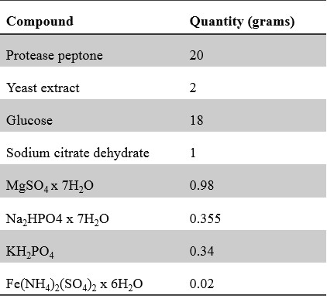

Table (2.1) Media for maintenance of infected *Acanthamoeba* culture

All compounds were solubilised in 1000 ml of distilled water, adjusted to a pH of 6.5 and autoclaved at 110oC for 15 minutes (this temperature was used due the composition of the media – high levels of glucose and amino-acids). Infected *Acanthamoeba* cultures do not need constant transfer to fresh media like the mammalian cell culture as they remain viable for a long period of time. They remain in the same flask for weeks or months depending on usage. Media is exchanged when the culture reaches a high cell density (> 90 % confluence) because nutrients in the media must have been used up by cells. To subculture in fresh media, *Acanthamoeba* cells are detached from culture flask using a cell scraper then centrifuged to remove media. Amoeba is then suspended in fresh media 1:4 dilution.

## 2.1.3 Cell counting

Cells counts were performed manually and with automated cell counters. Manual counts performed with the c-chip disposable haemocytometer (Nano Entek) and verified using the TC10™ Automated Cell Counter. To count the cells, cells are washed by centrifuging at 1500 g x 10 minutes, suspended were fresh media and vortexed for 60 secs. 20 µl of the suspension is injected into the haemocytometer (manual count) and viewed with a magnification of x100 Objectives lens. For the automated cell counts,

The TC20 automated cell counter performs cell counts for both mammalian and microbial cells, in one simple step using its advanced auto-focus technology and cell counting algorithm to deliver in less than 30 seconds accurate and reproducible counts. Upon insertion of a counting slide, the TC20 cell counter quickly generates a total cell count (with or without trypan blue staining). To calculate the cell concentration using manual cell counting technique, the average number of viable cells in the four or five sets of 16 squares is multiply by 104and then dilution factor to convert the count to number of cells per millilitre. By comparison, the manual cell count did show similar cell counts and was often used to validate the automated system

## 2.1.4 Cryogenic preservation of *Acanthamoeba* cells.

Log-phase cultures of axenic *Acanthamoeba* trophozoites were harvested by centrifugation at 1500 g x 10 minutes at room temperature. The cell pellet was re-suspended in fresh media to a concentration of 106/ml. cell suspension (500 µl) was placed in a 1.2 ml screw-capped polypropylene ampoules with an equal volume of glycerol (20 %v/v). The *Acanthamoeba* glycerol mix was put in a cell-freezing box (Igloo) to protect the cells from direct freeze shock during preservation. The igloo was stored at -80 oC for I week before ampoules were transferred into liquid nitrogen.

## 2.1.5 Recovery of *Acanthamoeba* cell from cryopreservation.

*Acanthamoeba* cells were recovered by removing storage ampoules from liquid nitrogen, carefully placing it in an enclosed container at room temperature inside an operating class 2-safety cabinet. Samples were then allowed to thaw in a flow cabinet for 10 minutes and then cultured axenically in PYG media to recover.

## 2.1.6 *Acanthamoeba* growth curve

The aim of generating *Acanthamoeba* growth curve is to understand the growth dynamics of *Acanthamoeba* after 9 days incubation period without sub-culturing. This will help to statistically give details on the appropriate time to harvest a particular morphological form as required during experiments. A cell growth curve was constructed over a 9-day period. 1:5 ration of amoeba suspension in media was cultured in T 75 culture flasks two T75 flasks were used so as to increase reproducibility by using the average of two independent cell counts, with a daily cell count for a period of 9 days. Culture flasks using the cell scrapper were agitated to remove cells adhered to the surface, cells were centrifuged at 1000 g x 10 minutes and re-suspended in 20 ml of fresh PYG media. Automated and manual cell counts were carried out as detailed above (2.1.3). Briefly, 1000 µl of cell suspension was removed from centrifuged cells; this is done in a sterile environment to avoid contamination of the samples, and 20 µl from the 1000 µl suspension was counted using a haemocytometer as detailed in section (2.1.3), then percentage cysts were calculated following this equation

$$Total number of cysts in 5 square$$

$Total number of cells \left( cysts and trophozoites\right) X 100$%

Both the automated and the manual cell counts were averaged and a curve of cell number versus time (days) was plotted.

## 2.2 DNA extraction for polymerase chain reaction (PCR).

The DNA extraction procedure was carried out in a vertical safety laminar flow cabinet in an aseptic room. To distinguish all five *Acanthamoeba* isolates, based on their genotypes, polymerase chain reaction (PCR) was used. An aspect of the PCR which needs optimisation is the DNA extraction technique. Three different commonly used DNA extraction methods; the use of InstaGene matrix, sonication and boiling (Maubon et al., 2012) was compared. This was done to compare the amount and purity of extracted DNA.

## 2.2.1 Use of InstaGene matrix for DNA extraction.

InstaGene matrix is a lysis reagent formulated with 6 % w/v Chelex resin (Niyyati, Lasgerdi and Lorenzo-Morales, 2015). The Chelex matrix binds to contaminants that might otherwise inhibit PCR thereby preventing loss of DNA from irreversible binding. Method of extraction was based on protocol provided by manufacturers. All five *Acanthamoeba* cells were cultured at 30 oC for 48 hrs to get the desired cell density (106 cells/ml). Amoeba cells, 10 mL were recovered by centrifugation at 1000 g for 5 minutes and washed three times in PBS. After washing cells were re-suspended in 500 µl of sterile water. The suspension of cell in sterile water was vortexed for 60 secs and counted using automated cell counter (TC20TM, Catalogue 145-#0101/Bio-Rad/UK). Cell density was optimised for DNA extraction to a total of 1 x 106 cells/ml. 200 µL from the cell suspension was transferred to a sterile centrifuge tube. 20 µL of the InstaGene matrix was added to the cells and incubated at 56oC for about 20 minutes. The tube was then vortexed for 20 seconds and put in a boiling water bath for 8 minutes. The tubes are vortexed once more and the supernatant was recovered after centrifugation at 12,000 g for 3 minutes. Then 50 µl of supernatant containing the extracted DNA put in a sterilised microfuge tube and the DNA concentration and purity was measured at A280 wavelength with Nanodrop Lite Spectrophotometer (Thermo Scientific/UK). Values higher than 1.8 shows that DNA is relatively pure and free of protein fragments. A260/A280 ratio is used to evaluate Protein Contamination, hence determine DNA purity. This procedure was initially described to measure protein purity in the presence of nucleic acids. However, in recent times it is used to monitor protein contamination of DNA. It is vital to state that a260/280 ratio is solely an indication of purity. Pure DNA samples have an A260/A280 ratio greater or equal to 1.8. This is the weighted average of the A260/A280 ratios for each nucleotide when measured independently (Kuhn, Frank-Kamenetskii and Demidov, 2001).

It is often calculated by subtracting the non-nucleic acid absorbance at A320.

DNA Purity (A260/A280) = (A260 reading – A320 reading) ÷ (A280 reading – A320 reading)

4 ng/ µl concentration of the DNA sample was used as a template for PCR analysis.

## 2.2.2 DNA extraction by sonication.

The cells were prepared as described earlier (2.4). A cell concentration of 106 cell/ml was sonicated for 10 minutes (amplitude of 22 nm, sonication interval of 15secs). The cells were vortexed and centrifuged 20,000 g for 3 minutes. DNA purity was determined as explained in (2.4.1) Concentration was adjusted to 4 ng/µL and used for PCR analysis.

## 2.2.3 DNA extraction by boiling

Cell pre-treatment was as described in (2.2.1 and 2.2.2). Pre-treated cell solution (1000 µL) was put in centrifuge tubes and heated at 100oC for 15 minutes, while vortexing the suspension every 30 secs. 50 µl was transferred to a new centrifuge tube and the purity and concentration of the extracted DNA were measured. 2 µl (4 ng/µl ) of the suspension was used for PCR analysis.

## 2.2.4 Polymerase chain reaction.

The PCR reaction was optimised from a protocol by Schroeder et al. (2001). The primers used specifically amplify a 423-551 bp amplicon of the 18S rDNA of the *Acanthamoeba* genotypes. The DNA sequences of the oligonucleotides used as primers were: forward primer JDPI (5′-GGCCCAGATCGTTTACCGTGAA-3′) and reverse primer JDP2 (5′-TCTCACAAGCTAGGGGAGTCA -3”) (Schroeder et al. 2001)

The DNA primers were manufactured by IDT (Integrated DNA technologies/UK). They were resuspended in sterile water for PCR. The analysis was carried out following protocols provided. Each 50 µl PCR tube contained: 2 µL of DNA template (as prepared above), 1 µl (3.2 pmol / µL) forward primer, 1 µL (3.2 pmol/µL) reverse primer, 25 µl of Master mix reagent containing (DNA polymerase, dNTPs, MgCl2 and reaction buffers) and the reaction volume was increased by adding 21 µl of PCR grade deionised water so as to keep the reaction volumes constant. The control contained all of the above minus DNA templates and the final volume was also made up to 50 µl. The program for the PCR was as follows; Template denaturation temperature 95o C for 3 minutes, 40 cycles of amplification at 95o C (30 secs) 62o C (30 secs) for primer annealing and 72o C (30 secs) for DNA synthesis. Gel electrophoresis was performed by loading 10 µl of PCR products to each well which was separated on a 1.85% agarose gel infused with gel red for 1 hour at 100 V.

## 2.2.5 Purification of extracted *Acanthamoeba* DNA

After PCR cycling, the gel was visualised under a UV light (NGFG05- Fast Gene Blue LED Gel Illuminator/UK). Purification of the DNA fragments was carried out using the Monarch DNA Extraction kit from BioLabs. The DNA fragment was cut from the gel and transferred to a 1.5 ml microfuge tube. The excess gel was removed from the DNA fragment while minimising UV light exposure. The cut gel slice was weighed so as to know the amount of dissolving buffer to be added. 4 volumes of the gel dissolving buffer were added to the cut gel and incubated for 10 minutes at 55oC, while vortexing at intervals until the gel is dissolved. The resulting sample was loaded onto a column; and spun for 1 minute at 16, 000 g. The flow-through was thrown away, and the column re-inserted into a second new collection tube. 200 µl of the DNA wash buffer was added to the column and centrifuged for 1 minute at 16, 000 g. Once more the flow-through was discarded, and the column reinserted to a new collection tube. 200 µl of the DNA wash buffer was added again and centrifuged for 1 minute at 16, 000g. Flow-through was discarded carefully avoiding contact with the tip of the column.

The column was then transferred into a clean 1.5 ml microfuge tube and 20 µl of DNA elution buffer was added to the centre of the matrix and left for 60 secs before centrifuging at 16, 000g for 1 minute to elute the DNA

## 2.2.6 Sequencing of purified *Acanthamoeba* DNA

The eluted DNA was sent for sequencing at DBS Genomics (University of Durham). The acquired sequence was then subjected to BLAST (Basic Local Alignment Search Tool). The sequence was also aligned using Clustal Omega (European Bioinformatics, Cambridge/ UK), and was phylogenetically analysed using Mega 6 software (Molecular Evolutionary Genetics Version 6.0).

## 2.3 Viability assays.

Methods optimisation during this study involved a comparison of different viability assays for *Acanthamoeba* susceptibility testing so as to ensure optimum cell performance and rational analysis of data. Viability assays carried out are summarised below.

## 2.3.1 Fluorescein diacetate (FDA) viability assay

Fluorescein diacetate is a metabolic activity-dependent viability assay and has been used for *Acanthamoeba* trophozoites viability assay (Khunkitti, 1997). Khunkitti (1997) also reported that the FDA was not applicable for cysts viability. FDA is an esterase substrate that hydrolyses none fluorescent FDA to highly fluorescent fluorescein. The fluorescence intensity is proportional to the number of viable cells in a cell population hence is used as a viability probe.

FDA stock solution was prepared 0.5% in phosphate-buffered saline. The solution was protected from direct light by covering with an aluminium foil and stored at -20o C. Hydrogen peroxide was serial-diluted to get concentrations ranging from (100 mM – 0.1 mM). A total of 106 cells/ml was used for the assay. A volume of 150 µl of *Acanthamoeba* trophozoites was incubated with 50 µl different concentrations of hydrogen peroxide and stored at 30oC for 20 minutes in the dark. The treated sample was subsequently washed in PDS to remove the excess drug. Then 100 µl of 0.5 % FDA was added to 100 µL of cells, incubated for 24 hours. Fluorescence was measured at 495 nm excitation and 520 nm emission using the spectrophotometer from Berthold technologies.

## 2.3.2 Resazurin cell concentration curve.

Resazurin dye has been broadly used as a viability indicator for both mammalian and bacterial cells (Heredero-Bermejo et al., 2013). Mitochondrial enzymes facilitate diaphorase activities, these enzymes catalyse the transfer of electrons from NADPH + H+ to purple Resazurin thereby reducing it to pink resorufin. The level of reduction can be evaluated since the absorption peak of resazurin and resorufin are different (600 nm and 570 nm respectively).

First, a cell growth curve was generated using *Acanthamoeba* trophozoites. To generate a cell response curve using resazurin, 106 cells/mL was required. High purity Resazurin was dissolved in PBS 0.15 mg/ml and filter sterilised through a 0.2 μm filter then stored at 4°C in an opaque container. *Acanthamoeba* cells (106/ml) was diluted (serial dilution) to a minimum of 102 cells/ml. 20 µl of Resazurin was added to each concentration which was in four replicates. A control well was prepared with media only for background subtraction and adjustment. The plates were then incubated at 30° C for 96 hrs. Fluorescence reading was taken using 560 nm excitation and 590 nm emission filters.

## 2.3.4 Adenosine triphosphate viability assay (ATP)

Adenosine triphosphate is a molecule that is present in all living thing. It is produced or used in serval metabolic cycle like the Krebs cycle, oxidative phosphorylation and glycolysis. In these metabolic process, the levels of ATP are tightly controlled. Because the level of ATP is tightly controlled, it can be used as an indicator of cell viability. ATP is involved in a reaction with D –luciferin and luciferase enzyme from [*Photinus pyraliss*](https://en.wikipedia.org/w/index.php?title=Photuris_lucicrescens&action=edit&redlink=1) to generate bioluminescence which can be detected by a luminometer at a specific wavelength. In this reaction, the amount of light produced is proportional to the number of viable cells in a population. However, because ATP is an intracellular molecule, cells must be lysed to release ATP before this reaction can be carried out. ATP is a very unstable molecule, it is rapidly hydrolysed at room temperature and slowly hydrolysed at 4oC (Wanders, van den Berg and Tager, 1984). The stability of ATP means that a controlled lysis method is required to lyse *Acanthamoeba* cells and release ATP intact. With this in mind, the ability of different lysis methods was evaluated for optimal release of ATP in *Acanthamoeba* cysts as they are more resistant to lysis using conventional lysis buffers.

## 2.3.5 Lysis of *Acanthamoeba* cyst

## 2.3.5.1 Sonication of *Acanthamoeba* cysts

*Acanthamoeba* cysts were mechanically lysed using Sonoprep150 sonicator (Tip diameter 9.5 mm). Cells were centrifuged (1000 g x 10 minutes) and re-suspended in fresh media. Microfuge tubes submerged in an ice bucket was used during sonication. 500 µl of amoeba growth media containing 106 more than 95% cysts cells were put in microfuge tubes and sonicated at an (amplitude of 22 mm, sonication interval of 15 secs for a duration of 2 minutes). To measure the amount of ATP released, 50 µl sonicated *Acanthamoeba* cyst cell was incubated with 50 µl of firefly luciferase enzyme in an opaque 96 well plate and the bioluminescence was measured at 600 nm wavelength using Spectrophotometer Tristar LB941 Berthold

**2.3.5.2 Detergent lysis of *Acanthamoeba* cysts.**

Detergent lysis of *Acanthamoeba* cyst cells was performed using an already made detergent lysis buffer purchased from Roche Pharmaceuticals. Detergent monomers solubilize membrane proteins by partitioning into the membrane bilayer

To lyse the cyst cells, 500 µl of 106/ mL *Acanthamoeba* cells were incubated with 500 µl of lysis buffer for 30 minutes at 30oC. After incubation 50 µl of the cells was then reacted with 50 µl of firefly enzyme luciferase in an opaque 96 well plate and the bioluminescence was measured @ 600 nm wavelength using Mithras Multimode Microplate Reader LB 940 from BERTHOLD TECHNOLOGIES

**2.4.4 Enzymatic lysis of *Acanthamoeba* cyst**

The lysis of *Acanthamoeba* cysts enzymatically has not been reported. Selection of lysozyme was based on availability. 10 mM of hen’s egg white lysozyme was dissolved in distilled water and filter sterilised with 0.2 µm filter. Dissolved lysozyme 500 µl was added to 500 µl of 106 cells/ ml of amoeba cysts, incubated at 4**°C** for 30 minutes. After incubation 50 µl of lysed amoeba cells was then left to react with 50 µl of 1 µM luciferase enzyme at room temperature and bioluminescence was measured at 600 nm.

**Lysis of *Acanthamoeba* cysts with lysozyme.**

A further experiment was carried out to evaluate the time range for complete lysis of a population of the cyst with lysozyme. A total of 106 cells/ml amoeba cysts were incubated with 10 mM hen’s egg white lysozyme and percentage lysis was calculated over at 5 – 40 mins interval. Percentage lysis was determined by dye exclusion using trypan blue. The percentage lysis was determined by adding equal parts of 0.4% trypan blue dye to the cell suspension (50 µl trypan blue + 50 µl cell suspension) and mixed by pipetting up and down. The mixture was incubated at room temperature for 3 minutes. Add 20 µl of the mixture of trypan blue and cell suspension to the haemocytometer

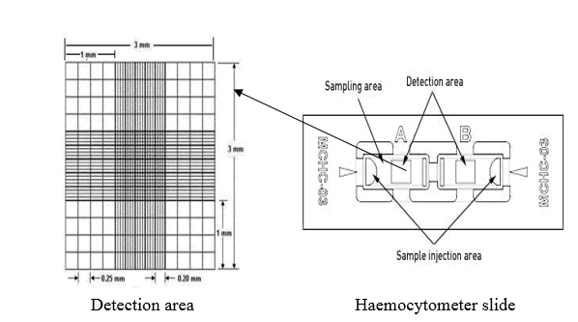

Fig 2.1 Haemocytometer showing detection area and sample injection area. The sampling area takes no more than 20 µl of the sample. Counts are typically done in duplicates and averaged.

Lysed cells will take up the dye while intact cells will remain clear. As seen above, in the detection area each side of the haemocytometer contains multiple squares total cells were counted (clear and blue) in the large square. Percentage lysis was calculated by dividing the number of blue cells (lysed cells) by the total number of cells then multiplying by 100.

**2.5 Ability of Hens egg white lysozyme to degrade *Acanthamoeba* cysts cell wall determined by transmission electron microscopy**

**Materials**

Standard fixative – 2.55 Glutaraldehyde 1% buffered osmium tetroxide, phosphate buffer (pH 7.2), Deionised water, alcohol dehydration series, low viscosity resin, microfuge tubes, beam capsule, number label and sample notebook

## 2.5.1 Fixation procedure

For TEM, 95% cyst cell sample was used. The cyst cells were washed by centrifugation at 1000g x 5 minutes and placed in microfuge tubes. The setup for the tubes was a control tube (C1) containing *Acanthamoeba* cyst cells in PBS and 4 other samples (labelled A-D) containing *Acanthamoeba* cysts incubated with 10 mM hen’s egg-white lysozyme. 25% glutaraldehyde was added to the tubes and allowed at room temperature for 60 minutes. After incubation, cells were washed with PBS by centrifuging at 500 g x 5 minutes incubated for 10 minutes. Second centrifugation was done with similar parameters, then washed with PBS and stored at 4oC for 12 hours. After that 1% osmium tetroxide was added an incubated for 60 minutes and washed with distilled water twice at 5 minutes’ interval.

## 2.5.2 Dehydration

*Acanthamoeba* cysts were dehydrated on a rotor at room temperature by washing with 0.5 ml of 50%, 70% 90% and 100% ethanol allowing 15 minutes interval between each wash.

2.5.3 Resin Embedding

First, 1ml 1:1 ratio of low viscosity resin with absolute alcohol mix was added to the sample and incubated at room temperature for 30mins. Then 1 ml 75:25 low viscosity resin: absolute ethanol mix was added stored at room temperature for 30 minutes. Then 1 ml 100% low viscosity resin: absolute alcohol mix was added and stored at 4oC for 24 hours. After 24 hours, the sample was transferred into a silicon mould with a tiny paper label inserted to identify the sample. Sample mix mould was polymerised at 60oC in a dry oven in a fume hood for 24 hr. For TEM examination, thin sections (70- 80 nm) were cut using glass knives. Glass knives are sharp-edged glass prisms manufactured from special glass strips free of reams and mounted onto 300 mesh copper grids. The section was stained using alcoholic uranyl acetate and alkaline lead citrate before a gentle wash. The sample was then observed using a Morgagni 268D transmission electron microscope at an operating voltage of 80kV. Images were retrieved with a CCD camera connected to the microscope.

## 2.6 Optimisation of ATP assay

Further experiments were carried out to further optimise the ATP assay. There were several method development assays that must be evaluated before ATP assay can be validated for use in this research. Such consideration was

* Stability; the overall stability of ATP in solution needed to be analysed should there be a need to store and reuse a previously made sample.
* Sensitivity / dynamic rage: What levels of ATP are in *Acanthamoeba* cells? Are the levels same for cysts and trophozoites? Are the levels within the dynamic range; The dynamic range is a ratio between the largest and smallest values that a certain quantity can take. It is usually used in perspectives like light and sound signals
* Interference: What are the solvents that can possibly inhibit the ATP assay process?
* Does the experiment display variabilities: reproducibility?

## 2.6.1 Stability of ATP after storage.

Usually, solubilised ATP and luciferase enzyme are stored at -20oC and can be reused after 24 hours of storage (Riss et al., 2013). As stated early ATP and luciferase enzyme in solution, is hydrolysed even at this temperature and hence their activity is reduced. An experiment designed to evaluated hydrolysis of ATP and loss of activity of luciferase enzyme was carried out. Different ATP dilutions were obtained from an ATP standard (1.65 µM - 0.0000165 µM)

A calibration curve was generated by reading the bioluminescence signal generated by reacting an equal volume of 1 µM luciferase enzyme with an ATP standard. (50 µl of ATP standard + 50 µl of luciferase enzyme). The reaction mix was pipetted into an opaque 96-well plate and the bioluminescence signal evaluated within 30 seconds of reaction. The leftover mix was stored at -20oC and this procedure were repeated after 24-hour storage. Both curves generated was then interpolated and analysed by plotting a graph of concentration against bioluminescence signals.

## 2.6.2 Effects of solvents on ATP and luciferase enzyme reaction.

The effects of phosphate-buffered saline, which was our solvent of choice were analysed. 1 X mix PBS 0.5 X mix PBS and a control dilution buffer containing distilled water were used to solubilise ATP, and concentration curve was generated as explained in 2.6.1

## 2.6.3 ATP calibrations curves

The importance of the calibration curves for ATP standard and the cell concentration calibration curves was to understand the dynamic range and also quantify what levels of ATP are seen in both morphological forms of *Acanthamoeba.* An ATP standard curve was generated as explained on page 99. Also, *Acanthamoeba* cysts and trophozoites concentration curves were performed with a serial dilution of know cell number ranging (106 to 103 cell /ml). To evaluate the amount of ATP contained in a single amoeba cell the calibration curve was interpolated with the concentration curve to determine this. For the bioluminescence of cell concentration curve, 50 µl of each cell concentration was mixed with 50 µl of 1 µM luciferase enzyme and bioluminescence signal read at 600 nm

## 2.7 Methods Validation (Drug assays)

To validate the optimised methods, the susceptibility of *Acanthamoeba* to four anti-microbial compounds was tested using the ATP bioluminescence assay.

## 2.7.1 Povidone-iodine drug assay

## The povidone-iodine complex is a DNA intercalator. Povidone permeates microbial cell releasing the iodine complex, which permeates the cell wall, disrupting its function and causing non-selective permeability of material through the cell (Sriwilaijaroen et al., 2009). A stock solution of 1000 mg/l of Polyvinyl (pyrrolidone) iodine complex was made from 100 g powder, in distilled water and filter sterilised using a 0.2 um filter. From the stock, a serial 1-fold dilution was made to get seven different concentrations of povidone. Each test well contains 4 replicates of 150 μl of cells in media and 50 μL of povidone (total of 200 μl of cell and drug). The plates were incubated for 24 hours at 30oC prior to ATP assay. After incubation, *Acanthamoeba* trophozoites were lysed by incubating 50 μl of cells (in growth media) with 50 µl of detergent lysis buffer for 30 minutes at 30oC. Cysts were lysed by incubating 50 μl cyst cell (in growth media) with 50 µl of 10 mM HEWL for 35 minutes at 30oC in a shaker thermostat incubator set to stir plates at 400 rpm. After lysis, 50 μl of firefly luciferase enzyme was added to 50 μl of lysed cells in an opaque 96 well plate and bioluminescence read at 600 nm using Berthold Tristar LB941 spectrophotometer.

## 2.7.2 Caspofungin drug assay

Further validation was carried out using caspofungin an anti-fungal drug.Caspofungin inhibits the synthesis of β (1, 3)-d-glucan of the fungal cell wall, by non-competitive inhibition of the enzyme β (1, 3)-d-glucan synthase. Linkage of β (1, 3)-d-glucan forms a solid three-dimensional matrix, which gives the cell wall robustness and shape.

Caspofungin diacetate ≥ 97% (HPLC). 500 mg/l working concentration was made in distilled water and filter sterilised using a 0.2 µM pore size filter. Working concentration was diluted to give (500, 250, 125, 62.5, 30, 15, 7.5 3.125 mg/l). Each test well contains 4 replicates of 150 µl of cells in media and 50 μl of caspofungin. The plates were incubated at 30oC for 24 hours and ATP assay is carried out as outlined in povidone drug assay.

**2.7.3 Amphotericin B**

Further validation of ATP viability assay was carried out with amphotericin B. Amphotericin B is the most common *polyene* antifungals. Its mechanism of action is by disruption of the fungi cell membrane stimulated by the agent binding to a sterol moiety, primarily ergosterol, in the cell membrane of the fungi. Amphotericin B has demonstrated very high activity against most fungal species. A stock solution of amphotericin B 1000 mg/ml made in distilled water was double diluted to get 8 concentrations. For the viability test, 50 μl of each drug concentration (x4) replicates was added to 150 μl of amoeba growth media containing 106 cells/ml. The drug + cell mix is incubated at 30oC for 24 hours. Cell viability is evaluated using an ATP assay (see ATP assay general protocol).

## 2.7.4 Miltefosine

Miltefosine is a broad-spectrum antimicrobial, anti-leishmanial and phospholipid drug that was initially manufactured in the 1980s as an anti-cancer compound. It is currently the only recognized oral agent used to treat visceral, cutaneous, and mucosal forms of leishmaniasis, a neglected tropical disease. Miltefosine was given orphan drug status for the treatment of *Acanthamoeba* keratitis by the US FDA in 2017. Miltefosine hydrate ≥ 50 mg/ml was prepared in sterile water and then diluted to get 8 test concentrations. The test concentrations were inoculated in already prepared *Acanthamoeba* cells (50 μl of each concentration X 150 μl of cell in media) and incubated at 30oC for 24 hours in a plate shaker incubator. Cell viability is evaluated using the ATP assay. (See protocol above).

**2.8 Photodynamic therapy assays.**

In order to carry out a detailed investigation of the efficacy of photodynamic therapy on the cyst and trophozoites of *Acanthamoeba*, we selected four porphyrins. These porphyrins have been synthesised to have other compounds as conjugate hence their chemical behaviours are expected to vary. Firstly, we evaluated the use of toluidine blue to inactivate *Acanthamoeba* trophozoites as a preliminary test. This was carried out to optimise our light system and establish parameters regarding dosing, quantification of light energy applied and exposure time. The general PDT process is illustrated below fig 2.2

Fig 2.2 The general process for *Acanthamoeba* Photodynamic therapy. Step (1) inoculation of cells with the photosensitiser. Step (2) irradiation (3) incubation, (4) lysis (5) ATP assay and finally spectrophotometric analysis.

## 2.8.1 Toluidine blue assay

A stock solution of 1 mM toluidine blue (TB) was prepared in distilled water, filter sterilised and stored in the dark at 4oC. Prior to use, the stock was diluted in PBS to get the required concentration. *Acanthamoeba* trophozoites were prepared by centrifugation (1500g x 5 minutes), and then re-suspended in fresh PYG media. The cell was counted and a total of 106 cells/ mL is required for the assay. For photodynamic inactivation studies, 10 µM 5 µM 2.5 µM 1.25 µM 0.625 µM of toluidine blue were diluted in PBS from stock. The 100-µl amoeba cell suspension was inoculated with 50 µl of diluted TB x 4 replicates and incubated in the dark for 30 minutes at room temperature. TB treated cells were irradiated with a 590 nm wavelength of light using an improvised lightbox. The light intensity of the delivered light was measured using a Digital Light Lux Meter. Model number LUX29TK. Total energy delivered was calculated to be 42 j / cm2. A control plate containing the same amount of *Acanthamoeba* cells and toluidine blue was protected from light by covering the plate in an aluminium foil. Plates were further incubated for 24 hours before viability was evaluated microscopically using trypan blue dye exclusion method. To determine the number of viable cells 50 µl of incubated cell suspension and 50 µl of 0.4% trypan blue dye were put in a microfuge tube and mixed properly by pipetting up and down.

The mixture was left for 3 minutes at room temperature. The total content of the tube was then pipetted into a clear bottom micro-plate and counted. Cells were counted in three (3) objective views as seen below fig 2.3. An average cell count is taken. This was done for all concentrations of toluidine blue.

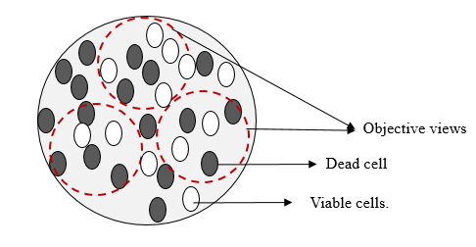

Fig 2.3 Clear flat-bottom 96-well plate used for microscopy. Each concentration is counted three times by moving the plate around to focus on an area that has not been counted a total of three views (X3 objective) was counted for each concentration of toluidine blue.

## 2.8.2 The kinetics of porphyrin accumulation in *Acanthamoeba* cells

The incubation time prior to photodynamic treatment for bacteria fungi and other microorganism vary across reports (Bliss et al., 2004; Quiroga, Alvarez and Durantini, 2010). The reason for this can be likened to the different morphology of their cell wall. It could also have something to do with the charge of the photosensitiser. The capacity of porphyrins to bind to the cell wall of *Acanthamoeba* cysts and trophozoites was evaluated in cell suspension of 106 cells/ ml in PYG media Thus, *Acanthamoeba* cells 106 cells /ml were incubated with 50 μM of all four porphyrin conjugates, and the amount of porphyrin accumulated in the cells was evaluated after lysis and fluorescence measurement at 350 nm excitation and 800 nm emission filters using a spectrophotometer.

## 2.8.3 Uptake of porphyrins by *Acanthamoeba* cells.

This experiment was designed to determine and compare the uptake of the four porphyrins used in the present study. The four porphyrin derivatives used in the present study are either anionic (4,4′,4′′,4′′′-(porphine-5,10,15,20-tetryl) tetrakis (benzene sulfonic acid) tetrasodium salt hydrate,) catatonic (5, 10, 15, 20- tetrakis (1-methyl-4-pyridinio) porphyrin tetra (p- toluene sulfonate) or neutral (5, 10, 15, 20-Tetraphenyl-21H, 23H- porphine).

To evaluate the uptake of all four porphyrins by *Acanthamoeba* cells, 100 µl of 50 µm concentration of each porphyrin was incubated with 900 µl of *Acanthamoeba* cells (cysts and trophozoites) at room temperature for 10 minutes. The incubated cells were washed in PBS by centrifugation with a microfuge centrifuge (5000 g x 5 minutes). Each porphyrin sample is washed 5 times and 100 µl was taken from microfuge tube into a 96 well plate after each wash as shown in figure 2.4. This process was carried out on both the cyst and the trophozoites. To determine the amount of porphine in the samples, the cells are lysed. Trophozoites were lysed by adding 100 µl of lysis buffer (25 mM Tris-phosphate (pH 7.8), 2 mM DTT, 2 mM 1,2-diaminocyclohexane-N, N, N´, N´-tetraacetic acid, 10% glycerol, 1% Triton® X-100), while the cysts were lysed with 100 µl 10 mM lysozyme from hens egg white both incubated at 30oC for 35- 40 minutes. The fluorescence from the lysed cells was then analysed spectrophotometrically using specific filters: 350 nm bandwidths excitation filter and 800 nm bandwidths emission filter.

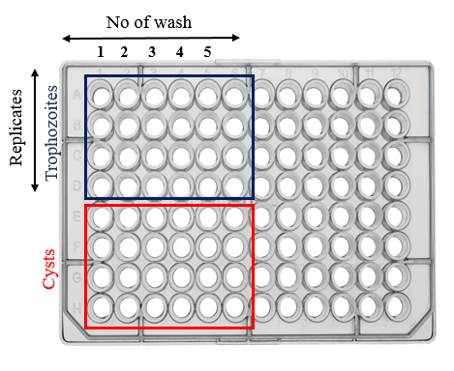

Fig 2.4 Microplate layout for porphyrin uptake assay. The red layout shows the number of wash and replicates for the cysts while the dark blue layout shows a number of wash and replicates for trophozoites. Control wells are set up for 100% uptake.

## 2.8.4 Excitation and emission spectrum of porphyrins.

Fluorescence Spectrophotometer PERKIN Elmer LS 55 was used to measure the excitation and emission wavelength of porphyrins. All porphyrins were diluted to a concentration of 1 ppm (first with DMSO and made up with water). Water was used as the solvent blank. Before reading was taken the blank was measured and the instrument was set to subtract the blank from the sample measurement. Each sample was then measured at their approximate excitation and emission range.

## 2.8.3 Porphyrin concentration curve.

To determine the limit of detection, and show linearity of concentration versus fluorescence, a concentration curve of porphyrin was generated with a stock solution of 5 μM 4,4′,4′′,4′′′-(porphine-5,10,15,20-tetryl) tetrakis (benzenesulfonic acid) tetrasodium salt hydrate was made in distilled water. From the stock, several dilutions from 1000 pmol – 10 pmol was made. In an opaque 96-well plate, 200 μL of each concentration was put in 4 replicates for each concentration and the fluorescence was measured at 400 ex and 750 em wavelengths.

## 2.8.4 Photosensitizer preparation

Solvents used in this study for porphyrins were either 0.2% DMSO or water. If the porphyrin was soluble in both then water is used. Preparation of porphyrin stock solution in done in a dark room (partial light). From a stock solution of 100 µM, different half dilutions of porphyrins are set up as shown below. For porphyrins solubilised in 0.2 % DMSO, control of cell + DMSO is set up to monitor the effects of DMSO.

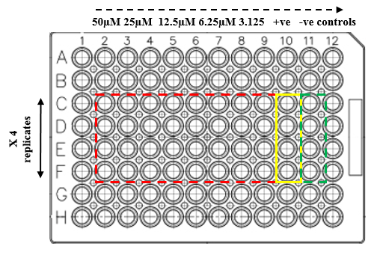

Fig 2.5 Microplate set up for all PDT assay. Usually, X8 (shown in red) concentrations (half dilutions) are used. Two control well, a positive and negative control. The positive control contains cells only (yellow) while negative control contains cell annihilated by heating at 100oC (green). Percentage viability is extrapolated from the difference between the two controls. A control plate with cells+ drug covered with aluminium foil was also set up.

## 2.8.5 Porphyrin PDT; Irradiation procedure

Not less than 106 cell/ml of cysts and trophozoites are required for the assay. Cells were centrifuged at 1500 g x 10 minutes and suspended in fresh media. Each well will contain 100 µl of cells in media x 4 replicates. 100 µl of dissolved porphyrin is added to each well containing cells, incubated at room temperature for 10 minutes. After incubation, excess drug was washed off by centrifuging at 2500 g x 5 minutes. Cells were then suspended in fresh media and irradiated for 1 hour using a red LED light.

**2.8.6 Reconstitution of ATP standard and Luciferase Enzyme**

The whole content of one bottle of the luciferase enzyme1µM is dissolved in double distilled water as directed by manufacturers. The solution was incubated for 5 minutes without stirring or shaking. The solution was homogenised by carefully rotating the bottle. The unused reagent was stable for one day at 15 to 25oC and for one week when stored at 0 to 4oC. A standard curve was set up prior to each experiment to ensure there was no loss of activity due to storage. Reconstitution of ATP standard

Each bottle of ATP contains approximately 10 mg of ATP. A stock solution of 10 mg/ml or 16.5 mM ATP was made (960 µL of distilled water to 9.60 mg ATP

Photodynamic treatment

Cells were exposed (for 60mins) at room temperature to a red LED light (Omega, Aqua light LED light therapy), delivering total energy of 85 j/cm2 energy. Before exposure, the control sample was protected from the LED light by covering it in an aluminium foil. After 60mins exposure, cells were incubated at 30oC for in a plate shaker incubator (400 g rotor speed) for 24 hours before viability assay.

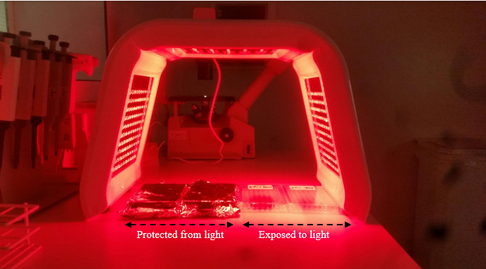

Fig 2.6 Irradiation of cells with red LED lamps. For each experiment x 4, clear bottom transparent 96-well plates are used. The trophozoites and cysts will have two plates set up one protected from light and the other exposed to light. A thermometer is set up to make sure localised heat does not exceed 30oC.

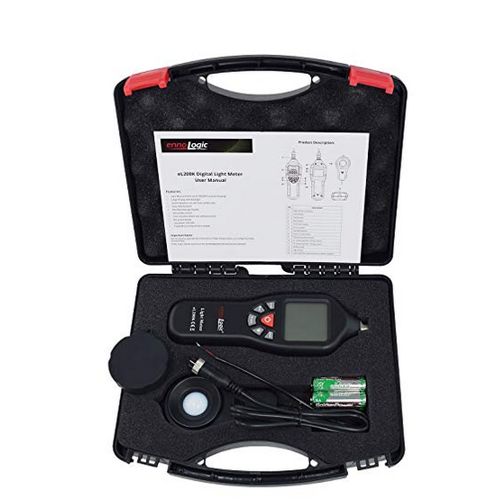

Fig 2.7 Digital Light Lux Meter. Model number LUX29TK, with Data Logging Function Measurement. Range 0 to 200,000 Lux Auto-Ranging Instrument Detachable sensors.

**CHAPTER THREE**

GENERAL RESULTS

# Chapter 3

# 3.0 Overview of the chapter.

This chapter, reports all relevant data obtained from all laboratory work. It is divided into three sections.

**Characterisation of *Acanthamoeba***

Section 3.1 presents results generated while characterising *Acanthamoeba.* These results involve growth kinetic studies fig (3.1), identification and characterisation of isolates sections 3.12 – 3.14.

**Viability assays**

Viability assays were performed to evaluate their potential use for *Acanthamoeba* susceptibility testing. Results from these assays are presented in section 3.2.

**Optimisation of ATP based assays**

Optimisation of ATP based assay involved several experiments ranging from calibration curves, lysis assays, and transmission electron microscopy, are presented in section 3.3.

**Validation of ATP based assay.**

To validate the adaptability of the ATP assay, known anti-parasitic and anti- fungi compounds were tested against *Acanthamoeba* cysts and trophozoites. Susceptibility of *Acanthamoeba* to these compounds was evaluated with ATP assay. Results from this experiment are presented in section 3.4

**Photodynamic therapy**

The result section presents photodynamic of *Acanthamoeba* cysts and trophozoites with selected cationic and anionic meso-substituted porphyrins.

## 3.1 Characterisation of *Acanthamoeba*

## 3.1.1 *Acanthamoeba* growth curve

*The Acanthamoeba* growth curve was generated to monitor the growth kinetic of *Acanthamoeba* in axenic culture. To generate a growth curve, 105 cell /ml of two *Acanthamoeba* isolates (trophozoites) were cultured in a T 75 culture flask and cell counts were carried out using both automated and manual cell count methods, percentage cyst and trophozoites were calculated. Cell number was recorded over a 9-day period and a graph of cell number versus time (days) was plotted to generate a growth curve (Fig 3.1). Also, The percentage of cysts and trophozoites was calculated every 24 hours (3.2). The percentage cysts are calculated by dividing the total number of cells (cysts and trophozoites), then divided by the total number of the cyst and multiplied by 100, the same applies to the percentage trophozoite. The results show a cell doubling time of about 24 hours, with 94% of cells being trophozoites during the exponential phase. The stationary phase starts 5 days after cultivation and more than 90% of cells appeared as cysts at this growth phase. This data is in agreement with the amoeba growth curve generated by (Berk and Garduño, 2012). This information’s are important in designing experiment was a particular morphological form is required.

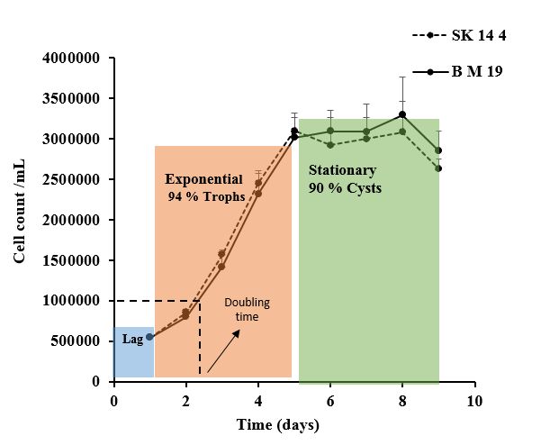

Fig 3.1 Growth curve of *Acanthamoeba* in PYG media, cell counts were done over a period of 9 days using manual and automated methods. Increase in cell number was observed after 12 hours incubation, with a doubling time of approximately 20 hours. Cell counts were stopped when cell number starts to decline (death phase). The error bars show standard error for 4 replicate counts.

Fig 3.2 Percentage cysts and trophozoites calculated every 24 hours while generating an amoeba growth curve. The error bars show the average standard deviation for 3 replicate counts.

## 3.1.2 *Acanthamoeba* genotyping (DNA extraction)

The genotype of five *Acanthamoeba* isolates SK-14-4, PM19, SK-19-9, SK-19-56, SK-19-59 collected was profiled using PCR. *Acanthamoeba* genotyping is important for different purposes like taxonomic, epidemiological and clinical studies. Genotyping produces valuable information for the development of novel diagnostic methods. Most importantly in this research, it was performed to identify potential genetic variations that may cause a different response of *Acanthamoeba* isolates. The pharmacogenomics study is a regulatory requirement during drug development (Hall et al., 2004). Three common methods of DNA extraction were compared (table 3.1). Extraction by heating, by physical agitation (sonication) and InstaGene matrix (Chelex; Biorad), were all evaluated. The result of extraction methods are compared in the table below

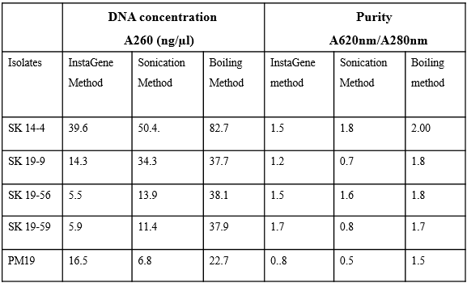

Table 3.1 Concentration and purity of DNA extracted using three DNA extraction methods for 5 strains of *Acanthamoeba*; SK 14-4, SK 19-9, SK 19-56, SK 19-59 and PM 19.

As seen in Table 3.1, the highest concentration of DNA extracted was by heating. Boiling at 100oC extracted more DNA in all five strains, though there are variations in the amount of DNA extracted across isolates. Also, DNA extracted by heating showed the highest purity of 2.00 compared to sonication and use of InstaGene matrix at 1.8 and 1.5 respectively.

## 3.1.3 Agarose gel electrophoresis of the PCR amplified products of *Acanthamoeba* -DNA

Extraction of *Acanthamoeba* DNA via heat shock was selected because it produced an acceptable value of purity (1.8). Gel electrophoresis of extracted DNA was performed as a quantitative method to compare the size of the DNA of all *Acanthamoeba* isolates fig (3.3)

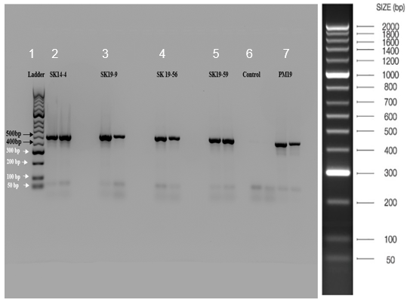

Fig 3.3 Gel electrophoresis of the five *Acanthamoeba* isolates DNA extraction method was by boiling. (A) Gel electrophoresis of all the five isolates. Lane 1 is 50bp Bioline ladder, lane 2 is SK-14-4, lane 3 is sk19-9, lane 4 is SK-19-56, lane 5 is SK-19-59, Lane 6 is the control and lane 7 is PM-19. Double bands see in each lane show duplicate samples

As seen in Fig 3.3 the boiling method was useful as it gave bands for four isolates Therefore we can say that from the results that the size of the DNA bands was relatively similar and are at the range of 450-500 bp. The size of *Acanthamoeba* T4 genotype is reported to range from 423–551 bp (Jercic et al., 2019)

## 3.1.4 Sequencing and genotyping of all five isolates of *Acanthamoeba*

To evaluate the variations among the five isolates, multiple DNA sequence alignment was performed on the elute DNA by DBS genomics (University of Durham) and the alignment of the highly variable region Diagnostic Fragment 3(DF3) as shown in figure 3.4 was performed using Clustal Omega (European Bioinformatics Institute, Cambridge/ UK). The DF3 fragment considered as a critical region in *Acanthamoeba* genotyping as it is a very useful tool to illustrate the diversity within a similar genotype (Ledee et al. 2009).

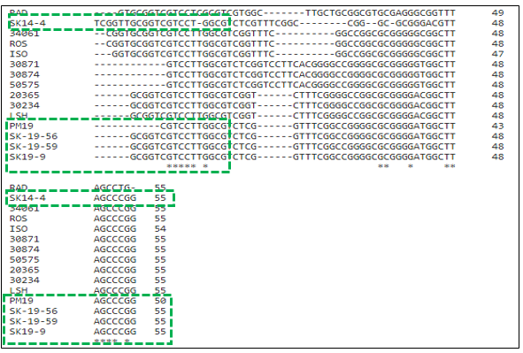

Fig. 3.4 Multiple Sequence Alignment of diagnostic fragment 3 (DF3) the 5 *Acanthamoeba* isolates. Highlighted in the green rectangular box are the five isolates of interest, asterisks show the identical base pairs in all sequences aligned, while the gaps are shown with dashes. This is part of a large study looking at other environmental isolates.

The results from the alignment fig (3.4) showed some diversity even though they are classed as the same genotype. The sequence was further analysed using BLAST to confirm the most similar genotype and accession number and all four isolates showed 100% similarity with T4 genotype table 3.2. The evolutionary diversity relationship, Mega 6 software (Molecular Evolutionary Genetics Analysis Version 6.0) was used to generate a neighbour-joining dendrogram (Fig 3.5), which is used to show genetic distance among strains (Xuan et al., 2017)

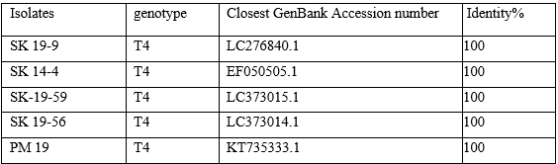

Table 3.2 Closest genotype and accession number to 5 *Acanthamoeba* isolates used. These parameters were identified using BLAST from NCBI homepage. After subjecting the sequences into BLAST, the similarity was (99-100%) with an E (expected) value of 0 in every case.

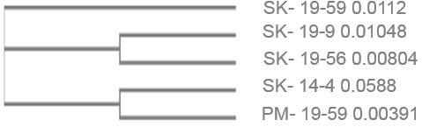

Fig 3.5 Dendrogram of *Acanthamoeba* strains based on 18S rDNA sequences. The neighbouring-joining tree shows the relationship of the *Acanthamoeba* strains SK- 19-9, PM 19, SK 14-4, SK- 19-59 and SK- 19-56 with already existing *Acanthamoeba* reference genes

The result gotten from (fig 3.5) reveals that there is “within-isolate” diversity, which is not significant enough to suggest the isolates are not T4 genotype as the degree of variation in the family tree for all isolates was less than 0.1 fig 3.5.

**3.2 Viability assays**

**3.2.1 Alamar blue or Resazurin cell concentration curve.**

The adaptability of the Alamar blue viability assay to *Acanthamoeba* trophozoites was evaluated first by generating a cell concentration curve of cell number versus fluorescence. Alamar blue as explained in the literature review is a permeability dependent dye and relies on the reduction of purple coloured Alamar blue to pink coloured resorufin by intracellular mitochondria reductase enzymes. In this assay, a varying cell dilution of *Acanthamoeba* trophozoites was incubated with Resazurin. The relationship between cell number and fluorescence was measured using 530 -570 nm excitation and emission wavelength*.*

Fig 3.6 Standard curve of Resazurin reduction versus cell numbers for *Acanthamoeba* trophozoites. Change in fluorescence was measured at 530-570 nm excitation *wavelength* and 585-590 nm emission *wavelength.* Error bars show SD for n=4 replicates readings fluorescence readings.

Although the resazurin concentration curve showed significant sensitivity, it did not show a good linear response. As seen in fig 3.5, after I hour incubation, linearity saturates. Based on this data, particularly the non-linearity of the assay, we decided not to use this approach. In addition, McBride et al., (2005) have shown that Alamar blue was not a useful viability assay technique for *Acanthamoeba* cysts.

## 3.2.2 Fluorescein diacetate assay (FDA)

Further optimization of viability assay was carried out with the fluorescein diacetate assay fig 3.7. The FDA cell concentration curve, for *Acanthamoeba* trophozoites, showed a good linear relationship between cell number and fluorescence intensity (fig 3.7)

Fig 3.7 (a) Cell density versus fluorescence after 24hrs incubation of *Acanthamoeba* trophozoites with fluorescein diacetate. Fluorescence was measured at ex: 490nm and em: 514nm. Error bars show SD for n=4 replicates readings fluorescence readings.

The further study evaluated the response of *Acanthamoeba* trophozoites to hydrogen peroxide. The results (fig 3.8) showed good concentration-dependent inhibition of *Acanthamoeba* trophozoites.

Fig 3.8. Inhibition of *Acanthamoeba* trophozoites by different dilutions of hydrogen peroxide as reported by the FDA viability assay. The % viability was calculated from Fluorescence measurements of positive control (100% live cells) and negative control (heat-inactivated cells). The error bars show the mean SD for n=4 replicate readings. Fluorescence was measured at ex: 490nm and em: 514nm

To investigate FDA applicability to cyst viability, a cell concentration curve was generated with the same protocols as the trophozoites. The result (fig 3.9) did not show a linear relationship. In addition, there was high variability between replicate samples as seen in the error bars. Asimilar study by Khunkitti, (1997) had shown that the metabolic inactivity of the cysts is a significant limitation of using FDA for *Acanthamoeba* cyst susceptibility tests. Very low metabolism will result in a reduced reduction of fluorescein diacetate to fluorescein resulting in a non-comparable and inaccurate viability report

Fig 3.9 (b) Cell density versus fluorescence after 24hrs incubation of *Acanthamoeba* cysts with fluorescein diacetate. Fluorescence was measured at ex: 490nm and em: 514nm. Error bars show SD for n=4 replicates readings fluorescence readings.

## 3.2.4 Viability assay with trypan blue after toluidine blue photodynamic therapy

The final approach with the dye was using trypan blue dye and microscopy to show the PDT effect of Toluidine blue on *Acanthamoeba* trophozoites. As we can see in (fig 3.10), there was a good photodynamic effect. Furthermore, the image in fig 3.11, presents two microscopic images after photodynamic treatment of Acanthamoeba cells with toluidine blue. The image in 3.11 (A) shows Acanthamoeba cells that appear to have a compromised cell wall. This is because the cells have taken up the blue colour of the toluidine blue dye. The corresponding image fig3.11 (b) is the control sample of *Acanthamoeba* cells which was incubated with the same concentration of toluidine blue and exposed to the same amount of red light but were protected from the effect of light using an aluminium foil. The cell cells did not take up the blue colour suggesting that the cell wall integrity remained intact. Hence the photodynamic effect was effective in (A) but was inhibited in (B).

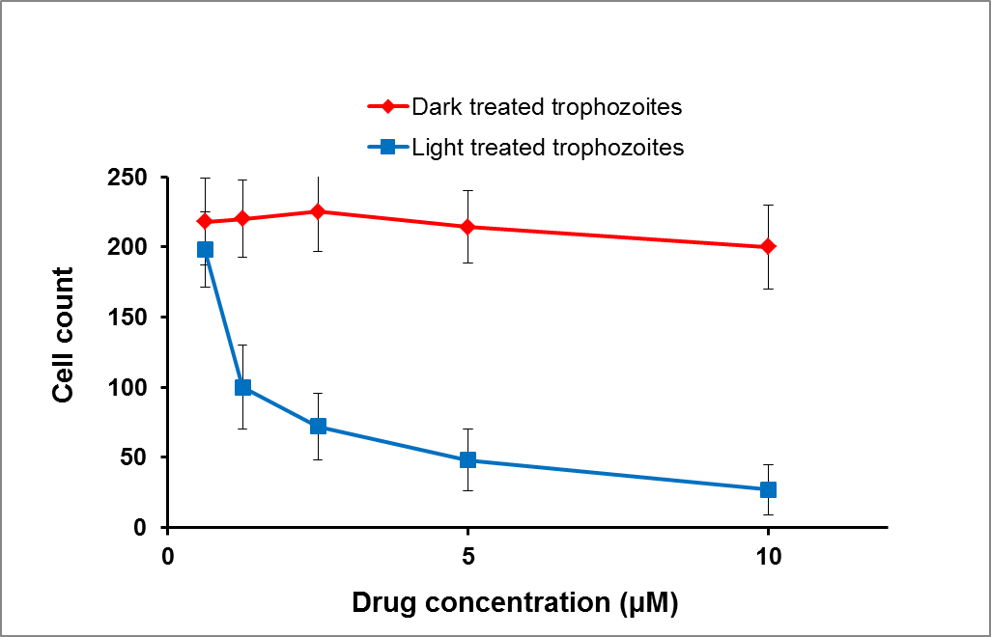

Fig 3.10 Photodynamic inactivation of *Acanthamoeba* trophozoites using different concentrations of toluidine blue and red fluorescent light. Error bars show standard error for 3 objectives (X 1000 magnification) views using the inverted microscope after staining cells with trypan blue.

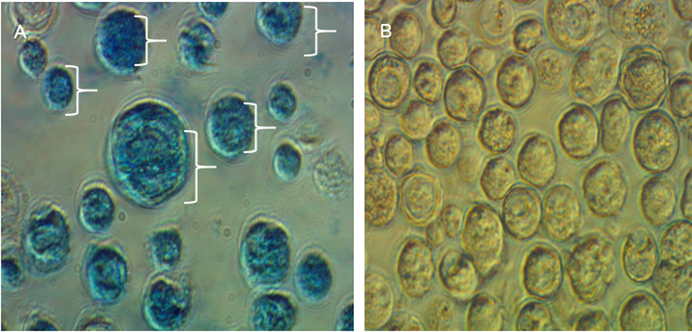

Fig 3.11. *Acanthamoeba* sp. As seen using a light inverted *microscope* (Nikon, Japan) using 10X objectives. (A) The white pointer shows cysts cells, which appears blue in colour because it has taken up the toluidine blue dye, after photodynamic treatment. (B) A control sample of cells exposed to the same concentration of toluidine blue but was protected from the photodynamic effect by covering with an aluminium foil.

## 3.3 Adenosine triphosphate assay (ATP)

After evaluating results from all viability assay methods, we decided to consider an alternative approach. The issue with the FDA assay was the low metabolism of the cyst and the data presented strongly supports that (fig 3.9). ATP viability assay was subsequently carried out. Part of the protocol in the ATP based assay was lysis of the treated cells to release intracellular ATP. The lysis buffer from the ATP assay kit (Tris EDTA and sodium dodecyl sulfate), was useful for trophozoite lysis: when incubated with the trophozoites, evidence of cell wall distortion and lysis trophozoite cells was seen after microscopic evaluation and staining. However, when we used it for the cyst the level of ATP release was significantly reduced. However, when incubated with the cysts and monitored microscopically, there was no evidence of complete cyst cell wall lysis as cyst cells did not take up dye when stained suggesting an intact cell wall.

**3.3.1 Enzymatic lysis with lysozyme**

Based on an earlier 2018 publication by Anwar et al, we looked to see if we can enzymatically lyse the cysts. As seen in fig 3.12, incubation of cysts cells with lysozyme lysed the cells as intracellular organelles can be seen pouring out of the cells after 40 minutes. Staining the cells with trypan blue confirm that the cells incubated with lysozyme had taken up the dye while the control samples did not ( fig 3.13)

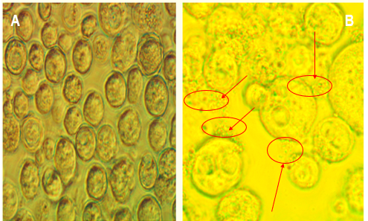

Fig 3.12 Lysis of acanthamoeba cyst with lysozyme. As seen using a light inverted *microscope* (Nikon, Japan) using 10 X obj, (a) control *Acanthamoeba* cyst sample and (b) *Acanthamoeba* cysts treated with 4 mg/ml HEWL.. Arrows show the release of intracellular contents of the cyst after 40 mins incubation with lysozyme.

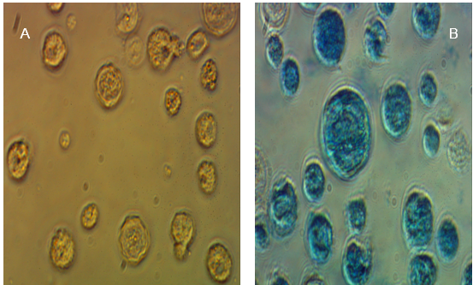

Fig 3.13. Staining the control sample (a) and the cyst cell incubated with lysozyme (b) with trypan blue showed that cells incubated with lysozyme had taken-up the blue colour of trypan blue.

**3.3.2 ATP standard curve**

To investigate the linearity of the relationship between concentration and bioluminescence signal (RLU), we generated an ATP standard curve with varying concentrations of ATP



Fig 3.14 linear relationship between ATP concentration and bioluminescence (relative light unit). Different concentrations of ATP standard ranging from 5ug/mL to 0.019ug/mL was reacted with luciferase enzyme and bioluminescence was measured at 600 nm. Error bars show SD n=4 replicate experiment. Inset graph shows linearity at lower ATP concentrations.

As see in fig (3.12), ATP concentration has a positive correlation with the bioluminescence signal. The higher the ATP concentration the higher the relative light unit. The experiment was also determined for very low concentrations of ATP see indented graph in fig 3.14

**3.3.3 Comparison of different lysis method**

The further investigation compared the use of lysozyme, detergent lysis and sonication, to determine the most suitable method for controlled lysis of *Acanthamoeba* cysts

Fig 3.15 Activity of released intracellular ATP after lysis of *Acanthamoeba* cysts with different lysis methods. LYZ represents lysis with lysozyme; DTG indicates lysis with a detergent buffer while SONI represents lysis by sonication. Two control set up was used in this experiment a negative control containing luciferase enzyme and positive control of known ATP standard. Bioluminescence (RLU) was measured at 600 nm. Error bars show SD for n=4 replicate readings.

The relative light unit signal showed more activity of released ATP using lysozyme fig (3.15) compared with sonication and detergent lysis. Further optimisation of the ATP assay involves confirming a linear relationship between the amount of ATP and bioluminescence using known concentrations of ATP (fig 3.15).

**3.3.4 Duration for complete lysis of *Acanthamoeba* cyst with lysozyme.**

Further investigation was carried out to determine the time taken for complete lysis of cysts by lysozyme

Fig 3.16 Percentage lysis of *Acanthamoeba* cysts after 40 minutes’ incubation at 30oC. The error bars show SD for n=4 replicate readings. Percentage lysis was calculated after dye exclusion with trypan blue.

Results in fig (3.16) showed that approximately 100 % of the cell in a population of cysts would be completely degraded after 30 - 40 minutes’ incubation

**3.3.5 TEM imaging of cysts lysed with lysozyme**

To evaluate enzymatic lysis of *Acanthamoeba* cells, hen’s egg white lysozyme was used. Availability was the bases for selection of hen’s egg-white lysozyme.Amoeba cysts were incubated with 10-µM lysozyme and transmission electron microscopy was used to monitor the degradation of *Acanthamoeba* cysts cell wall**.** The result compared to a sample of cell-only shows complete lysis of *Acanthamoeba* cysts as seen below in (fig 3.17)

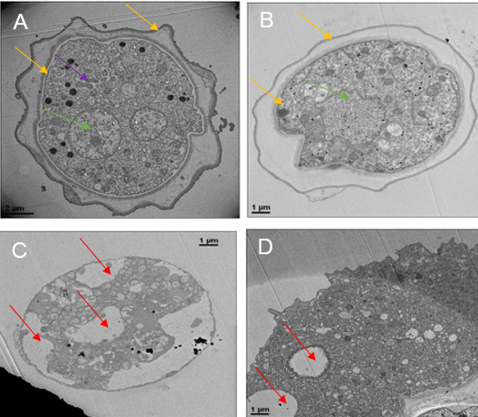

Fig 3.17 Degradation of *Acanthamoeba* cysts by 10 mM HEW lysozyme as seen by TEM (A) control of cysts which are not treated with lysozyme (B) shows a replicate of cyst not exposed to lysozyme. Yellow arrows in (A) and (B) shows the endocyst and the exocyst, purple arrow shows the mitochondria while the green arrow shows nucleus. Sample (C), shows sample treated with lysozyme. We can see what appear to be the remains of the endocyst, however, most of the cell structures were missing

**3.3.6 *Acanthamoeba* cell concentration curve**

A

**B**

Fig 3.18 Linear correlation of cell number and bioluminescence of *Acanthamoeba* concentration curve. (A) Trophozoite concentration curve (B) Cyst concentration curve. The R2 value shows a linear correlation between the cell numbers and the bioluminescence (RLU) which was measured at 600 nm. Error bars show SD n=4 replicate readings.

*Acanthamoeba* cell concentration curve showed good linearity for both morphological forms as seen in (fig 3.18).

**3.3.7 The stability of luciferase enzyme**

The stability of luciferase enzyme was checked after 24-hour storage in -20 oC. This was done to validate storage parameters and to ensure results are not misinterpreted because of the loss of enzyme activity during storage. The result as seen below in fig 3.19, shows no loss of enzyme activity after 24-hour storage.

Fig 3.19 Stability of luciferase enzyme after storage. There was no significant loss of activity of luciferase enzyme after 24hours incubation at -20 oC as seen in the response curves. Redline shows the response for the first day while the blue curve shows a response after 24 hours. Bioluminescence (RLU) was measured at 600 nm and error bars show SD n=4 replicate experiments.

**3.3.8 Inhibitory effects of phosphate-buffered saline on luciferase Enzyme.**

Firefly luciferase is a hydrophobic enzyme and the type of solvent, pH and elements of the reaction mixture can affect its activity (Trajkovska et al., 2005). The influence of phosphate-buffered saline was indirectly evaluated through the measurement of the light produced during the ATP luciferase reaction. The reaction mixture used includes distilled water 1 X concentration of PBS and 0.5 X concentration of PBS.

Fig 3.20 Reduction of bioluminescence signal caused by inhibitory effects of phosphate buffer saline (PBS) on luciferase enzyme. The broken lines show the highest concentration of PBS used as a solvent for luciferase enzyme (1X mix PBS), while the blue straight-line shows 0.5 mix PBS. The red line represents the curve for distilled water. Error bars show the standard deviation for 4 replicate sample.

Fig 3.20 showed inhibition of luciferase activity in a concentration-dependent manner. This result means distilled water is the preferred solvent for all luciferase assay experiment.

**3.4 Methods validation with drug assays.**

To further validate the use of ATP assay for cyst and trophozoite susceptibility testing different compounds were used.

## 3.4.1 Amphotericin B Drug assay.

Different concentration of amphotericin B fig 3.21 was incubated with *Acanthamoeba* trophozoites and cysts and viability were confirmed using ATP assay after 24 hours incubation

Fig 3.21 Viability of *Acanthamoeba* cysts and trophozoites determined by ATP assay, after 24-hour incubation with varying concentrations of amphotericin B. the redline shows trophozoite viability while the blue line shows cyst viability. Percentage viability was calculated from control cells. Bioluminescence signal was measured at 600 nm. The error bars represent the standard deviation for 4 replicate reading taken.

Results from the amphotericin B drug assay fig (3.21) showed a concentration-dependent inhibition of *Acanthamoeba* cysts and trophozoites. The response kinetics, however, was different for cysts and trophozoites. The trophozoites showed greater susceptibility as seen from the response curve (red line) fig (3.21). A lethal concentration of 500 µg/ml was seen in both morphological forms. However, the IC50 for the trophozoites was approximately 15 µg/ml while the cyst showed a greater resistance at 50 µg/ml. Furthermore, the minimal inhibitory concentration for the cysts was greater at (250 µg/ml) against 100 µg/ml for the trophozoites.

## 3.4.2 Miltefosine Drug assay

The susceptibility of *Acanthamoeba* with miltefosine was also evaluated by incubating different concentration of miltefosine with *Acanthamoeba* cysts and trophozoites and viability accessed after 24 hours incubation. Fig (3.22)

Fig 3.22 Viability of *Acanthamoeba* cysts and trophozoites determined by ATP assay, after 24-hour incubation with varying concentrations of miltefosine. The red line shows trophozoites viability while the blue line shows cyst viability. Percentage viability was calculated from control cells. Bioluminescence signal was measured at 600 nm. The error bars represent the standard deviation for 4 replicate reading taken

As seen in the response curve fig 3.22, *Acanthamoeba* trophozoites were more susceptible to miltefosine than the cysts. A 100% inhibition of the trophozoites was observed at 50 μg/ml; three times of this concentration was not enough to totally inactivate the cysts. The IC50 for the trophozoites was 15 µg/ml while the cysts were 25 µg/ml. minimal inhibitory concentration for trophozoites was 25 µg/ml and again the cysts showed more resistance at approximately 125 µg/ml.

## 3.4.3 Povidone-iodine drug assay.

Further drug assay was carried out. This time Povidone-iodine was used to further validate the adaptability of ATP assay for cysts and trophozoites viability. As usual, different concentrations of povidone-iodine was incubated with the cysts and trophozoites over a 24-hour period and viability was evaluated with ATP assay.

Fig 3.23 Viability of *Acanthamoeba* cysts and trophozoites determined by ATP assay, after 24-hour incubation with varying concentrations of povidone-iodine. The red line shows trophozoites viability while the blue line shows cyst viability. Percentage viability was calculated from control cells. Bioluminescence signal was measured at 600 nm. The error bars represent the standard deviation for 4 replicate reading taken

Results from povidone drug test fig (3.23), showed that *Acanthamoeba* trophozoites were more susceptible to povidone-iodine than amphotericin B and miltefosine. A concentration of 100 µg/ml was lethal for the trophozoites while 500 µg/ml was lethal for cysts. The IC50 for the cysts was 100 µg/ml, while IC50 was 15 µg/ml for trophozoites. More drug test was carried out using caspofungin a new class of antifungal

## 3.4.4 Caspofungin Drug assay.

Different concentration of caspofungin was also used against *Acanthamoeba* cysts and trophozoites*.* Viability was evaluated using ATP assay after 24-hour incubation at 30oC

Fig 3.24 Viability of *Acanthamoeba* cysts and trophozoites determined by ATP assay, after 24-hour incubation with varying concentrations of caspofungin. The red line shows trophozoite viability while the blue line shows cyst viability. Percentage viability was calculated from control cells. Bioluminescence signal was measured at 600 nm. The error bars represent the standard deviation for 4 replicate reading taken

*Acanthamoeba* cysts and trophozoites were less susceptible to Caspofungin (fig 3.24). A concentration of 500 mg/l was not able to give 100 % inhibition of both morphological forms. The IC50 for the trophozoites was about 50 µg/ml while the cysts were about 100 µg/ml. The table below shows Regrowth assay for the highest concentration of test compound used for the assay.

## 3.4.5 Regrowth assay.

Terminal subculture otherwise called regrowth assay was carried out using the highest concentration of drug for each test compound. Cells incubated with the highest concentration of each compound was cultured in fresh amoeba media and allowed over a period of two weeks while monitoring growth. Results, as seen in table 3.1, shows that both morphological forms of pathogen did not survive the highest concentration of Amphotericin B and povidone-iodine used hence the cells did not replicate in fresh media. However, the cells incubated with Caspofungin and Miltefosine did survive after 7 days in fresh amoeba media as seen in table 3.1

Table 3.1 Survival after Regrowth assay for the highest concentration of all test compounds used in the present study.

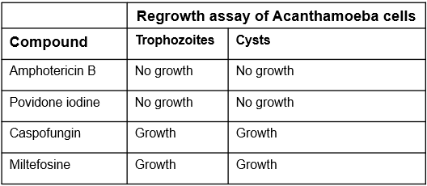

## 3.5 Photodynamic therapy

After validating the ATP viability assay with different compounds, porphyrin was selected as a photosensitizer for photodynamic assay. This is primarily because the porphyrins exhibit powerful fluorescence from 400 to 730 nm; a wavelength range in which deeper penetration of tissues occurs see (fig 1.14). Porphyrins can be conjugated with desired compounds and molecules to reduce their polarity by addition of desired side groups hence enhancing permeability into bacterial cells. Four (4) porphyrins were used for PDT

Tetra anionic 4, 4′, 4′′, 4′′′-(porphine-5, 10, 15, 20-tetrayl) tetrakis (benzene sulfonic acid) tetrasodium salt hydrate [TPPS4].

5, 10, 15, 20-tetrakis (1-methyl-4-pyridino) porphyrin tetra (P-toluene sulfonate).

5, 10, 15, 20- tetrakis (pentafluorophenyl)-21H, 23H-porphine Iron (III) chloride

5, 10, 15, 20-Tetrakis (4-methyl phenyl)-21H23H porphine

First, the fluorescence spectrum of porphyrins was evaluated using the Gemini™ XPS and EM Microplate Readers to determine the optimal excitation and emission settings for fluorescence intensity assays. Comparison of relative fluorescence units (RFUs) between samples is allowed by a unique calibration against an internal standard

## 3.5.1 Spectra of porphyrins used for PDT

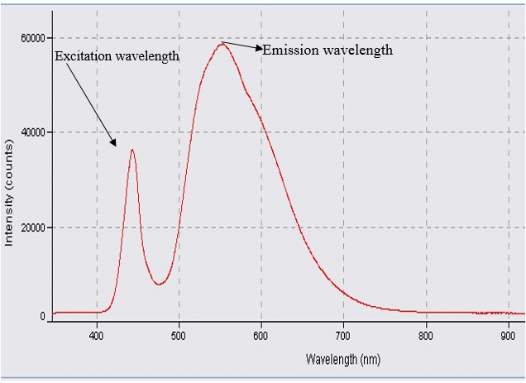

Fig 3.25. Excitation and emission spectrum of 5, 10, 15, 20-tetrakis (1-methyl-4-pyridino) porphyrin tetra (P-toluene sulfonate). Arrows show emission and excitation maximums

As seen in fig 3.25, the fluorescence spectrum showed that the porphyrins have excitation maximum of 400 nm and emission maximum 700 nm (see appendix for all four porphyrins.). In addition, a porphyrin calibration curve was set up to show the linear relationship between concentration and fluorescence. fig 3.26 showed good linearity between fluorescence and concentration at a dynamic range of porphyrin

Figure 3.26 Calibration curve of porphyrin showing a linear relationship between concentration and fluorescence. Error bars show the standard deviation for four replicate readings.

## 3.5.2 Porphyrin uptake after incubation

To evaluate the uptake of porphyrin by *Acanthamoeba* cells, 106 cells /ml of Acanthamoeba cyst and trophozoites suspension in PBS were incubated with porphyrins for 5, 10, 20 and 30 minutes. At each of these time points, the cells were washed once then lysed and fluorescence was measured at 400 excitations and 730 emission wavelengths. Fig (3.27) shows the uptake dynamics for four porphyrins on trophozoites (A) and cyst (B). The maximum uptake was reached after 10 minutes, an increase in fluorescence was not significant after 10 minutes meaning that the uptake saturation point is about 10 minutes after incubation. Generally, uptake was higher in trophozoites than cysts and varies among the porphyrins used. The cationic porphyrins showed and maintained greater permeability in trophozoites and the cysts compared to the only anionic porphyrin used.

**A**

**B**

Fig 3.27 Amount of porphyrin recovered from *Acanthamoeba* cells (106 cell /ml) after incubation at different times, with 50 μM of various porphyrins molecules. TP1 and CP1 = 5, 10, 15, 20-tetrakis (1-methyl-4-pyridino) porphyrin tetra (P-toluene sulfonate) trophozoites and cysts, “5, 10, 15, 20- tetrakis (pentafluorophenyl)-21H, 23H-porphine Iron (III) chloride =TP2 and CP2. 5, 10, 15, 20-Tetrakis (4-methyl phenyl)-21H23H porphine = TP3 and CP3. 4,4′,4′′,4′′′-(porphine-5,10,15,20-tetryl) tetrakis (benzenesulfonic acid) tetrasodium salt hydrate = TP4 and CP4. After incubation at different times, the trophozoite cells (A) was lysed with lysis buffer while the cysts cells were lysed with 10 mM HEWL and fluorescence evaluate at 400 excitations and 730 emission filters.

## 3.6 Binding strength of porphyrins for cysts and trophozoites

## **3.6.1 Binding strength of 5, 10, 15, 20-tetrakis (1-methyl-4-pyridino) porphyrin tetra** **(P-toluene sulfonate), *Acanthamoeba* cells**

*Acanthamoeba* cysts and trophozoites were incubated with all four porphyrins for 10 minutes, washed in PBS five times at 10,000 g for 5 minutes. After 5 washes the cells were lysed and fluorescence evaluated at 400 ex and 730 em wavelengths. The idea was to monitor per cent permeability and loose binding in both cysts and trophozoites. The results showed the permeability of all four porphyrins are different and also trophozoites uptake was more than cyst uptake. However, only about 25 % of the porphyrin concentration used as the highest concentration permeated the cell.

Fig 3.26 Percentage amount of 5, 10, 15, 20-tetrakis (1-methyl-4-pyridino) porphyrin tetra (P-toluene sulfonate) (50-µM), recovered after 10 minutes incubation with *Acanthamoeba* cysts and trophozoites, after five washing steps. The grey and blue bars represent the percentage amount of porphyrin recovered from trophozoites and cysts respectively. Error bars = mean SD n =4 replicate readings.

Fig 3.26 showed that only about 25 % of 5, 10, 15, 20-tetrakis (1-methyl-4-pyridino) porphyrin tetra (P-toluene sulfonate), permeated the trophozoites, and while about 20 % was retained by the cysts after the first wash. The amount of porphyrin retained continued to decrease in each wash, and after the x 5 wash, less than 2 % porphyrin was retained by the cell

## **3.6.2 Permeability of 5, 10, 15, 20- tetrakis (pentafluorophenyl)-21H, 23H-porphine Iron (III) chloride to *Acanthamoeba* cells**

Fig 3.27 Percentage amount of 5, 10, 15, 20- tetrakis (pentafluorophenyl)-21H, 23H-porphine Iron (III) chloride recovered (50-µM), recovered after 10 minutes incubation with *Acanthamoeba* cysts and trophozoites, after five washing steps. The grey and blue bars represent the percentage amount of porphyrin recovered from trophozoites and cysts respectively. Error bars = mean SD n =4 replicate readings.

Figure 3.27 showed about 18 % binding in trophozoites and 12 % in cysts binging continued to reduce after each wash after 5 washes there was less than 1 % 5, 10, 15, 20- tetrakis (pentafluorophenyl)-21H, 23H-porphine Iron (III) chloride in the cysts.

## 3.6.3 Binding strength of 5, 10, 15, 20-Tetrakis (4-methyl phenyl)-21H23H porphine to *Acanthamoeba cells*

Fig 3.28 The percentage amount of **5, 10, 15, 20-Tetrakis (4-methyl phenyl)-21H23H porphine** (50-µM), recovered after 10 minutes incubation with *Acanthamoeba* cysts and trophozoites, after five washing steps. The grey and blue bars represent the percentage amount of porphyrin recovered from trophozoites and cysts respectively. Error bars = mean SD n =4 replicate readings.

As seen in figure 3.28 the percentage uptake of 5, 10, 15, 20-Tetrakis (4-methyl phenyl)-21H23H porphine was significantly low at 6 and 5 % for trophozoites and cysts after 10 minutes incubation. Furthermore, there was less than 1 % porphyrin seen after three washing steps. After the fifth wash, the percentage of porphyrin left was effectively zero.

## **3.6.4 Binding of 4, 4′, 4′′, 4′′′-(porphine-5, 10, 15, 20-tetrayl) tetrakis (benzene** **sulfonic acid) tetrasodium salt hydrate [TPPS4], to *Acanthamoeba* cells**

Fig 3.29 The percentage amount of 4, 4′, 4′′, 4′′′-(porphine-5, 10, 15, 20-tetrayl) tetrakis (benzene sulfonic acid) tetrasodium salt hydrate (50-µM), recovered after 10 minutes incubation with Acanthamoeba cysts and trophozoites, after five washing steps. The grey and blue bars represent the percentage amount of porphyrin recovered from trophozoites and cysts respectively. Error bars = mean SD n =4 replicate readings.

Figure 3.29 showed the least affinity to *Acanthamoeba* cells with maximum binding at 3 % after the first wash and less than 1 % after x 5 wash.

**3.7 Porphyrin photodynamic therapy results.**

3.7.1 PDT with 4, 4′, 4′′, 4′′′-(porphine-5, 10, 15, 20-tetrayl) tetrakis (benzene sulfonic **acid) tetrasodium salt hydrate**

Figure 3.30 Survival curves of *Acanthamoeba* trophozoites (106/ml) incubated with different concentrations of 4,4′,4′′,4′′′-(porphine-5,10,15,20-tetrayl) tetrakis (benzenesulfonic acid) tetrasodium salt hydrate for 10 minutes in the dark and irradiated with an LED light for 60 minutes (Redline). Control cells incubated with porphyrin, but was protected from irradiation by covering with aluminium foil was set up (blue line). Cell viability was determined with the ATP assay and percentage viability was calculated from bioluminescence signals, measured at 600nm wavelength. The error bars represent the standard deviation from 4 replicate reading taken from test wells.

Figure 3.31 Survival curves of *Acanthamoeba* cysts (106/ml) incubated with different concentrations of 4,4′,4′′,4′′′-(porphine-5,10,15,20-tetrayl) tetrakis (benzenesulfonic acid) tetrasodium salt hydrate for 10 minutes in the dark and irradiated with an LED light for 60 minutes (Redline). Control cells incubated with porphyrin but was protected from irradiation by covering with aluminium foil was set up (blue line). Cell viability was determined with the ATP assay and percentage viability was calculated from bioluminescence signals, measured at 600nm wavelength. The error bars represent the standard deviation from 4 replicate reading taken from test wells.

PDT with 4, 4′, 4′′, 4′′′-(porphine-5, 10, 15, 20-tetrayl) tetrakis (benzene sulfonic acid) tetrasodium salt hydrate as seen in fig 3.30 shows a 40 % reduction of viability of the trophozoites in both control samples and irradiated samples. This data means there could have been dark toxicity caused by the concentration used. There was no significant loss of viability for both irradiated samples and control sample for the cysts fig 3.31.

3.7.2 PDT with 5, 10, 15, 20-tetrakis (1-methyl-4-pyridino) porphyrin tetra (P-toluene sulfonate).

Fig 3.32 Survival curves of *Acanthamoeba* trophozoites (106/ml) incubated with different concentrations of 5, 10, 15, 20-tetrakis (1-methyl-4-pyridino) porphyrin tetra (P-toluene sulfonate), for 10 minutes in the dark and irradiated with an LED light for 60 minutes (Redline). Control cells incubated with porphyrin but was protected from irradiation by covering with aluminium foil was set up (blue line). Cell viability was determined with the ATP assay and percentage viability was calculated from bioluminescence signals measured at 600nm wavelength. The error bars represent the standard deviation from 4 replicate reading taken from test wells.

Photodynamic therapy with 5, 10, 15, 20-tetrakis (1-methyl-4-pyridino) porphyrin tetra (P-toluene sulfonate), as seen in fig 3.32 showed significant reduction of *Acanthamoeba* trophozoites. There was a 90% reduction of viability and an IC50 of about 15-µM concentration. However, results show that there was not 100% inhibition of trophozoites at the concentration of 5, 10, 15, 20-tetrakis (1-methyl-4-pyridino) porphyrin tetra (P-toluene sulfonate) used.

Fig 3.33 Survival curves of *Acanthamoeba* cysts (106/ml) incubated with different concentrations of 5, 10, 15, 20-tetrakis (1-methyl-4-pyridino) porphyrin tetra (P-toluene sulfonate) for 10 minutes in the dark and irradiated with an LED light for 60 minutes (Redline). Control of cells incubated with but was protected from irradiation by covering with aluminium foil was set up (blue line). Cell viability was determined with the ATP assay and percentage viability was calculated from bioluminescence signals measured at 600nm wavelength. The error bars represent the standard deviation from 4 replicate reading taken from test wells.

The cysts, on the other hand, as seen above fig 3.33 indicated 80 % reduction in viability with similar IC50. The concentration of the porphyrin used did not inactivate 100 % of the cysts. Dark toxicity for both the trophozoites and cysts was not significant.

3.7.3 PDT with 5, 10, 15, 20- tetrakis (pentafluorophenyl)-21H, 23H-porphine Iron(III) chloride.

Fig 3.34 Survival curves of *Acanthamoeba* trophozoites (106/ml) incubated with different concentrations of 5,10,15,20-Tetrakis(pentafluorophenyl)-21H,23H-porphyrin iron(III) chloride for 10 minutes in the dark and irradiated with an LED light for 60 minutes (Redline). Control cells incubated with porphyrin but was protected from irradiation by covering with aluminium foil was set up (blue line). Cell viability was determined with the ATP assay and percentage viability was calculated from bioluminescence signals measured at 600 nm wavelength. The error bars represent the standard deviation from 4 replicate reading taken from test wells

As observed from fig 3.34 there was approximately 75 % reduction of viability in *Acanthamoeba* trophozoites treated with 5,10,15,20-Tetrakis(pentafluorophenyl)-21H,23H-porphyrin iron(III) chloride. The observed IC50 was just below 10 µM. There was no significant dark toxicity observed in the non-irradiated controls.

Fig 3.35 Survival curves of *Acanthamoeba* cysts (106/ml) incubated with different concentrations of 5,10,15,20-Tetrakis(pentafluorophenyl)-21H,23H-porphyrin iron(III) chloride for 10 minutes in the dark and irradiated with an LED light for 60 minutes ( Redline). Control cells incubated with porphyrin for but was protected from irradiation by covering with aluminium foil was set up (blue line). Cell viability was determined with the ATP assay and percentage viability was calculated from bioluminescence signals measured at 600 nm wavelength. The error bars represent the standard deviation from 4 replicate reading taken from test wells

Cyst viability was reduced to 25 % after exposure to 5,10,15,20-Tetrakis(pentafluorophenyl)-21H,23H-porphyrin iron(III) chloride fig 3.35. The cysts were more resistant than the trophozoites as the IC50 for the cysts was higher at 25 µM. Reduction in the viability of the dark controls was not significant in both the cysts and the trophozoites.

## 3.7.4 PDT with 5, 10, 15, 20-Tetrakis (4-methyl phenyl)-21H23H porphine

Fig 3.36 Survival curves of *Acanthamoeba* trophozoites (106/ml) incubated with different concentrations of 5, 10, 15, 20-Tetrakis (4-methyl phenyl)-21H23H porphine, for 10 minutes in the dark and irradiated with an LED light for 60 minutes (Redline). Control cells incubated with porphyrin but was protected from irradiation by covering with aluminium foil was set up (blue line). Cell viability was determined with the ATP assay and percentage viability was calculated from bioluminescence signals measured at 600 nm wavelength. The error bars represent the standard deviation from 4 replicate reading taken from test wells

As seen in fig 3.36 after 60 minutes irradiation, there was about 30 % reduction of *Acanthamoeba* trophozoites by 5, 10, 15, 20-Tetrakis (4-methyl phenyl)-21H23H porphine. No dark toxicity was noticed with the control sample.

Fig 3.37 Survival curves of *Acanthamoeba* cysts (106/ml) incubated with different concentrations of 5, 10, 15, 20-Tetrakis (4-methyl phenyl)-21H23H porphine, for 10 minutes in the dark and irradiated with an LED light for 60 minutes (Redline). Control cells incubated with porphyrin but was protected from irradiation by covering with aluminium foil was set up (blue line). Cell viability was determined with the ATP assay and percentage viability was calculated from bioluminescence signals measured at 600 nm wavelength. The error bars represent the standard deviation from 4 replicate reading taken from test wells

As shown in Fig 3.37 There was no reduction in viability of both irradiated and non-irradiated cysts sample. NO dark toxicity was seen as all cell samples were on average 100 % viable.

**CHAPTER FOUR**

DISCUSION

# 4.0 DISCUSSION

Change in morphology in adverse environments and lack of suitable viability assay methods have slowed the development of drugs against *Acanthamoeba*. This inherent ability of *Acanthamoeba spp* to transform into a more robust and tightly protected cell wall makes the cysts resistant most antimicrobial compounds and is the main reason for reinfection after treatment. There are no drugs licenced in the United Kingdom for the treatment of *Acanthamoeba* infections. In 2018 orphan drug status was given for miltefosine for treatment of *Acanthamoeba* infection I the United States of America. This drug is not yet available in all European country including the United Kingdom and Is not advisable for use by women of childbearing age as it is intragenic. The primary objective of the present study was to evaluate the use of photodynamic therapy to inactivate *Acanthamoeba* trophozoites and cysts using selected photosensitizers. This requires the use of viability assay methods that will be compatible with the trophozoites and the cysts. However, because there are no standard viability assay methods for *Acanthamoeba* we had to develop or rather optimised the adenosine triphosphate assay ATP for this purpose. The ATP assay was selected based on its applicability with both morphological forms of *Acanthamoeba*. Different other viability assay methods showed limited used, especially for estimating the viability of *Acanthamoeba* cysts. These viability assay which is mostly dependent on permeability showed limited used for cyst viability as it was difficult for these compound to penetrate the cyst cell wall. We were able to develop a new optimised ATP assay based on controlled lysis of *Acanthamoeba* cyst cell wall with hen’s egg-white lysozyme. This novel development has not been previously reported or published as at the time of this report. We were also able to calculate and compare the levels of ATP in both morphological. This achievement has not been reported nor published previously.

## 4.1 Viability assays

The ability to plan, generate and run specific, sensitive and reproducible viability assays during susceptibility testing is critical in all areas of drug development and repurposing. For example, while repurposing drugs and developing new active pharmaceutical compounds, selecting a suitable susceptibility assay is critical and involves many considerations. Typically, to adopt a high throughput assay involves a good understanding of the metabolic or enzymatic reaction used as a reporter of viability. Furthermore, regardless of the specific application or estimation of enzymatic reactions, that report cell death, other factors must be considered. It is very important that emphasis is not limited to the assay mechanism alone, but to the morphology and behaviour of the pathogen and the entire workflow, which needs to be developed from sample preparation protocols to the analysis of data delivered by the assay. To this effect, the assay conditions and the morphology of the pathogen assayed are two important factors that will determine assay selection criteria (Fitzgibbons et al., 2014). As a requirement for a drug or product to be marketed as a disinfectant or antimicrobial compound, it should comply with international standard ISO 14729, where there must be a demonstration of its antimicrobial activity against target bacteria, fungi or yeast (Miller, 2000). This standard as at the time of writing this report does not exist for *Acanthamoeba* (Kilvington, 2001). Regardless, many studies have adopted several viability assays often based on terminal subculture (otherwise called re-growth assays) as (viability) testing method. These methods have not particularly presented quantitative data that gives more insight to susceptibility kinetics of *Acanthamoeba* to these compounds hence this has resulted in inconsistent and contradictory data. Considering the morphology of *Acanthamoeba* cells, the key aspect of method development emphasised in this research are the general applicability for all morphological forms and adaptability to high-throughput systems.

## 4.1.1 MTT based viability assay

The adaptability of the MTT based viability assay was first evaluated on *Acanthamoeba* trophozoites and cysts (Results not included). MTT based viability assays as stated earlier are based on the ability of the mitochondrial dehydrogenase enzymes present in viable cells, to hydrolyse MTT to purple formazan. The amount of the formazan product of this hydrolysis is measured spectrophotometrically. It is generally believed that this conversion only occurs in viable cells. The result from MTT assay carried out in this study was not consistent for *Acanthamoeba* trophozoites and was not adaptable to cyst viability test. Studies have shown that the MTT assay can be affected by various factors. Studies showed that MTT assay could be influenced by pH (Johnno, Takahashi and Kitamura, 2010). Johnno et al. discovered that the acidity of culture conditions significantly affected assay outcomes. In this study, Johnno and co-workers observed that the absorbance of tetrazolium-formazan reduced in a pH-dependent manner without affecting cell viability. The nonspecific effect they believed was because of acidic pH on the production of formazan. Furthermore, it has been reported that superoxide activates reduction of MTT to formazan (Wang, Yu and Wickliffe, 2011). This report was further confirmed by the use of MTT assay to quantify superoxide (Madesh and Balasubramanian, 1998; Du et al., 2006; Rai et al., 2018). With the knowledge that the type 1 reactions of photodynamic therapy produce superoxide, we stopped further optimisation of the MTT based assay.

## 4.1.2 Alamar blue (resazurin) viability assay.

The reduction of resazurin to resorufin by mitochondria esterases have been used as a colourimetric viability assay for susceptibility testing of the different mammalian cells (Yu et al., 2003), fungi (Yamaguchi et al., 2002) and bacteria (Bonnier et al., 2015). Alamar blue assay has been used for *Acanthamoeba* trophozoite susceptibility tests (Mcbride et al., 2005). To evaluate its application for *Acanthamoeba* susceptibility testing, we generated a cell concentration curve to monitor the relationship between cell number and fluorescence output. The results fig 3.5 did not indicate a linear correlation with the trophozoites. Further literature search suggested that Alamar blue is not a suitable assay for *Acanthamoeba* cyst viability (Mcbride et al., 2005). In this report, they suggested that their results (unpublished) showed the limited ability of viable cysts to reduce resazurin to resorufin. This they attributed to variation in the metabolic rate of the cysts. Further experiments with Alamar blue were suspended.

## 4.1.3 Fluorescein diacetate (FDA) assay.

Similar to the Alamar blue assay, the FDA susceptibility test is a permeability dependent viability assay typically used as a probe for both enzymatic activities required to trigger its fluorescence and cell-membrane integrity required for intracellular preservation of their fluorescent product. Upon hydrolysis by mitochondrial enzymes, non-fluorescent FDA yields fluorescent fluorescein. The FDA assay has found a use for the quantification of viable bacteria cells (Du et al., 2006). In the present research, although the FDA assay showed significant applicability to the viability of *Acanthamoeba* trophozoites fig 3.6 (b) and 3.7, FDA assay was not adopted for *Acanthamoeba* viability because of its lack of applicability for cyst viability assay. Results from the cell concentration assay fig 3.6 (b) showed a non-linear response for the cyst cell concentration curve fig 3.6 (B). This result was consistent with an earlier report by (Khunkitti et al., 1997). Khunkitti et al studied the lethal effects of different biocides on *Acanthamoeba* cysts and trophozoites with flow cytometry, using propidium iodide and FDA dye. Their results were contradictory as 33% of untreated cysts counted using the haemocytometer were able to hydrolyse FDA while less than 10% were stained by propidium iodide. They attributed this to low metabolic rate and less permeability of these dyes through the double cyst cell wall. Metabolic activity and permeability dependent viability assays have not shown significant adaptability to cyst viability assay hence their further use in this research was stopped.

## 4.1.4 The Adenosine triphosphate assay.

The ATP assay is a slightly different viability assay based on a specific reaction of intracellular ATP with firefly luciferase enzyme to produce bioluminescence. There is no published work for its use to quantify the viability of *Acanthamoeba*. The only study on *Acanthamoeba* ATP viability evaluation was a study by Dr Reanne Hughes and Dr S. Kilvington (Hughes and Kilvington, 2005). They studied the efficacy of novel disinfectants and therapeutic agents on *Acanthamoeba.* After comparing several viability assays they reported that *Acanthamoeba* cysts were very resistant to detergent cell lysis and as such, the amount of ATP contained in them could not be effectively quantified. Tv hey suggested that the ATP assay could be a useful viability assay if a robust and controlled lysis approach can be optimised for cyst lysis. The poor permeability of luciferase enzyme through microbial cell envelope means that cells must be lysed for ATP luciferase reaction to occur and to obtain a robust, data lysis must be performed in a controlled manner.

## 4.2 Extraction of microbial intracellular proteins

Microbial intracellular metabolites are usually encapsulated by the cell membrane or cell wall. Therefore, to identify and quantify these metabolites, they must be extracted from within the cells. Extraction is usually carried out by different methods; solvents sonication and enzyme. A model for extracting intracellular metabolites should be reproducible and able to release intracellular metabolites while preventing biochemical degradation (Canelas et al., 2009). The performance of a method of extraction can be estimated by applying a different extraction method to the same sample and comparing the activity of the extracted sample. The application of ATP assay for viability testing in bacterial cells has driven the development of different methods for the rapid extraction of ATP from bacterial cells. Among the methods reviewed from literature, sources are by boiling, use of butanol, chloroform and formic acid. However, none of these methods is accepted as a standard method for ATP extraction, partly because of the insufficient description of their performance. By using these methods, extraction of ATP has been studied in plants (Soccio et al., 2013), blood (Chida et al., 2012; Chida and Kido, 2013), mycobacteria and *Escherichia coli* (3). No studies have evaluated or compared levels of ATP produced from *Acanthamoeba* cells using any lysis method. *Acanthamoeba* trophozoites are susceptible to conventional lysis buffers containing (150 mM NaCl 1.0% [Triton X-100](https://en.wikipedia.org/wiki/Triton_X-100) 50 mM Tris-Cl pH 7). However, the cysts are very robust and resistant to these buffers. It is fair to think that using stronger buffers will likely denature released intracellular ATP hence reducing its activity, but this is only a hypothesis. We assessed several lysis options: sonication and used detergent buffers and enzymatic degradation.

No studies have compared the use of these three methods for extracting *Acanthamoeba* ATP. A report by (Anwar, Khan and Siddiqui, 2018) has suggested the enzymatic degradation of cyst cell wall using cellulases. This suggestion was based on an earlier study on the carbohydrate composition of the endocyst and ectocyst, which was reported to contain mostly polysaccharides including cellulose (Neff and Neff 1969; Murti, 1973; Garajová et al., 2019). With these reports in mind and based on which enzymes we have in stock, we were able to lyse *Acanthamoeba* cysts using lysozyme from hen’s egg white.

## 4.2.1 Lysozyme specificity to *Acanthamoeba* cyst cell wall

The cyst cell wall of *Acanthamoeba* offers the required robustness that causes resistance and subsequent reinfection after treatment with chemotherapeutic agents and disinfectants. It is startling how the cysts of *Acanthamoeba* are able to remain intact after treatment with SDS plus boiling, EDTA and the use of several hydrolytic enzymes like papain, DNase, RNase, aminoglycosides, proteinase K (Goldschmidt et al., 2007; Dudley et al., 2007). The robust nature of the cyst cell wall suggests that they are partly made up of carbohydrates. This assumption was confirmed by a study on the carbohydrate analysis of the cyst cell wall of *Acanthamoeba* using GC/MS analytical method (Dudley et al., 2007). In their study, linkage analysis showed the presence of 4-linked glucopyranose (22.2%) which suggests the presence of cellulose. This result is consistent with earlier findings by (Murti, 1973; Tomlinson and Jones, 1962. The presence of carbohydrate moieties unique to the cyst cell wall to *Acanthamoeba* presents a potential target for hydrolytic enzymes (Dudley *et al*., 2007, 2009). Lysozymes exhibit hydrolytic activity to specifically cleave the β-1, 4-glycosidic bonds between the *N*-acetyl glucosamine and *N*-acetylmuramic acid of peptidoglycan (Callewaert and Michiels, 2010). Peptidoglycan is a vital and unique cross-linked bacterial cell wall heteropolymer that provides structural strength and protects the osmotically sensitive protoplast (Alcorlo et al., 2017). Thus, the disruption of the peptidoglycan mesh-like structure present in the cyst cell walls has fatal consequences for bacteria and results in cell lysis (Lakhundi, Siddiqui and Khan, 2015). In addition to hydrolytic muramidase activity, most lysozymes also possess chitinase activity, probably as a result of the similarity between peptidoglycan (heteropolymer of β-1,4 linked *N*-acetylmuramic acid and *N*-acetylglucosamine) and chitin (homopolymer of β-1,4 linked *N*-acetylglucosamine) (Wohlkönig et al., 2010). Among the I-type lysozymes, some have chitinase activity, whereas others were shown to be incapable of hydrolysing chitin. The molecular basis for this difference is unknown. Furthermore, lysozymes also exhibit isopeptidase activity (Josková et al., 2009; Bathige et al., 2013). The difference in optimum pH for lysozyme and isopeptidase activity may indicate that these activities are carried out by independent active sites within the molecule. There is a general belief that lysozyme, can only bind *NAG* or *NAM,* and the reason being the specificity of the active site. However, several reports have shown lysozyme specificity to glucose-glucose linkages (Zehavi et al., 1968; Alcorlo et al., 2017). Such linkages as seen in covalently liked glucose molecules found in cellulose suggest that the belief that lysozyme is only specific to *NAG* and *NAM* is arguable and misleading. Linkage analysis determined that *Acanthamoeba* cyst cell walls are composed of variously linked sugar residues, including 1, 4- linked glucose which is indicative of cellulose (Dudley, Jarroll and Khan, 2009). As suggested by Zehavi and co-workers, the active site of lysozyme can accommodate six sugars, and depending on the position occupied by glucose, the free energy of binding differs. They, however, claimed that the rate of hydrolysis of glucose bond by lysozyme is 50 times slower than *NAG*-*NAM* linkages (Zehavi et al., 1968). A preliminary experiment designed to evaluate the specificity of lysozyme to *Acanthamoeba* cyst was based on microscopical analysis of cyst cell wall after incubating cyst cells with 10 mM HEWL fig (3.14). Results from this study showed complete lysis of the cyst cell wall at 35-40 minutes after incubation at room temperature. Further investigation using T.E.M analysis showed complete lysis of cyst cell wall after incubation with 10 mM lysozyme from hen’s egg white

|  |
| --- |
|  |
| Chitin a long-chain polymer of *N-acetyl glucosamine* |

Fig 4.0. Chitin is a derivative of glucose and linked by β- (1-4) glycosidic bonds. Chitin and cellulose are confirmed components of *Acanthamoeba* cell walls (Fouque et al., 2012)

|  |
| --- |
|  |
| N Acetyl-D-glucosamine |

Fig 4.1 Polymer of β- (1-4) –N Acetyl-D-glucosamine units showing the substrate (circled in red) for hen’s egg-white lysozyme. These linkages as seen below in cellulose and chitin is hydrolysed by lysozyme but is a much slower rate compared to the hydrolysis of NAG and NAM.

|  |
| --- |
|  |
| Cellulose |

Fig 4.2 Structure of Cellulose. Cellulose is made up of assembled glucose molecules joined by β- (1-4) glycosidic bond (red square). Although lysozyme hydrolyses glucose-glucose linkage, it is specific to *NAG* and *NAM*, and the reason for this is the specificity of the active site.

4.2.2 General optimization of the ATP assay protocol.

Analysis of the time taken for complete lysis of Acanthamoeba cysts using lysozyme showed that it took about 40 minutes for complete lysis of the cyst cell wall at room temperature. Recall that the detergent lysis buffer was able to lyse the trophozoites after 35 minutes of incubation. Earlier reports have shown close to 100 % release of ATP *from Escherichia coli*, *Bacillus cereus,* *Klebsiella pneumonia*, *Staphylococcus aureus* and *Pseudomonas aeruginosa* using organic solvents (Arne and Anders 1975). What this implies is that we can generate comparable data by using to lysis approach for cysts and trophozoites. However, we wanted to show that close to 100% ATP is released by lysing the cyst cell wall with lysozyme. Comparison of the three available lysis method for ATP extraction using the firefly luciferase fig 3.12 showed that close to 100 % ATP is extracted via lysozyme lysis compared to about 50% extraction with lysis buffer and sonication. Following this result, a standard curve for known concentrations of ATP diluted serially was used to generate a standard curve. The correlation between bioluminescence intensity (RLU) and ATP concentration (µg) as shown in figure 3.11. The bioluminescence intensity increases in a concentration-dependent manner with the ATP concentration. Similar results were also seen from a cell concentration curve with the trophozoites and the cysts fig 3.15. Usually, a stock solution of compounds is stored for future use and it is fair to anticipate a loss of activity over time. The experiment conducted to monitor loss of activity of ATP and luciferase enzyme after 24 hours of storage at – 20 oC showed that there was no significant loss of activity fig 3.16. Further investigation on the effect of phosphate-buffered saline used as a solvent for ATP luciferase action showed concentration-dependent inhibition of luciferase enzyme activity as seen by the highest reduction of the bioluminescence signal at X1 mix PBS compared to a control of sterile water fig 3.17

## 4.3 Activity of disinfectants and therapeutic agents measured using ATP bioluminescence assay.

Results from the susceptibility of *Acanthamoeba* cysts and trophozoites showed a 100% inactivation of cysts and trophozoites after 24 hours exposure to 1000 µg/ml amphotericin B fig 3.18. Comparing the IC50 for both, the trophozoites are understandably more susceptible to amphotericin B than the cysts. Considering the mode of action of amphotericin B (enhances membrane permeability by binding ergosterol found in the cell membrane, leading to intracellular leakage and cell death, it is likely that it will bind the membrane of the trophozoites faster than it will for the cysts hence trophozoites are more sensitive. In agreement with the present result and as seen in figure 3.18, *Acanthamoeba* cysts and trophozoites have been reported to be susceptible to a concentration of 100 µg/ml amphotericin B (Aqeel Siddiqui, and Khan, 2016). Other studies show greater sensitivity of *Acanthamoeba* to amphotericin B when amphotericin B is conjugated to permeability enhancing silver nanoparticle (Anwar et al., 2017). Total inactivation of *Acanthamoeba* after exposure to 1000 µg/ml of amphotericin B was confirmed after a re-growth assay, neither the trophozoites nor the cysts were able to recover after 14 days’ subculture in fresh growth media. Dead cells were visibly seen in culture media, no transformation to cysts, no locomotion and no replication was seen. *Acanthamoeba* cysts and trophozoites also showed susceptibility to 125 µg/ml of miltefosine. Recall that miltefosine was only given orphan drug status for *Acanthamoeba* treatment by US FDA in 2017. Miltefosine was used for the treatment of *Acanthamoeba* in the United Kingdom for the first time in March 2018. (Tavassoli et al., 2018)

The highest concentration of miltefosine used for assay (125 µg/ ml) was not able to achieve a hundred per cent kill of *Acanthamoeba* cysts and trophozoites, although there was less than 5 % viability for both after exposure. This was confirmed from the regrowth assay as both the cyst and the trophozoites recovered after subculture. An explanation for this is that a single viable cyst has the potential to replicate when sub-cultured and that might be the case. Again, the trophozoites and cysts showed different response kinetics, the trophozoites typically were more susceptible to miltefosine compared to the cysts. *Acanthamoeba* cysts and trophozoites appeared to be more sensitive to povidone-iodine. Exposure of trophozoites and cysts to 1000 µg/ml of povidone showed complete kill, this was further established from re-growth assay. The cysts were more resistant to povidone-iodine compared to trophozoites that are highly susceptible to povidone-iodine. A concentration of 10 µg/ml reduced the viability of trophozoites by 50% at this concentration; the viability of the cysts was nearly 80% fig (3.20). Such a high variation in sensitivity can be connected to the mode of action of povidone-iodine. Povidone-iodine is an iodophor and has a very fast penetrating capacity to microbial cells. Within minutes of incubation, it permeates the cell releasing iodine, which intercalates the DNA causing cycle arrest and cell death. Unlike the trophozoites, the double cell wall of the cysts means they are selectively permeable and will inhibit permeation of the iodine complex through the cells. In a study by (Padzik et al., 2018) he evaluated the efficacy of povidone-iodine, chlorhexidine digluconate and toyocamycin on amphizoic amoebic strains. Although Padzik et al used a much higher concentration of povidone; they concluded that all amoeba strains were highly susceptible to povidone compared to chlorhexidine digluconate and toyocamycin.

Susceptibility of *Acanthamoeba* cysts and trophozoites was also noticed after 24-hour incubation with concentrations of caspofungin fig (3.21). Close to a hundred per cent inhibition was seen after incubation with 500 µg/ml. this result agrees with earlier studies that which reported that 250 and 500 µg/ml concentrations gave a 100 % inhibition of trophozoites and cysts (Bouyer et al., 2006). At concentrations lower than 100 µg/ml the trophozoites and cysts were more than 80 % viable.

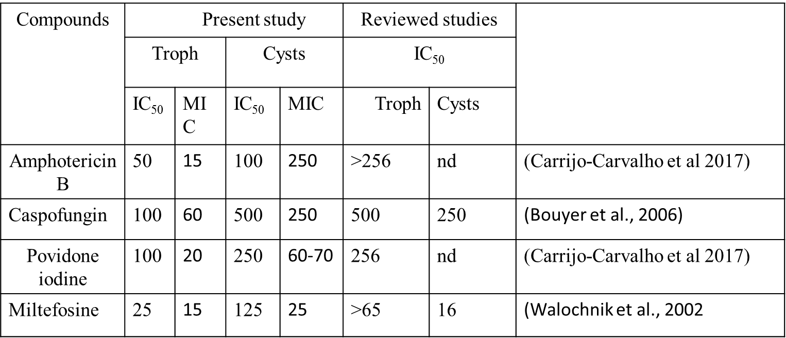

Table. 4.0 The response of *Acanthamoeba* cysts and trophozoites to drugs/ antimicrobial disinfectants showing IC50 and MICs. Data from the methodology from the present study is comparable to other studies, which used other susceptibility assay methods. Results from some studies have the abbreviation (nd) means “no data”. ATP assay method shows information for MIC for *Acanthamoeba* trophozoites for amphotericin B and miltefosine; reviewed studies have no information on this as at the time of data presentation.

## 4.4 *Acanthamoeba* photodynamic therapy Photodynamic therapy

## 4.1.1 Toluidine blue photodynamic therapy

The use of photoactive compounds in combination with the light of specific wavelength has been suggested as a promising therapeutic modality for Acanthamoeba keratitis (Anwar et al., 2017). While most studies have concentrated on the efficacy of photodynamic therapy for the treatment of cancer, there has been a significant result for it use therapeutic use for localised bacteria, fungi and parasitic infections (Lin et al., 2009; Arboleda et al., 2014; Tseng et al., 2017). Only a few studies till date have exploited its application for the treatment of *Acanthamoeba* keratitis (Mito et al., 2012; Siddiqui and Khan, 2012; Corrêa et al., 2016; Wu et al., 2017). The mode of action of photodynamic therapy suggests that there is likely to be reduced resistance by microbes. Preliminary results from toluidine blue photodynamic therapy with methylene blue exclusion assay showed a significant reduction in viability of *Acanthamoeba trophozoites* fig (3.10) see fig 8 of the appendix for microscopy image. Several studies have shown the use of toluidine blue as PS for treatment of oral bacteria infection in rats (Lin et al., 2009). Toluidine blue has also been used for the inactivation of primary human fibroblast (Kashef, Ravaei Sharif Abadi and Djavid, 2012).

Toluidine blue has also found its application for the treatment of keratitis caused by fungi infections (Arboleda et al., 2014). Photodynamic inactivation of *Acanthamoeba* cells using toluidine blue has not been reported before the present research. Our preliminary studies have shown its potential use for the treatment of *Acanthamoeba* keratitis. However, more toxicology studies are needed to confirm its applicability, especially for Acanthamoeba keratitis.

## 4.1.2 Photodynamic therapy using porphyrins.

The four porphyrins used in the present study are structurally different and exhibit different physiochemical properties. All four porphyrins have the same primary structure but with different conjugate-molecules hence their different polarity, ionic state and ultimately different ability to bind or permeate *Acanthamoeba* cells. The localised effect of singlet oxygen produced during photodynamic therapy shows that photodynamic therapy is more effective if the photosensitiser (PS) can penetrate the target cell prior to light delivery (Dai et al., 2013). Subsequently, the singlet oxygen has the ability to attack several intracellular targets like enzymes, lipids and proteins causing bacterial death (Cieplik et al., 2018). However, structural modifications and inherent cell membrane potential of a microbial cell are factors that can limit binding and diffusion of photosensitiser through the cells (Jarlier, 1994; Aharon, Weitman and Ehrenberg, 2011; Benov, 2015). Earlier experiments carried out in the present research showed that the binding strength of all four porphyrins differs. These results suggest that the non-polar and cationic porphyrins have a stronger affinity to *Acanthamoeba* cell wall compared to the polar and anionic porphyrins. In general, the highest binding affinity to *Acanthamoeba* cell wall determined via fluorescence measurement showed that only about 24% affinity was seen after incubation and washing fig 3.23. These results also show that binding of porphyrins to *Acanthamoeba* cell wall is non-specific as percentage affinity to cell wall continued to decrease after several washes. The continuous decrease was seen in both trophozoites and cysts but was more pronounced for the cysts. After 5 washed, the only anionic porphyrin used for this study showed less than 1% bound porphyrins on *Acanthamoeba* cysts cells fig 3.26.

Alves et al., (2009) showed that charge distribution and the number of positive charges, and the meso-substituent have different effects on the photoinactivation of bacteria. A similar report also explained that interaction between cationic PS molecule and the negatively charged bacteria causes widening of the pores leading to enhanced diffusion of photosensitiser inside the cell thereby enhancing the overall photodynamic process (Hurst et al., 2019). No reports on the binding affinity or overall uptake of porphyrins on *Acanthamoeba* cell exists as at the time of this report. Therefore, our discussion is entirely based on our findings and comparison with other studies that have to evaluate the binding and uptake of porphyrins by bacteria cells. Further experiments showed that incubation of porphyrins for a duration of 10 minutes was enough for binding and uptake. Our data shows that diffusion through the cells or binding of porphyrin in *Acanthamoeba* cyst and trophozoites saturates after 10 mins incubation at room temperature. This result is in agreement with an earlier study monitoring the uptake of porphyrins by *Candida albicans* (Quiroga, Alvarez and Durantini, 2010). Quiroga et al (2010) also showed that the cationic porphyrin used for their study reached the highest cell-bound sensitizer after 15 mins incubation and consistent with the present report they suggested that an increase in incubation time did not cause the increase of cell-bound sensitizer after 15 minutes. Furthermore, and in agreement with this report, they showed that there was a decrease in cell-bound porphyrin after each washing step. They concluded that the photodynamic effect of porphyrin was directly proportional to the amount of tightly bound porphyrin on the cell.

Results from the photodynamic treatment of all four porphyrins showed varying degree of efficacy after comparison. 4, 4′, 4′′, 4′′′-(porphine-5, 10, 15, 20-tetryl) tetrakis (benzene sulfonic acid) tetrasodium salt hydrate a water-soluble tetra-anionic porphyrin did not inhibit *Acanthamoeba* cells both the cysts and the trophozoites. An explanation for this can be linked to the binding affinity assay. 4, 4′, 4′′, 4′′′-(porphine-5, 10, 15, 20-tetryl) tetrakis (benzene sulfonic acid) tetrasodium salt hydrate showed the least biding strength compared to all four porphyrins. Less than 4% was taken up by *Acanthamoeba* trophozoites while approximately 0.5 % was recovered from cysts after lysis. This result is similar to an earlier study comparing the ability of cationic and anionic porphyrins to inactivate *Vibrio Campbell* (Malara et al., 2017). Malara and co-workers showed that 4, 4′, 4′′, 4′′′-(porphine-5, 10, 15, 20-tetryl) tetrakis (benzene sulfonic acid) tetrasodium salt hydrate did not show any inhibitory effects on the pathogen. Their result was consistent with an earlier report, which explained that among other factors, that the charge and lipophilicity of a porphyrin significantly affect its photodynamic efficacy (Benov, 2015). Other studies showed that the length of the side chains of meso-substituted porphyrins affected their uptake (Ezzeddine et al., 2013). They further explained that although, electrostatic induction causes the positively charged anionic porphyrin to bind to the target tissue but that at the locality of the lipid bilayer, hydrophobic forces dominate and inhibit permeability

Other studies consistent with this assumption by Ezzeddine, (2013) interestingly showed that the uptake of porphyrins by cells increases by the increasing length of the alkyl chain (Pavani et al., 2009). This study evaluated the properties of several photosensitizers, including their uptake, transport through vesicle and retention inside the cells. Pavani and co-workers reported that even though the photo-physical characteristics of porphyrins are the same, that their uptake by cells is greatly enhanced by their lipophilicity and membrane potential. Pavani et al (2009) showed that the phototoxicity of porphyrins increases proportionately with membrane-binding efficacy. In agreement with all contributions so far (Pavani et al., 2009; Ezzeddine et al., 2013; Benov , 2015; Malara et al., 2017), photodynamic treatment of *Acanthamoeba* cysts and trophozoites with a lipophilic, non-polar cationic porphyrin, 5, 10, 15, 20-tetrakis (1-methyl-4-pyridino) porphyrin tetra (P-toluene sulfonate) showed significant activity . 5, 10, 15, 20-tetrakis (1-methyl-4-pyridino) porphyrin tetra (P-toluene sulfonate), was able to inhibit in a concentration-dependent manner more than 90% trophozoites and about 80% cysts after photodynamic treatment fig 3.29. As seen in fig 3.29, the highest concentration of porphyrin used for this study was not lethal for cysts nor trophozoites. The efficacy of 5, 10, 15, 20-tetrakis (1-methyl-4-pyridino) porphyrin tetra (P-toluene sulfonate) to inhibit *Acanthamoeba* cells can be attributed to its increased cellular uptake observed after the binding strength experiment fig 3.23. Further experiment performed with another non-polar lipophilic cationic porphyrin 5, 10, 15, 20- tetrakis (pentafluorophenyl)-21H, 23H-porphine benzene sulfonic acid showed enhanced photodynamic activity also supported by its superior binding affinity to *Acanthamoeba* cells fig 3.24. 5,10,15,20-Tetrakis(pentafluorophenyl)-21H,23H-porphyrin iron (III) chloride is a non-polar cationic Iron substituted mesoporphyrin. The binding strength of this porphyrin evaluated in the present report was higher than its anionic counterpart’s fig 3.24. (Pavani et al 2009) have explained the reason for this. They showed that Metallo-conjugated porphyrins have enhanced permeability into mammalian cells. The reason for this they explained was enhanced permeability stimulated by metal-phosphate complexes formed by the interaction of Iron with the phosphate in phospholipid bilayer to form Iron phosphate complex. Further experiment with 5, 10, 15, 20-tetraphenyl porphine showed some activity against the trophozoites of *Acanthamoeba* fig 3.35; however, there was no effect on the cysts fig 3.36. This is again is linked to the degree of permeability of photosensitiser through *Acanthamoeba* cells, which was less compared to 5, 10, 15, 20-tetrakis (1-methyl-4-pyridino) porphyrin tetra (P-toluene sulfonate) and 5, 10, 15, 20- tetrakis (pentafluorophenyl)-21H, 23H-porphine Iron (III) chloride. Studies have suggested poor permeability of 5, 10, 15, 20-tetraphenyl porphin through mammalian cells (Skidan, Dholakia and Torchilin, 2008). In this study, 5, 10, 15, 20-tetraphenylporphin was incorporated in a nano-vesicle of polyethene glycol-diacyl lipid micelles to increase permeability through B-16 melanoma thereby increasing photodynamic activity. Results in this report showed that incorporation of 5, 10, 15, 20-tetraphenylporphin in polyethene glycol-diacyl lipid micelles enhanced its solubility by 150 folds compared to 5, 10, 15, 20-tetraphenylporphin alone that was poorly permeable to B-16 melanoma cells. This work further confirmed our hypothesis that the reduced PDT efficacy of 5, 10, 15, 20-tetraphenylporphin could be because of reduced permeability caused by poor solubility.

**CHAPTER FIVE**

CONCLUSION AND FUTURE WORK

# 5.0 Conclusion

**Conclusion and future work**

The search for potent drugs for the treatment of *Acanthamoeba* infections continues to be a challenge to the drug development industries (Khan, Anwar and Siddiqui, 2018). Several studies have shown potential efficacy of a variety of compounds against *Acanthamoeba* (Kuhunkiti, 1997; Liesegang et al., 2002; Carnt et al., 2016; Siddiqui et al., 2016; Padzik et al., 2018; Carpinteyro Sanchez et al., 2019), but further *in-vivo* studies have not been forthcoming. Reports have successfully identified new chemical entities and potential candidate drugs for repurposing against *Acanthamoeba* infections. However, for obvious reasons the large pharmaceuticals companies, whose resources are required to proceed to the next level of drug development, are reluctant to invest. Big pharma’s will rather invest in developing blockbuster drugs, to finance the development of compounds for relatively rare disease. However, considering the continuous increase in contact lens wearers, which is estimated at 125 million in 2004, with 35 million of these people in the USA alone, the contact lens market is booming at an estimated $ 6.1 billion in 2010 and this figure is predicted to get to a staggering $17.6 billion in 2024 (Zion market research, 2018). For a multi-billion industry, it remains unexplainable why the pharmaceutical industries have not invested in *Acanthamoeba* research.

In this study, we showed the potential application of porphyrin based photodynamic therapy for treatment of infections caused by *Acanthamoeba*. Consistent with report by (Hurst et al., 2019), results showed that the non-polar cationic porphyrins were potent photosensitisers than the anionic porphyrins. The binding affinity results showed that the cationic porphyrins had more affinity to *Acanthamoeba* cells compared to the anionic polar porphyrins. Although a maximum of 25 % affinity was recorded there was close to 80% inactivation of *Acanthamoeba* cells (cysts and trophozoites). The reduced permeability of the porphyrins explains why there was not 100 % inactivation of *Acanthamoeba* cells. This suggest that more modifications to enhance permeability of porphyrins is required to get an ideal level of efficacy as less than 95 % efficacy is not acceptable for advance clinical trials. Development of “third generation porphyrin-based sensitizers has been suggested and is underway. Synthesis of these porphyrin will focus on enhancing permeability and targeted delivery using nano-carriers. Numerous studies have shown that incorporating porphyrins to nano-carriers have significantly enhanced efficacy in anti-cancer photodynamic therapy (Yi et al., 2018; Hynek et al., 2018; Mesquita et al., 2018). Rational molecular synthesis, for example, synthesizing porphyrins to increase permeability by maintaining a hydrophilic and lipophilic balance can increase efficacy in antimicrobial photodynamic therapy

During this project, a key element was the use of a robust bioassay to assess the activity of photosensitizer against both life cycle of *Acanthamoeba.* However, I realised that the commonly used viability assay was not adaptable for cyst viability assay. Microscopy was the only viability assay useful for both cysts and trophozoites, but it was labour intensive, not reproducible and not adaptable for high-throughput screening. As part of this work, we adapted the ATP assay for susceptibility testing. The ATP assay gave good sensitivity and excellent reproducibility. The ATP assay has been used to evaluate the viability of other organisms and there is strong evidence of a correlation between microbial counts and ATP levels. Ultimately, the choice between ATP assay and another viability assay will depend largely on the needs and constraints of assay methods. In this case, the ATP assay was most suitable considering the life cycle of *Acanthamoeba.* However, I must reiterate the fact that in addition to viability assay developed we should use the regrowth assay as validation for results of the ATP assay.

However, a limitation of ATP based assay is the cost and table 5.0 shows a comparison of the cost of ATP assay with another viability assay.

|  |  |  |  |  |
| --- | --- | --- | --- | --- |
| Assay type | Applicability | | Cost of assay | HTS systems |
| Trophs | Cysts |
| FDA assay | Yes | No | 20p | Yes |
| Resazurin | Yes | No | 20p | Yes |
| Microscopy | Yes | Yes | 20p | No |
| ATP assay | Yes | Yes | 50p | Yes |
| MTT assay | Yes | No | 20p | Yes |

Table 5.0 Comparison of the applicability cost and adaptability of viability assay considered for the present study.

# Novelty.

Development of the ATP assay based on lysozymes ability to lyse *Acanthamoeba* cysts in a controlled manner was a novel finding. As at the time of writing this report, no study has optimised ATP assay based on enzymatic lysis to be adaptable for cyst viability testing. Some studies, which have tried the ATP based assay on *Acanthamoeba*, concluded it was not useful based on non-repeatability of results which they attributed to lack of controlled lysis approach (Hughes and Kilvington, 2004). In this study they suggested that a controlled lysis approach could enhance development of ATP based assay for Acanthamoeba susceptibility testing.

Another interesting novel finding was the deduction of the approximate amount of ATP contained in a single trophozoite and cyst. This research was the first to attempt to calculate the exact amount of ATP contained in a single *Acanthamoeba* cell. We were able to compare ATP levels for both morphological forms and our calculations (See appendix 8), shows that approximately similar amount of ATP was recovered from trophozoites and cysts (0.5 mM and 0.75 mM) respectively, more experiment needs to be carried out to further validate this result.

# Future work

1. To survey a wider range of porphyrin-based molecules to alter their activity against cysts and trophozoites and from there develop their structural relationship
2. Use the information on structural relationship to synthesize new porphyrins in a strategic and targeted way to increase its activity against *Acanthamoeba*.
3. Evaluate the potential of lysozyme as a prophylactic use in contact lens cleaning solutions. It may also be useful to look at the activity of lysozyme to increase activity against the cysts.
4. Further validation of the data on the ATP level in *Acanthamoeba* cyst and trophozoites using alternative approaches to measure intracellular ATP.

# LIST OF PRESENTATIONS

**Poster Presentations**

1. Annual University of Sunderland Research Conference, held at St. Peters Campus, University of Sunderland, United Kingdom. 7th January 2016.
2. Seventh Academy of Pharmaceutical Society Conference held at the University of Strathclyde, Glasgow, Scotland, and United Kingdom. Five to 7th September 2016.
3. Great North Pharmacy Research Conference 2017 held at the University of Sunderland, Sunderland UK. 21st July/ 2017.
4. Research Conference /Sunderland University 21 / 07 / 2017.
5. Federation of Infection Societies Annual Conference / Birmingham 30 / 11-2 / 12 / 17
6. Society of applied microbiology (SfAM) conference/Birmingham University 23 / 03 / 2018

**Oral Presentation**

1. British Society for Parasitology (BSP) Spring/Aberystwyth University, 08-11 / 04 / 2018.

**Publications in preparation**

1. Novel ATP bioluminescence assay for susceptibility testing of all morphological forms of *Acanthamoeba*
2. Lysozyme specificity for carbohydrate components of *Acanthamoeba* cysts cell wall.

**Appendix 1**

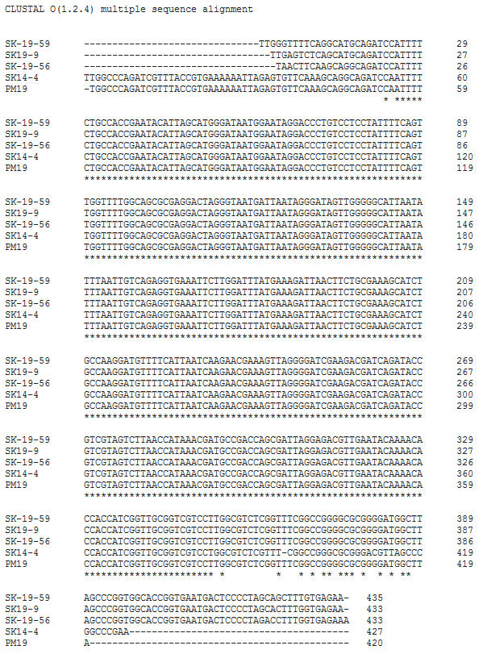

Fig 1 Multiple sequence alignment of *Acanthamoeba* as generated from Cluster Omega software. The sequence alignment was used to generate the dendrogram or family tree of the *Acanthamoeba* isolates. <http://www.clustal.org/omega/>

**Appendix 2**

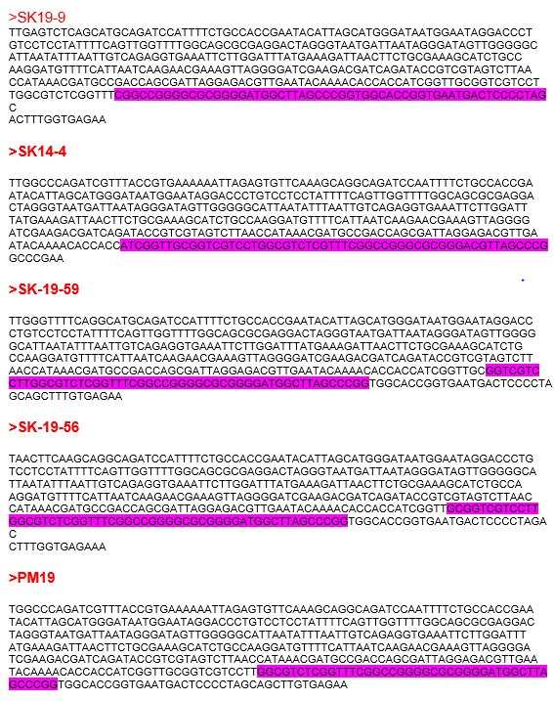

Fig 2 highlighted in pink color are the diagnostic fragment 3 of multiple sequence used to generate the family tree.

**Appendix 3**

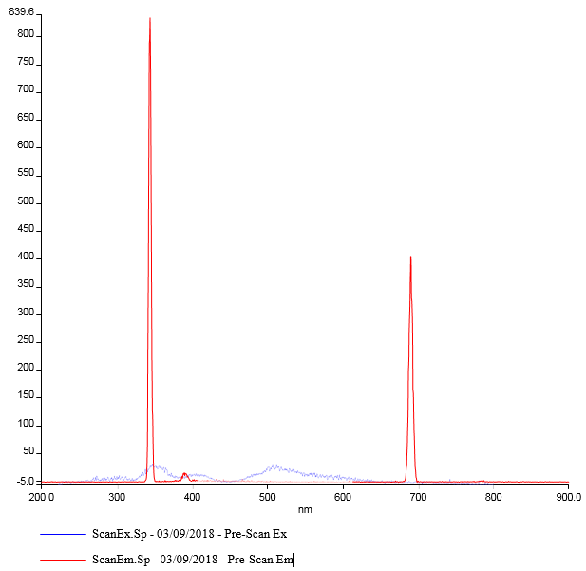

Fig. 3. The excitation and emission wavelength of 5, 10, 15, 20-Tetrakis (4-methyl phenyl)-21H23H porphine.

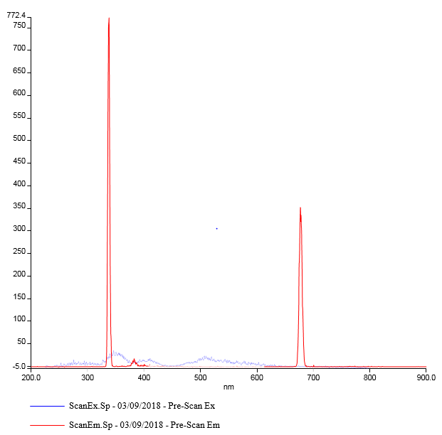

Fig. 4. The excitation and emission wavelength of5, 10, 15, 20- tetrakis (pentafluorophenyl)-21H, 23H-porphine Iron (III) chloride

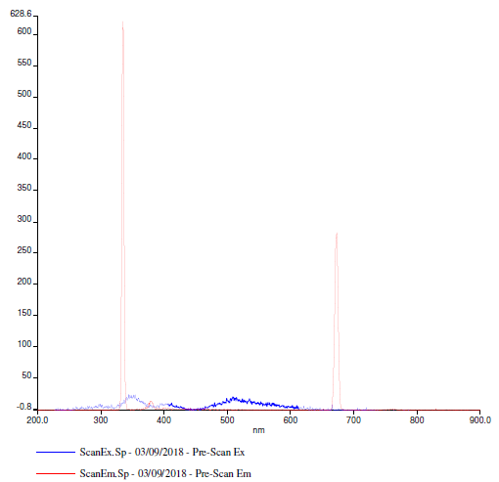

Fig. 5. The excitation and emission wavelength of 4, 4′, 4′′, 4′′′-(porphine-5, 10, 15, 20-tetrayl) tetrakis (benzene sulfonic acid) tetrasodium salt hydrate

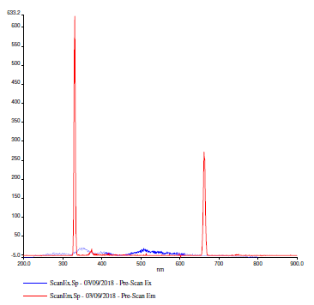

Fig. 6. The excitation and an emission wavelength of 45, 10, 15, 20-tetrakis (1-methyl-4-pyridino) porphyrin tetra (P-toluene sulfonate).

**Appendix 4**

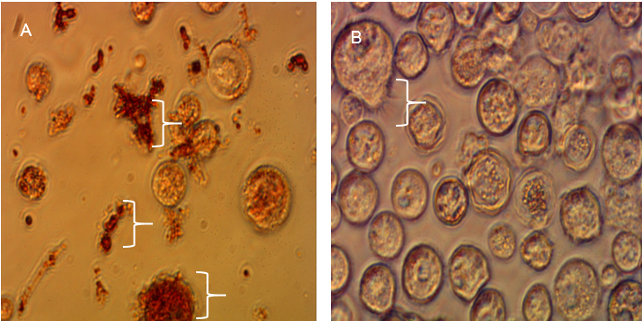

Fig 7. Representative photograph showing the images of *Acanthamoeba* sp. As seen using a light inverted microscope (Nikon, Japan) using 10X objectives. (A) *Acanthamoeba* cysts treated with 50 µM of 5, 10, 15, 20-tetrakis (1-methyl-4-pyridino) porphyrin tetra (P-toluene sulfonate) and exposed to a LED light for 1 hour. The white pointers show what appears to be cell fragments and cells, which appear to have taken up the red colour of the porphyrin. (B) A control sample of cell incubated with the same concentration of porphyrin but protected from LED light using an aluminium foil. The pointer shows *Acanthamoeba* cyst transformation to trophozoites, acanthopodia is visible.

**Appendix 5**

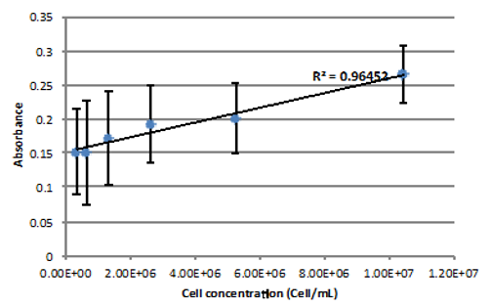

Fig 9 *Acanthamoeba* cell concentration curve using MTT assay to show the relationship between cell number and fluorescence intensity. The error bars show the standard deviation for 4 replicate absorbance measurement

**Appendix 6**

Fig 10 Concentration curve using a different concentration of ATP

**Appendix 7**

A

B

Fig 11 *Acanthamoeba* cell concentration curve. (A) Shows concentration curve for trophozoites while (B) cyst cell concentration curve. Equal concentration of both morphological forms was used to generate curve

**Appendix 8**

To calculate the amount of ATP for a single trophozoite cell?

From the ATP standard curve and the cell concentration curve

**Step-1:** Get the straight-line regression-equation for a high concentration of ATP standard curve.

Applicable Range

RLU range = 7741157 – 36221

Concentration of ATP = 0.0195 – 5 µg/ mL

Regression line, Y = mX + C

Y-axis = RLU (relative luminescence unit) | X-axis = Concentration of ATP (µg/ mL)

C = Y-intercept, m – Slope of the line

The regression equation for 1st graph is, [Range of ATP conc. =

Y = 2E+06x + 34347 (R² = 0.9988)

RLU = 2E+06 [Conc. of ATP, µg/ mL] + 34347

Here, m = 2 x 106, C = 34347

**Step – 2**: Calculate the concentration of ATP

To calculate the concentration of ATP from luminescence we need the previous equation from the standard curve,

RLU = 2E+06 [Conc. of ATP, µg/ mL] + 34347

Re-arranging the equation, we get

[Conc. of ATP, µg/ mL] = (RLU – 34347) / (2 x 106)

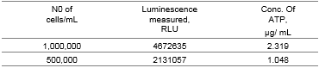

The reaction that produced the bioluminescence from *Acanthamoeba* is,

*Acanthamoeba*, [x cells/ mL] = 50 µL

Luciferase enzyme + D-Luciferin salt = 50 µL

Total volume = 100 µL

The reaction, which produce bioluminescence from *Acanthamoeba*, is

That is, the reaction used for ATP standard

ATP [x µg/mL] = 50 µL

Luciferase enzyme + D-Luciferin salt = 50 µL

Total volume = 100 µL

**Step-3**: Calculating the number of ATP per cell

For example,

When the concentration of pathogen was 1,000,000 cell/ mL

And if 50 µL (0.05 mL) of the pathogen solution was used for the assay,

Then the total number of pathogens = 1,000,000 $\frac{cells}{mL}$ x 0.05 mL = 50,000 cells

Therefore, 50,000 cells produced 4672635 RLU of luminescence.

This corresponds to 2.319 µg/ mL of ATP

So, the total mass of ATP in *Acanthamoeba* trophozoites

= 2.319 $\frac{µg}{mL}$ x 0.05~~mL~~= 0.11595 $µg$ of ATP this means,

50,000 cells has 0.11595 $µg$ of ATP

= $\frac{0.11595 µg}{ 551.14 g/mol}$ = 210 x 10-6 µmols= 210 pmol = 2.1 x 10-10mols

Calculating the amount of ATP in a single cell

$$\frac{0.11595 µg}{ 50000 cell}$$

= 2.319 X 10-6 which is equivalent to 2.319 pg. ATP/ cell

Considering the volume of the trophozoite cell which is spherical an appx (25 µm)

And using the equation for calculating the volume of the cyst

V = $4π\frac{r3}{3}$ we have 8181 µm3

Then converting µm3 – litres (1 µm3 x 1 x 10-15)

=

= 0.000283 (2.83 x 10-4 pg /

Converting to gram

2.83 x 10-16 g / µm3= 0.283 g/l x 10-15

= 0.5 mM in a single Trophozoite cell.

**To calculate the amount of ATP for a single cyst cell**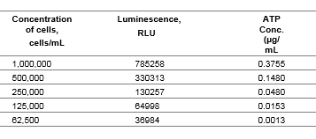

When the concentration of pathogen was 1,000,000 cell/ mL

And if 50 µL (0.05 mL) of *Acanthamoeba* cell suspension was used for the assay, then the total number of pathogens =

1,000,000 $\frac{cells}{mL}$ x 0.05 mL = 50,000 cells

Therefore, 50,000 cells produced 785258 RLU of luminescence.

This corresponds to 0.3754555 µg/ mL of ATP

So, the total mass of ATP in the pathogen solution

= 0.3754555 $\frac{µg}{mL}$ x 0.05~~mL~~= 0.018772775 $µg$ of ATP

This means,

50,000 cells has 0.018772775 $µg$ of ATP

= $\frac{0.018772775µg}{ 551.14 g/mol}$ = 34.0 x 10-6 µmols

= 34 pmol = 0.34 x 10-10mols of ATP

Following similar calculation for the trophozoites

$$\frac{0.018772 µg}{50 000}$$

= 3.754 x 10-7 µg x 106

= 0.3754 pg / cyst

Calculating volume considering size of the cysts (12 µm) with similar equation

V = $4π\frac{r3}{3}$ $\frac{0.3754 pg}{905 µm3}$

= 4.15 x 10-4 pg / µm3

Converting pg to g (x 1012)

= 4.15 x 10-16 ATP / µm3

Converting µm3 to litre (x 10-15)

= 0.415 g ATP/ l divided by the formula weight ATP

=7.53 x 10-4 Molar ATP

7.53 x 10-4 x 1000

= 0.75 mM ATP

**One way anova statistical analysis of significant variation between acanthamoeba sample exposed to or protected from PDT.**

**5,10,15,20-Tetrakis(pentafluorophenyl)-21H,23H-porphyrin iron(III) chloride**





**5, 10, 15, 20-tetrakis (1-methyl-4-pyridino) porphyrin tetra (P-toluene sulfonate).**





**5,10,15,20-Tetrakis(4-methylphenyl)-21H23H porphine**





**4, 4′, 4′′, 4′′′-(porphine-5, 10, 15, 20-tetrayl) tetrakis (benzene sulfonic acid) tetrasodium salt hydrate**





**References**

Abdelkader, A. (2014). Cosmetic soft contact lens-associated ulcerative keratitis in Southern Saudi Arabia. *Middle East African Journal of Ophthalmology*, 21(3), p.232.

Abdel-Latif, M., El-Far, A., Elbestawy, A., Ghanem, R., Mousa, S. and Abd El-Hamid, H. (2017). Exogenous dietary lysozyme improves the growth performance and gut microbiota in broiler chickens targeting the antioxidant and non-specific immunity mRNA expression. *PLOS ONE*, 12(10), p.e0185153.

Abe, K. and Matsuki, N. (2000). Measurement of cellular 3-(4,5-dimethylthiazol-2-yl)-2,5-diphenyltetrazolium bromide (MTT) reduction activity and lactate dehydrogenase release using MTT. *Neuroscience Research*, 38(4), pp.325-329.

Abrahamse, H. and Hamblin, M. (2016). New photosensitizers for photodynamic therapy. *Biochemical Journal*, 473(4), pp.347-364.

Aftab Khan, M., Aftab, S., Shams, N. and Ullah Khan, R. (2019). Efficacy of photodynamic therapy in the treatment of cutaneous leishmaniasis. *The Professional Medical Journal*, 26(06).

Aharon, D., Weitman, H. and Ehrenberg, B. (2011). The effect of liposomes’ surface electric potential on the uptake of hematoporphyrin. *Biochimica et Biophysica Acta (BBA) - Biomembranes*, 1808(8), pp.2031-2035.

Akimoto, J., Fukami, S., Ichikawa, M., Mohamed, A. and Kohno, M. (2019). Intraoperative Photo diagnosis for Malignant Glioma Using Photosensitizer Talaporfin Sodium. *Frontiers in Surgery*, 6, pp. 3 - 6.

Alcorlo, M., Martínez-Caballero, S., Molina, R. and Hermoso, J. (2017). Carbohydrate recognition and lysis by bacterial peptidoglycan hydrolases. *Current Opinion in Structural Biology*, 44, pp.87-100.

Alharbi, A., La Hood, D. and Swarbrick, H. (2005). Overnight Orthokeratology Lens Wear Can Inhibit the Central Stromal Edema Response. *Investigative Opthalmology & Visual Science*, 46(7), p.2334.

Alizadeh, H., Tripathi, T., Abdi, M. and Smith, A. (2014). TLR4 and Initiated Inflammatory Responses in the Cornea recognize pathogenic Strains of Acanthamoeba. *PLoS ONE*, 9(3), p.e92375. Lakhundi, S., Siddiqui, R. and Khan, N. (2017). Pathogenesis of microbial keratitis. *Microbial Pathogenesis*, 104, pp.97-109.

Alkharashi, M., Lindsley, K., Law, H. and Sikder, S. (2015). Medical interventions for Acanthamoeba keratitis. *Cochrane Database of Systematic Reviews*, 9(2), pp.18-21.

Alves, E., Costa, L., Carvalho, C., Tomé, J., Faustino, M., Neves, M., Tomé, A., Cavaleiro, J., Cunha, Â. and Almeida, A. (2009). Charge effect on the photoinactivation of Gram-negative and Gram-positive bacteria by cationic meso-substituted porphyrins. *BMC Microbiology*, 9(1), p.70.

Andrade, C., Figueiredo, R., Ribeiro, K., Souza, L., Sarmento-Neto, J., Rebouças, J., Santos, B., Ribeiro, M., Carvalho, L. and Fontes, A. (2018). Photodynamic effect of zinc porphyrin on the promastigote and amastigote forms of Leishmania braziliensis. *Photochemical & Photobiological Sciences*, 17(4), pp.482-490.

Ansari, S., Battogtokh, G., Wen, L., Bae, S. and Ahn, W. (2011). Synthesis of the chlorin-based fatty acid conjugate as a photosensitizer for photodynamic therapy. *Photodiagnosis and Photodynamic Therapy*, 8(2), p.194.

Anwar, A., Khan, N. and Siddiqui, R. (2018). Combating Acanthamoeba spp. cysts: what are the options? *Parasites & Vectors*, 11(1).

Anwar, A., Siddiqui, R., Hussain, M., Ahmed, D., Shah, M. and Khan, N. (2017). Silver nanoparticle conjugation affects antiacanthamoebic activities of amphotericin B, nystatin, and fluconazole. *Parasitology Research*, 117(1), pp.265-271.

Aqeel, Y., Siddiqui, R., Anwar, A., Shah, M., Khoja, S. and Khan, N. (2015). Photochemotherapeutic Strategy against Acanthamoeba Infections. *Antimicrobial Agents and Chemotherapy*, 59(6), pp.3031-3041.

Arboleda, A., Miller, D., Cabot, F., Taneja, M., Aguilar, M., Alawa, K., Amescua, G., Yoo, S. and Parel, J. (2014). Assessment of Rose Bengal Versus Riboflavin Photodynamic Therapy for Inhibition of Fungal Keratitis Isolates. *American Journal of Ophthalmology*, 158(1), pp.64-70.

Ardito, F., Giuliani, M., Perrone, D., Troiano, G. and Muzio, L. (2017). The crucial role of protein phosphorylation in cell signaling and its use as targeted therapy (Review). *International Journal of Molecular Medicine*, 40(2), pp.271-280.

Armour, A., Powell, H. and Boyce, S. (2008). Fluorescein Diacetate for Determination of Cell Viability in Tissue-Engineered Skin. *Tissue Engineering Part C: Methods*, 14(1), pp.89-96.

Arnalich-Montiel, F., Reyes-Batlle, M., López-Vélez, R. and Lorenzo-Morales, J. (2018). Treatment of intraocular spread of acanthamoeba after tectonic corneal graft in acanthamoeba keratitis. *Eye*, 32(7), pp.1286-1287.

Arne L. and Anders T. (1975). Comparison of methods for extraction of bacterial adenine nucleotides determined by firefly assay. *Journal of applied microbiology*, 30(5), pp 713-721.

Aslantürk, Ö. (2018). In Vitro Cytotoxicity and Cell Viability Assays: Principles, Advantages, and Disadvantages. *Geno toxicity - A Predictable Risk to Our Actual* World.

Asoklis, R. (2017). Contact lens-related corneal infections. *Acta Ophthalmologica*, 95.

Asoklis, R. (2017). Contact lens-related corneal infections. *Acta Ophthalmologica*, 95. Augustyniak, E., Adam, A., Wojdyla, K., Rogowska-Wrzesinska, A., Willetts, R., Korkmaz, A., Atalay, M., Weber, D., Grune, T., Borsa, C., Gradinaru, D., Chand Bollineni, R., Fedorova, M. and Griffiths, H. (2015). Validation of protein carbonyl measurement: A multi-centre study. *Redox Biology*, 4, pp.149-157.

Augustyniak, E., Adam, A., Wojdyla, K., Rogowska-Wrzesinska, A., Willetts, R., Korkmaz, A., Atalay, M., Weber, D., Grune, T., Borsa, C., Gradinaru, D., Chand Bollineni, R., Fedorova, M. and Griffiths, H. (2015). Validation of protein carbonyl measurement: A multi-centre study. *Redox Biology*, 4, pp.149-157.

Augustyniak, E., Adam, A., Wojdyla, K., Rogowska-Wrzesinska, A., Willetts, R., Korkmaz, A., Atalay, M., Weber, D., Grune, T., Borsa, C., Gradinaru, D., Chand Bollineni, R., Fedorova, M. and Griffiths, H. (2015). Validation of protein carbonyl measurement: A multi-centre study. *Redox Biology*, 4, pp.149-157.

Ayala, A., Muñoz, M. and Argüelles, S. (2014). Lipid Peroxidation: Production, Metabolism, and Signaling Mechanisms of Malondialdehyde and 4-Hydroxy-2-Nonenal. *Oxidative Medicine and Cellular Longevity*, 2014, pp.1-31.

Badenoch, P. (1991). The pathogenesis of Acanthamoeba keratitis. *Australian and New Zealand Journal of Ophthalmology*, 19(1), pp.9-20.

Bagga, B., Joseph, J., Garg, P., Chandran, K., Jayabhasker, P., Manjulatha, K. and Sharma, S. (2018). Efficacy of Topical Miltefosine in Patients with Acanthamoeba Keratitis: A Pilot Study. *Ophthalmology*.

Baig, A., Iqbal, J. and Khan, N. (2013). In VitroEfficacies of Clinically Available Drugs against Growth and Viability of an Acanthamoeba castellanii Keratitis Isolate Belonging to the T4 Genotype. *Antimicrobial Agents and Chemotherapy*, 57(8), pp.3561-3567.

Bairagi, SH. (2017). Acanthamoeba Keratitis: Diagnosis and Treatment. J Rare Disord Diagn Ther. Vol. 3 No. pp 4-8.

Bajerski, F., Stock, J., Hanf, B., Darienko, T., Heine-Dobbernack, E., Lorenz, M., Naujox, L., Keller, E., Schumacher, H., Friedl, T., Eberth, S., Mock, H., Kniemeyer, O. and Overmann, J. (2018). ATP Content and Cell Viability as Indicators for Cryostasis across the Diversity of Life. *Frontiers in Physiology*, 9.

Balouiri, M., Sadiki, M. and Ibnsouda, S. (2016). Methods for in vitro evaluating Antimicrobial activity: A review. *Journal of Pharmaceutical Analysis*, 6(2), pp.71-79.

Bandyopadhyay, U., Das, D., & Banerjee, R. (1999). Reactive oxygen species: Oxidative damage and pathogenesis. *Current Science,* *77*(5), 658-666. Retrieved from http://www.jstor.org/stable/24102839 Amescua, G., Arboleda, A., Nikpoor, N., Durkee, H., Relhan, N., Aguilar, M., Flynn, H., Miller, D. and Parel, J. (2017). Rose Bengal Photodynamic Antimicrobial Therapy. *Cornea*, 36(9), pp.1141-1144.

Banfi, S., Caruso, E., Buccafurni, L., Battini, V., Zazzaron, S., Barbieri, P. and Orlandi, V. (2006). Antibacterial activity of tetraaryl-porphyrin photosensitizers: An in vitro study on Gram-negative and Gram-positive bacteria. *Journal of Photochemistry and Photobiology B: Biology*, 85(1), pp.28-38.

Baptista, M., Cadet, J., Di Mascio, P., Ghogare, A., Greer, A., Hamblin, M., Lorente, C., Nunez, S., Ribeiro, M., Thomas, A., Vignoni, M. and Yoshimura, T. (2017). Type I and Type II Photosensitized Oxidation Reactions: Guidelines and Mechanistic Pathways. *Photochemistry and Photobiology*, 93(4), pp.912-919.

Barolet, D. (2008). Light-Emitting Diodes (LEDs) in Dermatology. *Seminars in Cutaneous Medicine and Surgery*, 27(4), pp.227-238.

Barrera, G. (2012). Oxidative Stress and Lipid Peroxidation Products in Cancer Progression and Therapy. *ISRN Oncology*, 2012, pp.1-21.

Bellnier, D., Greco, W., Loewen, G., Nava, H., Oseroff, A. and Dougherty, T. (2006). Clinical Pharmacokinetics of the PDT Photosensitizers Porfimer Sodium (Photofrin), 2-[1-Hexyloxyethyl]-2-Devinyl Pyropheophorbide-a (Photochlor) and 5-ALA-Induced Protoporphyrin IX. *Lasers in Surgery and Medicine*, 38(5), pp.439-444.

Benov, L. (2015). Photodynamic Therapy: Status and Future Directions. *Medical Principles and Practice*, 24(s1), pp.14-28.

Berk, S. and Garduño, R. (2012). The Tetrahymena and Acanthamoeba Model Systems. *Methods in Molecular Biology*, pp.393-416.

Berridge, M., Herst, P. and Tan, A. (2005). Tetrazolium dyes as tools in cell biology: New insights into their cellular reduction. *Biotechnology Annual Review*, pp.127-152.

Bheri, M. and Pandey, G. (2018). Protein phosphatases meet reactive oxygen species in plant signalling networks. *Environmental and Experimental Botany*.

Birsoy, K., Wang, T., Chen, W., Freinkman, E., Abu-Remaileh, M. and Sabatini, D. (2015). An Essential Role of the Mitochondrial Electron Transport Chain in Cell Proliferation Is to Enable Aspartate Synthesis. *Cell*, 162(3), pp.540-551.

Bliss, J., Bigelow, C., Foster, T. and Haidaris, C. (2004). Susceptibility of Candida Species to Photodynamic Effects of Photofrin. *Antimicrobial Agents and Chemotherapy*, 48(6), pp.2000-2006.

Bonnier, F., Keating, M., Wróbel, T., Majzner, K., Baranska, M., Garcia-Munoz, A., Blanco, A. and Byrne, H. (2015). Cell viability assessment using the Alamar blue assay: A comparison of 2D and 3D cell culture models. *Toxicology in Vitro*, 29(1), pp.124-131.

Bouyer, S., Imbert, C., Daniault, G., Cateau, E. and Rodier, M. (2006). Effect of caspofungin on trophozoites and cysts of three species of Acanthamoeba. *Journal of Antimicrobial Chemotherapy*, 59(1), pp.122-124.

Brasseur, G., Favennec, L., Perrine, D., Chenu, J. and Brasseur, P. (1994). Successful Treatment of Acanthamoeba Keratitis by Hexamidine. *Cornea*, 13(5), pp.459-462.

Brehm-Stecher, B. and Johnson, E. (2004). Single-Cell Microbiology: Tools, Technologies, and Applications. *Microbiology and Molecular Biology Reviews*, 68(3), pp.538-559.

Bristow, C., Hudson, R., Paget, T. and Boyle, R. (2006). Potential of cationic porphyrins for photodynamic treatment of cutaneous Leishmaniasis. *Photodiagnosis and Photodynamic Therapy*, 3(3), pp.162-167.

Brocious, J., Tarver, M., Hampton, D. and Eydelman, M. (2018). Acanthamoeba. *Eye & Contact Lens: Science & Clinical Practice*, 44(6), pp.351-354.

Brown, A., Ross, J., Jones, D., Collier, S., Ayers, T., Hoekstra, R., Backensen, B., Roy, S., Beach, M. and Yoder, J. (2017). Risk Factors for Acanthamoeba Keratitis—A Multistate Case-Control Study, 2008–2011. *Eye & Contact Lens: Science & Clinical Practice*, p.1.

Brown, R. and Audet, J. (2008). Current techniques for single-cell lysis. *Journal of The Royal Society Interface*, 5(suppl_2).

Cabello-Vílchez, A., Martín-Navarro, C., López-Arencibia, A., Reyes-Batlle, M., Sifaoui, I., Valladares, B., Piñero, J. and Lorenzo-Morales, J. (2013). Voriconazole as a first-line treatment against potentially pathogenic Acanthamoeba strains from Peru. Parasitology Research, 113(2), pp.755-759.

Cadet, J. and Wagner, J. (2013). DNA Base Damage by Reactive Oxygen Species, Oxidizing Agents, and UV Radiation. *Cold Spring Harbor Perspectives in Biology*, 5(2), pp.a012559-a012559.

Caldecott, K. (2003). DNA Single-Strand Break Repair and Spinocerebellar Ataxia. *Cell*, 112(1), pp.7-10.

Callewaert, L. and Michiels, C. (2010). Lysozymes in the animal kingdom. *Journal of Biosciences*, 35(1), pp.127-160.

Canelas, A., ten Pierick, A., Ras, C., Seifar, R., van Dam, J., van Gulik, W. and Heijnen, J. (2009). Quantitative Evaluation of Intracellular Metabolite Extraction Techniques for Yeast Metabolomics. *Analytical Chemistry*, 81(17), pp.7379-7389.

Cao, Z., Jefferson, D. and Panjwani, N. (1998). Role of Carbohydrate-mediated Adherence in Cytopathogenic Mechanisms acanthamoeba. *Journal of Biological Chemistry*, 273(25), pp.15838-15845.

Carnt, N., Hoffman, J., Verma, S., Hau, S., Radford, C., Minassian, D. and Dart, J. (2018). *Acanthamoeba* keratitis: confirmation of the UK outbreak and a prospective case-control study identifying contributing risk factors. *British Journal of Ophthalmology*, 102(12), pp.1621-1628.

Carnt, N., Robaei, D., Watson, S., Minassian, D. and Dart, J. (2016). The Impact of Topical Corticosteroids Used in Conjunction with Antiamoebic Therapy on the Outcome of Acanthamoeba Keratitis. Ophthalmology, 123(5), pp.984-990.

Carpinteyro Sanchez, A., Scott, F., Suckling, C. and Roberts, C. (2019). Development of antimicrobials against Acanthamoeba. *Access Microbiology*, 1(1A), pp 1.

Carrijo-Carvalho, L., Sant'ana, V., Foronda, A., de Freitas, D. and de Souza Carvalho, F. (2017). Therapeutic agents and biocides for ocular infections by free-living amoebae of Acanthamoeba genus. *Survey of Ophthalmology*, 62(2), pp.203-218.

Castano, A., Demidova, T. and Hamblin, M. (2004). Mechanisms in photodynamic therapy: part one-photosensitizers, photochemistry and cellular localization. *Photodiagnosis and Photodynamic Therapy*, 1(4), pp.279-293.

Castellani, A. (1930). Amoeba found in culture of yeast. *Journal of Tropical Medicine and hygiene,* 33 (11), pp. 188-191.

Celik, A. and Saydan, N. (2011). Polymeric nanoparticles as an efficient delivery system for phthalocyanine-based photosensitizers in photodynamic therapy (PDT). *Photodiagnosis and Photodynamic Therapy*, 8(2), p.206.

Chaidaroon, W. and Supalaset, S. (2016). Corneal Ring Infiltrates Caused by *Serratia marcescensin* a Patient with Human Immunodeficiency Virus. *Case Reports in Ophthalmology*, 7(2), pp.359-363.

Chan, G., Kleinheinz, T., Peterson, D. and Moffat, J. (2013). A Simple High-Content Cell Cycle Assay Reveals Frequent Discrepancies between Cell Number and ATP and MTS Proliferation Assays. *PLoS ONE*, 8(5), p.e63583.

Chatterjee S R, Posse l H, Srivatsava T S, Kamal J P, Wolf G & Devasagayam T P A., (1999). Photodynamic effects induced by meso-tetrakis(4-(carboxymethyleneoxy)pheny l) porphyrin on isolated sarcoma-I 80 ascites mitochondria, J Photo-chem Photobiol B Biol, 50 79.

Chelkha, N., Colson, P., Levasseur, A. and La Scola, B. (2018). Deciphering the genomes of 16 Acanthamoeba species does not provide evidence of integration of known giant virus-associated mobile genetic elements. *Virus Research*, 251, pp.14-16.

Chen, Y. and Xia, X. (2016). Comparison of the Orbscan II topographer and the iTrace aberrometer for the measurements of keratometry and corneal diameter in myopic patients. *BMC Ophthalmology*, 16(1).

Chida, J. and Kido, H. (2013). Extraction and Quantification of Adenosine Triphosphate in Mammalian Tissues and Cells. *Methods in Molecular Biology*, pp.21-32.

Chida, J., Yamane, K., Takei, T. and Kido, H. (2012). An efficient extraction method for the quantitation of adenosine triphosphate in mammalian tissues and cells. *Analytica Chimica Acta*, 727, pp.8-12.

Chomicz, L., Szaflik, J., Padzik, M. and Izdebska, J. (2016). Acanthamoeba Keratitis: The Emerging Vision-Threatening Corneal Disease. Advances in Common Eye Infections.

Chrisman, C., Alvarez, M. and Casadevall, A. (2010). Phagocytosis of Cryptococcus neoformans by, and Nonlytic Exocytosis from, Acanthamoeba castellanii. *Applied and Environmental Microbiology*, 76(18), pp.6056-6062.

Cieplik, F., Deng, D., Crielaard, W., Buchalla, W., Hellwig, E., Al-Ahmad, A. and Maisch, T. (2018). Antimicrobial photodynamic therapy – what we know and what we do not. *Critical Reviews in Microbiology*, 44(5), pp.571-589.

Cieplik, F., Späth, A., Regensburger, J., Gollmer, A., Tabenski, L., Hiller, K.- A., et al. (2013b). Photodynamic biofilm inactivation by SAPYR-An exclusive singlet oxygen photosensitizer. Free Radic. Biol. Med. 65, 477–487.

Clarke, B., Sinha, A., Parmar, D. and Sykakis, E. (2012). Advances in the Diagnosis and Treatment of Acanthamoeba Keratitis. *Journal of Ophthalmology*, 2012, pp.1-6.

Clarke, J., Gillings, M., Altavilla, N. and Beattie, A. (2001). Potential problems with fluorescein diacetate assays of cell viability when testing natural products for antimicrobial activity. *Journal of Microbiological Methods*, 46(3), pp.261-267.

Collins, T. L., Markus, E. A., Hassett, D. J., and Robinson, J. B. (2010). The effect of a cationic porphyrin on Pseudomonas aeruginosa biofilms.Curr. Microbiol. 61,411–416

Corrêa, T., Geralde, M., Carvalho, M., Bagnato, V., Kurachi, C. and de Souza, C. (2016). Photodynamic inactivation ofAcanthamoeba polyphagia with curcuminoids: anin Vitro study. *Optical Methods for Tumor Treatment and Detection: Mechanisms and Techniques in Photodynamic Therapy XXV*.

Culbertson, C., Smith, J. and Minner, J. (1958). *Acanthamoeba*: Observation on animal Pathogenicity. Science, 127(3313), pp. 1506-1506.

Cury, E., Chang, M. and Pontes, E. (2018). Non-viral microbial keratitis in adults: clinical and laboratory aspects. *Brazilian Journal of Microbiology*, 49, pp.205-212.

Czekanska, E. (2011). Assessment of Cell Proliferation with Resazurin-Based Fluorescent Dye. *Methods in Molecular Biology*, pp.27-32.

Dai, Z., Tian, L., Xiao, Y., Ye, Z., Zhang, R. and Yuan, J. (2013). A cell-membrane-permeable europium complex as an efficient luminescent probe for singlet oxygen. *Journal of Materials Chemistry B*, 1(7), p.924.

Dan Dunn, J., Alvarez, L., Zhang, X. and Soldati, T. (2015). Reactive oxygen species and mitochondria: A nexus of cellular homeostasis. *Redox Biology*, 6, pp.472-485.

Das, K. and Roychoudhury, A. (2014). Reactive oxygen species (ROS) and the response of antioxidants as ROS-scavengers during environmental stress in plants. *Frontiers in Environmental Science*, 2.

De Craene, S., Knoeri, J., Georgeon, C., Kestelyn, P. and Borderie, V. (2018). Assessment of Confocal Microscopy for the Diagnosis of Polymerase Chain Reaction–Positive Acanthamoeba Keratitis. *Ophthalmology*, 125(2), pp.161-168.

De Moraes, J. and Alfieri, S. (2008). Growth, encystment and survival of Acanthamoeba castellanii grazing on different bacteria. FEMS Microbiology Ecology, 66(2), pp.221-229.

Dekina, S. (2015). ISOLATION AND PURIFICATION OF LYSOZYME FROM THE HEN EGG WHITE. *Biotechnologia Acta*, 8(6), pp.41-47.

Di Poto, A., Sbarra, M. S., Provenza, G., Visai, L., and Speziale, P. (2009). The effect of photodynamic treatment combined with antibiotic action or host defence mechanisms on Staphylococcus aureus biofilms. Biomaterials 30, 3158–3166.

Ding, H., Yu, H., Dong, Y., Tian, R., Huang, G., Boothman, D., Sumer, B. and Gao, J. (2011). Photoactivation switch from type II to type I reactions by electron-rich micelles for improved photodynamic therapy of cancer cells under hypoxia. *Journal of Controlled Release*, 156(3), pp.276-280.

Dos Santos, A., Terra, L., Wailemann, R., Oliveira, T., Gomes, V., Mineiro, M., Meotti, F., Bruni-Cardoso, A., Baptista, M. and Labriola, L. (2017). Methylene blue photodynamic therapy induces selective and massive cell death in human breast cancer cells. *BMC Cancer*, 17(1).

Dougherty, T., Gomer, C., Henderson, B., Jori, G., Kessel, D., Korbelik, M., Moan, J. and Peng, Q. (1998). Photodynamic Therapy. *JNCI Journal of the National Cancer Institute*, 90(12), pp.889-905.

Doughty, M. and Jonuscheit, S. (2018). Corneal structure, transparency, thickness and optical density (densitometry), especially as relevant to contact lens wear—a review. *Contact Lens and Anterior Eye*.

Douglas, M. (1930). Notes on the classification of the amoeba found by *Castellani* on culture of a yeast-like fungus. J Trop Med Hyg, 33 pp.258–59.

Du, J., Daniels, D., Asbury, C., Venkataraman, S., Liu, J., Spitz, D., Oberley, L. and Cullen, J. (2006). Mitochondrial Production of Reactive Oxygen Species Mediate Dicumarol-induced Cytotoxicity in Cancer Cells. *Journal of Biological Chemistry*, 281(49), pp.37416-37426.

Duarte, J., Furst, C., Klisiowicz, D., Klassen, G. and Costa, A. (2013). Morphological, genotypic, and physiological characterization of Acanthamoeba isolates from keratitis patients and the domestic environment in Vitoria, Espírito Santo, Brazil. *Experimental Parasitology*, 135(1), pp.9-14.

Dudley, R., Alsam, S. and Khan, N. (2007). Cellulose biosynthesis pathway is a potential target in the improved treatment of Acanthamoeba keratitis. *Applied Microbiology and Biotechnology*, 75(1), pp.133-140.

Dupuy, M., Berne, F., Herbelin, P., Binet, M., Berthelot, N., Rodier, M., Soreau, S. and Héchard, Y. (2014). The sensitivity of free-living amoeba trophozoites and cysts to water disinfectants. *International Journal of Hygiene and Environmental Health*, 217(2-3), pp.335-339.

Elson, A. (2018). Stepping out of the shadows: Oncogenic and tumour-promoting protein tyrosine phosphatases. *The International Journal of Biochemistry & Cell Biology*, 96, pp.135-147.

Evans, M., Dizdaroglu, M. and Cooke, M. (2004). Oxidative DNA damage and disease: induction, repair and significance. *Mutation Research/Reviews in Mutation Research*, 567(1), pp.1-61.

Ezzeddine, R., Al-Banaw, A., Tovmasyan, A., Craik, J., Batinic-Haberle, I. and Benov, L. (2013). Effect of Molecular Characteristics on Cellular Uptake, Subcellular Localization, and Phototoxicity of Zn (II) N-Alkylpyridylporphyrins. *Journal of Biological Chemistry*, 288(51), pp.36579-36588.

Fasciani, R., Brocca, D., Agresta, A., Grimaldi, G. and Caporossi, A. (2018). Acanthamoeba Ocular Infection: Anomalous Presentation of a Potentially Vision-Threatening Condition. *SN Comprehensive Clinical Medicine*, 1(2), pp.113-117.

Ferrari, G., Matuska, S. and Rama, P. (2011). Double-Biguanide Therapy for Resistant <i>Acanthamoeba </i>Keratitis. Case Reports in Ophthalmology, 2(3), pp.338-342.

Fitzgibbons, P., Bradley, L., Fatheree, L., Alsabeh, R., Fulton, R., Goldsmith, J., Haas, T., Karabakhtsian, R., Loykasek, P., Marolt, M., Shen, S., Smith, A. and Swanson, P. (2014). Principles of Analytic Validation of Immunohistochemical Assays: Guideline from the College of American Pathologists Pathology and Laboratory Quality Center. *Archives of Pathology & Laboratory Medicine*, 138(11), pp.1432-1443.

Foster, S. (2015). Bacterial Cell Wall Peptidoglycan Architecture and Dynamics. *Biophysical Journal*, 108(2), pp.198a-199a.

Fouque, E., Trouilhé, M., Thomas, V., Hartemann, P., Rodier, M. and Héchard, Y. (2012). Cellular, Biochemical, and Molecular Changes during Encystment of Free-Living Amoebae. *Eukaryotic Cell*, 11(4), pp.382-387.

Fukai, T. and Ushio-Fukai, M. (2011). Superoxide Dismutases: Role in Redox Signaling, Vascular Function, and Diseases. *Antioxidants & Redox Signaling*, 15(6), pp.1583-1606.

Garajová, M., Mrva, M., Vaškovicová, N., Martinka, M., Melicherová, J. and Valigurová, A. (2019). Cellulose fibrils formation and organisation of cytoskeleton during encystment are essential for Acanthamoeba cyst wall architecture. *Scientific Reports*, 9(1).

Garg, P., Kalra, P. and Joseph, J. (2017). Non-contact lens related Acanthamoeba keratitis. *Indian Journal of Ophthalmology*, 65(11), p.1079.

Garland, M., Cassidy, C., Woolfson, D. and Donnelly, R. (2009). Designing photosensitizers for photodynamic therapy: strategies, challenges and promising developments. *Future Medicinal Chemistry*, 1(4), pp.667-691.

Gatti, S., Cevini, C., Bruno, A., Penso, G., Rama, P. and Scaglia, M. (1998). In Vitro Effectiveness of Povidone-Iodine onAcanthamoeba Isolates from Human Cornea. *Antimicrobial Agents and Chemotherapy*, 42(9), pp.2232-2234.

Gilquin, B., Guilbert, C. and Perahia, D. (2000). Unfolding of hen egg lysozyme by molecular dynamics simulations at 300K: Insight into the role of the interdomain interface. *Proteins: Structure, Function, and Genetics*, 41(1), pp.58-74.

Goldschmidt, P., Degorge, S., Saint-Jean, C., Year, H., Zekhnini, F., Batellier, L., Laroche, L. and Chaumeil, C. (2007). Resistance of Acanthamoeba to classic DNA extraction methods used for the diagnosis of corneal infections. *British Journal of Ophthalmology*, 92(1), pp.112-115.

Gonçalves, D., Ferreira, M. and Guimarães, A. (2019). Extracellular Vesicles from the Protozoa Acanthamoeba castellanii: Their Role in Pathogenesis, Environmental Adaptation and Potential Applications. *Bioengineering*, 6(1), p.13.

Gonzales, F. P., Felgenträger, A., Bäumler, W., and Maisch, T. (2013). Fungicidal photodynamic effect of a twofold positively charged porphyrin against Candida albicans planktonic cells and biofilms. Future Microbiol. 8, 785–797

Griendling, K., Touyz, R., Zweier, J., Dikalov, S., Chilian, W., Chen, Y., Harrison, D. and Bhatnagar, A. (2016). Measurement of Reactive Oxygen Species, Reactive Nitrogen Species, and Redox-Dependent Signaling in the Cardiovascular System. *Circulation Research*, 119(5).

Grimm, S., Hoehn, A., Davies, K. and Grune, T. (2010). Protein oxidative modifications in the ageing brain: Consequence for the onset of neurodegenerative disease. *Free Radical Research*, 45(1), pp.73-88.

Grover, N. (2010). Echinocandins: A ray of hope in antifungal drug therapy. *Indian Journal of Pharmacology*, 42(1), p.9.

Gueudry, J., Le Goff, L., Compagnon, P., Lefevre, S., Colasse, E., Aknine, C., Duval, F., François, A., Razakandrainibe, R., Ballet, J., Muraine, M. and Favennec, L. (2018). Evaluation of voriconazole anti-Acanthamoeba polyphaga in vitro activity, rat cornea penetration and efficacy against experimental rat Acanthamoeba keratitis. Journal of Antimicrobial Chemotherapy, 73(7), pp.1895-1898.

Guimaraes, A., Gomes, K., Cortines, J., Peralta, J. and Peralta, R. (2016). Acanthamoeba spp. as a universal host for pathogenic microorganisms: One bridge from the environment to host virulence. *Microbiological Research*, 193, pp.30-38.

Guo, R., Gu, J., Zong, S., Wu, M. and Yang, M. (2018). Structure and mechanism of mitochondrial electron transport chain. *Biomedical Journal*, 41(1), pp.9-20.

Hamblin, M. (2016). Antimicrobial photodynamic inactivation: a bright new technique to kill resistant microbes. *Current Opinion in Microbiology*, 33, pp.67-73.

Hamblin, M. and Juri, G. (2016). *Photodynamic inactivation of microbial pathogens: medical and environmental applications*. 1st ed. Cambridge: Royal society of chemistry, pp.65, 162, 197, 204.

Hanakova, A., Bogdanova, K., Tomankova, K., Pizova, K., Malohlava, J., Binder, S., Bajgar, R., Langova, K., Kolar, M., Mosinger, J. and Kolarova, H. (2014). The application of antimicrobial photodynamic therapy on S. aureus and E. coli using porphyrin photosensitizers bound to cyclodextrin. *Microbiological Research*, 169(2-3), pp.163-170.

Henderson, C. (2018). *Physical Methods for Microorganisms Detection*. US: Tritech Digital Media.

Heredero-Bermejo, I., Copa-PatiÃ±o, J., Soliveri, J., GÃ³mez, R., de la Mata, F. and PÃ©rez-Serrano, J. (2013). In vitro comparative assessment of different viability assays in Acanthamoeba castellanii and Acanthamoeba polyphaga trophozoites. *Parasitology Research*, 112(12), pp.4087-4095.

Heredero-Bermejo, I., Copa-Patiño, J., Soliveri, J., Gómez, R., de la Mata, F. and Pérez-Serrano, J. (2013). In vitro comparative assessment of different viability assays in Acanthamoeba castellanii and Acanthamoeba polyphaga trophozoites. Parasitology Research, 112(12), pp.4087-4095.

Heredero-Bermejo, I., Copa-Patiño, J., Soliveri, J., Gómez, R., de la Mata, F. and Pérez-Serrano, J. (2013). In vitro comparative assessment of different viability assays in Acanthamoeba castellanii and Acanthamoeba polyphaga trophozoites. *Parasitology Research*, 112(12), pp.4087-4095.

Hishikawa, K., Oemar, B., Yang, Z. and Lüscher, T. (1997). Pulsatile Stretch Stimulates Superoxide Production and Activates Nuclear Factor-κB in Human Coronary Smooth Muscle. *Circulation Research*, 81(5), pp.797-803.

Hosseinzadeh, R. and Khorsandi, K. (2017). Methylene blue, curcumin and ion pairing nanoparticles effects on photodynamic therapy of MDA-MB-231 breast cancer cell. *Photodiagnosis and Photodynamic Therapy*, 18, pp.284-294.

Huang, F., Shih, M., Chang, K., Huang, J., Shin, J. and Lin, W. (2017). Characterizing clinical isolates of Acanthamoeba castellanii with high resistance to polyhexamethylene biguanide in Taiwan. *Journal of Microbiology, Immunology and Infection*, 50(5), pp.570-577.

Huang, L., Xuan, Y., Koide, Y., Zhiyentayev, T., Tanaka, M. and Hamblin, M. (2012). Type I and Type II mechanisms of antimicrobial photodynamic therapy: An in vitro study on gram-negative and gram-positive bacteria. *Lasers in Surgery and Medicine*, 44(6), pp.490-499.

Hughes, R., and Kilvington, S. (2004). Studies on the efficacy of novel disinfectants and therapeutic agents against Acanthamoeba. Pro|Quest LLC 2789 East Eisenhower Parkway USA.

Huhtala, A., Salminen, L., Tähti, H., Uusitalo, H., (2008). Corneal models for the toxicity testing of drugs and drug releasing materials. In: Ashammakhi, N. (Ed.), Topics in Multifunctional Biomaterials and Devices. Biomaterials and Tissue Engineering Group. http://www.oulu.fi/spareparts/ ebook_topics_multifunctional/index.html.

Hurst, A., Scarbrough, B., Saleh, R., Hovey, J., Ari, F., Goyal, S., Chi, R., Troutman, J. and Vivero-Escoto, J. (2019). Influence of Cationic meso-Substituted Porphyrins on the Antimicrobial Photodynamic Efficacy and Cell Membrane Interaction in Escherichia coli. *International Journal of Molecular Sciences*, 20(1), p.134.

Hurt, M., Neelam, S., Niederkorn, J. and Alizadeh, H. (2003). Pathogenic Acanthamoeba spp. Secrete a Mannose-Induced Cytolytic Protein That Correlates with the Ability To Cause Disease. *Infection and Immunity*, 71(11), pp.6243-6255.

Huth, S., Reverey, J., Leippe, M. and Selhuber-Unkel, C. (2017). Adhesion forces and mechanics in mannose-mediated Acanthamoeba interactions. *PLOS ONE*, 12(5), p.e0176207. Sharma, S., Sankaridurg, P., Venkata, N., Potluri, S., Athmanathan, S., Reddy, S., Holden, B. and Rao, G. (1999). Adherence of Acanthamoeba to human corneal epithelial cells recovered from normal non-lens wearers and asymptomatic contact lens wearers. *Contact Lens and Anterior Eye*, 22(4), pp.110-115.

Hynek, J., Jurík, S., Koncošová, M., Zelenka, J., Křížová, I., Ruml, T., Kirakci, K., Jakubec, I., Kovanda, F., Lang, K. and Demel, J. (2018). The nanoscaled metal-organic framework ICR-2 as a carrier of porphyrins for photodynamic therapy. *Beilstein Journal of Nanotechnology*, 9, pp.2960-2967.

Ibrahim, Y., Boase, D. and Cree, I. (2009). How Could Contact Lens Wearers Be at Risk of Acanthamoeba Infection? A Review. *Journal of Optometry*, 2(2), pp.60-66.

Ighodaro, O. and Akinloye, O. (2018). First line defence antioxidants-superoxide dismutase (SOD), catalase (CAT) and glutathione peroxidase (GPX): Their fundamental role in the entire antioxidant defence grid. *Alexandria Journal of Medicine*, 54(4), pp.287-293.

Imayasu, M., Tchedre, K. and Cavanagh, H. (2013). Effects of Multipurpose Solutions on the Viability and Encystment of Acanthamoeba Determined by Flow Cytometry. *Eye & Contact Lens: Science & Clinical Practice*, 39(3), pp.228-233.

Iqbal, I., Bajeli, S., Akela, A. and Kumar, A. (2018). Bioenergetics of Mycobacterium: An Emerging Landscape for Drug Discovery. *Pathogens*, 7(1), p.24.

Isenberg, S., Apt, L., Valenton, M., Sharma, S., Garg, P., Thomas, P., Parmar, P., Kaliamurthy, J., Reyes, J., Ong, D., Christenson, P., Del Signore, M. and Holland, G. (2017). Prospective, Randomized Clinical Trial of Povidone-Iodine 1.25% Solution Versus Topical Antibiotics for Treatment of Bacterial Keratitis. American Journal of Ophthalmology, 176, pp.244-253.

Islam, S., Rahman, F., Munshi, S., Ahmed, J., Kamal, S. and Noor, R. (2012). Use of fluorescein diacetate (FDA) staining to detect viable Mycobacterium tuberculosis. *Bangladesh Journal of Medical Science*, 11(4), pp.322-330.

Issons, J., Alsam, S., Goldsworthy, G., Lightfoot, M., Jarroll, E. and Khan, N. (2006). *BMC Microbiology*, 6(1), p.42.

Jafari, M. and Mehrnejad, F. (2016). Molecular Insight into Human Lysozyme and Its Ability to Form Amyloid Fibrils in High Concentrations of Sodium Dodecyl Sulfate: A View from Molecular Dynamics Simulations. *PLOS ONE*, 11(10), pp.165-213.

Jager, B. and Stamm, W. (1972). Brain abscesses caused by free-living amoeba probably of the genus hartmannella in a patient with Hodgkins disease. The Lancet, 300 (7791), pp. 1343-1345.

James, S. and McManus, J. (2012). Thermal and Solution Stability of Lysozyme in the Presence of Sucrose, Glucose, and Trehalose. *The Journal of Physical Chemistry B*, 116(34), pp.10182-10188.

Jarlier, V. (1994). Mycobacterial cell wall: Structure and role in natural resistance to antibiotics. *FEMS Microbiology Letters*, 123(1-2), pp.11-18.

Jester, J., Murphy, C., Winkler, M., Bergmanson, J., Brown, D., Steinert, R. and Mannis, M. (2013). Lessons in Corneal Structure and Mechanics to Guide the Corneal Surgeon. *Ophthalmology*, 120(9), pp.1715-1717.

Jo, H., Kim, Y., Park, H., Moon, H., Bae, S., Kim, J., Kim, D. and Paek, S. (2015). The Unreliability of MTT Assay in the Cytotoxic Test of Primary Cultured Glioblastoma Cells. *Experimental Neurobiology*, 24(3), p.235.

Johno, H., Takahashi, S. and Kitamura, M. (2010). Influences of Acidic Conditions on Formazan Assay: A Cautionary Note. *Applied Biochemistry and Biotechnology*, 162(6), pp.1529-1535.

Johnston, S., Sriram, R., Qvarnstrom, Y., Roy, S., Verani, J., Yoder, J., Lorick, S., Roberts, J., Beach, M. and Visvesvara, G. (2009). The resistance of Acanthamoeba Cysts to Disinfection in Multiple Contact Lens Solutions. *Journal of Clinical Microbiology*, 47(7), pp.2040-2045.

Jones, H., Vernon, D. and Brown, S. (2003). Photodynamic therapy effect of m-THPC (Foscan®) in vivo: correlation with pharmacokinetics. *British Journal of Cancer*, 89(2), pp.398-404.

Kalogeris, T., Bao, Y. and Korthuis, R. (2014). Mitochondrial reactive oxygen species: A double-edged sword in ischemia/reperfusion vs preconditioning. *Redox Biology*, 2, pp.702-714.

Kashef, N., Ravaei Sharif Abadi, G. and Djavid, G. (2012). Photodynamic inactivation of primary human fibroblasts by methylene blue and toluidine blue O. *Photodiagnosis and Photodynamic Therapy*, 9(4), pp.355-358.

Kato, M., Chiba, T., Li, M. and Hanyu, Y. (2011). Bioluminescence Assay for Detecting Cell Surface Membrane Protein Expression. *ASSAY and Drug Development Technologies*, 9(1), pp.31-39.

Kaya, Y., Baldemir, A., Karaman, Ü., Ildız, N., Arıcı, Y., Kaçmaz, G., Kolören, Z. and Konca, Y. (2019). Amebicidal effects of fenugreek (Trigonella foenum‐graecum) against Acanthamoeba cysts. *Food Science & Nutrition*, 7(2), pp.563-571.

Kays, M. (2010). Book Review: Mandell, Douglas, and Bennett's Principles and Practice of Infectious Diseases, 7th Edition. *Annals of Pharmacotherapy*, 44(9), pp.1510-1511.

Khan, N. (2006). Acanthamoeba: biology and increasing importance in human health. FEMS Microbiology Reviews, 30(4), pp.564-595.

Khan, N. (2015). *Acanthamoeba*. Norfolk: Caister Academic Press.

Khan, N., Anwar, A. and Siddiqui, R. (2018). Acanthamoeba keratitis: current status and urgent research priorities. *Current Medicinal Chemistry*, 25.

Khan, N., Jarroll, E. and Paget, T. (2002). Molecular and Physiological Differentiation between Pathogenic and Nonpathogenic Acanthamoeba. *Current Microbiology*, 45(3), pp.197-202.

Khdair, A., Handa, H., Mao, G. and Panyam, J. (2009). Nanoparticle-mediated combination chemotherapy and photodynamic therapy overcome tumour drug resistance in vitro. *European Journal of Pharmaceutics and Biopharmaceutics*, 71(2), pp.214-222.

Khunkitti, W. (1997). Effects of biocides on Acanthamoeba castellanii as measured by flow cytometry and plaque assay. *Journal of Antimicrobial Chemotherapy*, 40(2), pp.227-233.

Kilvington, S. (2001). A comparison of cyst age and assay method of the efficacy of contact lens disinfectants against Acanthamoeba. *British Journal of Ophthalmology*, 85(3), pp.336-340.

Kleanthous, C. and Armitage, J. (2015). The bacterial cell envelope. *Philosophical Transactions of the Royal Society B: Biological Sciences*, 370(1679), p.20150019.

Klotz, L., Kröncke, K. and Sies, H. (2003). Singlet oxygen-induced signalling effects in mammalian cells. *Photochem. Photobiol. Sci.*, 2(2), pp.88-94.

Koh, E. and Fluhr, R. (2016). Singlet oxygen detection in biological systems: Uses and limitations. *Plant Signaling & Behavior*, 11(7), p.e1192742.

Koh, E., Carmieli, R., Mor, A. and Fluhr, R. (2016). Singlet Oxygen-Induced Membrane Disruption and Serpin-Protease Balance in Vacuolar-Driven Cell Death. *Plant Physiology*, 171(3), pp.1616-1625.

Kostrzewa, M. and Nagy, E. (2016). How MALDI-TOF mass spectrometry can aid diagnosis of hard-to-identify pathogenic bacteria. *Expert Review of Molecular Diagnostics*, 16(5), pp.509-511.

Kou, J., Dou, D. and Yang, L. (2017). Porphyrin photosensitizers in photodynamic therapy and its applications. *Oncotarget*, 8(46).

Kwiatkowski, S., Knap, B., Przystupski, D., Saczko, J., Kędzierska, E., Knap-Czop, K., Kotlińska, J., Michel, O., Kotowski, K. and Kulbacka, J. (2018). Photodynamic therapy – mechanisms, photosensitizers and combinations. *Biomedicine & Pharmacotherapy*, 106, pp.1098-1107.

Lakhundi, S., Siddiqui, R. and Khan, N. (2015). Cellulose degradation: a therapeutic strategy in the improved treatment of Acanthamoeba infections. *Parasites & Vectors*, 8(1), p.23.

Lamb, D., Warrilow, A., Rolley, N., Parker, J., Nes, W., Smith, S., Kelly, D. and Kelly, S. (2015). Azole Antifungal Agents to Treat the Human Pathogens Acanthamoeba castellanii and Acanthamoeba polyphaga through Inhibition of Sterol 14α-Demethylase (CYP51). *Antimicrobial Agents and Chemotherapy*, 59(8), pp.4707-4713.

Lammer, A., Cook, M. and Sessler, J. (2015). Synthesis and anti-cancer activities of a water-soluble gold (III) porphyrin. *Journal of Porphyrins and Phthalocyanines*, 19(01-03), pp.398-403.

Larkin, D., Kilvington, S. and Dart, J. (1992). Treatment of Acanthamoeba Keratitis with Polyhexamethylene Biguanide. *Ophthalmology*, 99(2), pp.185-191.

Lee-Huang, S., Huang, P., Sun, Y., Huang, P., Kung, H., Blithe, D. and Chen, H. (1999). Lysozyme and RNases as anti-HIV components in -core preparations of human chorionic gonadotropin. *Proceedings of the National Academy of Sciences*, 96(6), pp.2678-2681.

Legarreta, J., Nau, A. and Dhaliwal, D. (2013). Acanthamoeba Keratitis Associated With Tap Water Use During Contact Lens Cleaning. *Eye & Contact Lens: Science & Clinical Practice*, 39(2), pp.158-161.

Lerche, C., Heerfordt, I., Heydenreich, J. and Wulf, H. (2016). Alternatives to Outdoor Daylight Illumination for Photodynamic Therapy—Use of Greenhouses and Artificial Light Sources. *International Journal of Molecular Sciences*, 17(3), p.309.

Levashov, P., Matolygina, D., Ovchinnikova, E., Adamova, I., Gasanova, D., Smirnov, S., Nelyub, V., Belogurova, N., Tishkov, V., Eremeev, N. and Levashov, A. (2019). The bacteriolytic activity of native and covalently immobilized lysozyme against Gram-positive and Gram-negative bacteria is differentially affected by charged amino acids and glycine. *FEBS Open Bio*, 9(3), pp.510-518.

Liang, Y., Lu, L., Chen, Y. and Lin, Y. (2016). Photodynamic therapy as an antifungal treatment. *Experimental and Therapeutic Medicine*, 12(1), pp.23-27.

Liesegang, T. (2002). Effect of steroids on Acanthamoeba cysts and trophozoites. American Journal of Ophthalmology, 133(5), p.737.

Lin, J., Bi, L., Zhang, Z., Fu, Y. and Dong, T. (2009). Toluidine blue-mediated photodynamic therapy of oral wound infections in rats. *Lasers in Medical Science*, 25(2), pp.233-238.

Lindsay, S., Oates, A. and Bourdillon, K. (2017). The detrimental impact of extracellular bacterial proteases on wound healing. *International Wound Journal*, 14(6), pp.1237-1247.

Lis, M., Wizert, A., Przybylo, M., Langner, M., Swiatek, J., Jungwirth, P. and Cwiklik, L. (2011). The effect of lipid oxidation on the water permeability of phospholipids bilayers. *Physical Chemistry Chemical Physics*, 13(39), p.17555.

Liu, B., Xue, Q., Tang, Y., Cao, J., Guengerich, F. and Zhang, H. (2016). Mechanisms of mutagenesis: DNA replication in the presence of DNA damage. *Mutation Research/Reviews in Mutation Research*, 768, pp.53-67.

Liu, J., Shi, S., Ji, L. and Mei, W. (2005). Investigation on DNA Binding and Photo-Cleavage Properties of Water-Soluble Porphyrin and Metalloporphyrins. *Transition Metal Chemistry*, 30(6), pp.684-690.

Lobo, V., Patil, A., Phatak, A. and Chandra, N. (2010). Free radicals, antioxidants and functional foods: Impact on human health. *Pharmacognosy Reviews*, 4(8), p.118.

Lomakina, G., Modestova, Y. and Ugarova, N. (2015). Bioluminescence assay for cell viability. *Biochemistry (Moscow)*, 80(6), pp.701-713.

Lorenzo-Morales, J., Khan, N. and Walochnik, J. (2015). An update onAcanthamoebakeratitis: diagnosis, pathogenesis and treatment. *Parasite*, 22, p.10.

Lorenzo-Morales, J., Kliescikova, J., Martinez-Carretero, E., De Pablos, L., Profotova, B., Nohynkova, E., Osuna, A. and Valladares, B. (2008). Glycogen Phosphorylase in *Acanthamoeba spp*: Determining the Role of the Enzyme during the Encystment Process Using RNA Interference. *Eukaryotic Cell*, 7(3), pp.509-517.

Lorenzo-Morales, J., Martín-Navarro, C., López-Arencibia, A., Arnalich-Montiel, F., Piñero, J. and Valladares, B. (2013). Acanthamoeba keratitis: an emerging disease gathering importance worldwide? *Trends in Parasitology*, 29(4), pp.181-187.

Luke-Marshall, N., Mang, T., Hansen, L. and Campagnari, A. (2014). Moraxella catarrhalisis susceptible to antimicrobial photodynamic therapy with Photofrin. *Lasers in Surgery and Medicine*, 46(9), pp.712-717.

Luo, X., Li, J., Chen, C., Tseng, S. and Liang, L. (2017). Ocular Demodicosis as a Potential Cause of Ocular Surface Inflammation. *Cornea*, 36, pp.S9-S14.

Macdonald, I. and Dougherty, T (2001). Basic principles *of Porphyrins and Phthalocyanines (JPP)*, 05(02), pp.105-129.

Madesh, M & Balasubramanian, Ka. (1998). Microliter plate assay for superoxide dismutase using MTT reduction by superoxide. Indian journal of biochemistry & biophysics. 35. 184-8.

Mafra, C., Carrijo-Carvalho, L., Chudzinski-Tavassi, A., Taguchi, F., Foronda, A., Carvalho, F. and de Freitas, D. (2013). Antimicrobial Action of Biguanides on the Viability of Acanthamoeba Cysts and Assessment of Cell Toxicity. *Investigative Ophthalmology & Visual Science*, 54(9), p.6363.

Mai-Prochnow, A., Clauson, M., Hong, J. and Murphy, A. (2016). Gram-positive and Gram-negative bacteria differ in their sensitivity to cold plasma. *Scientific Reports*, 6(1).

Malara, D., Hoj, L., Heimann, K., Citarrella, G. and Oelgemöller, M. (2017). The capacity of cationic and anionic porphyrins to inactivate the potential aquaculture pathogen Vibrio campbellii. *Aquaculture*, 473, pp.228-236.

Mamone, L., Ferreyra, D., Gándara, L., Di Venosa, G., Vallecorsa, P., Sáenz, D., Calvo, G., Batlle, A., Buzzola, F., Durantini, E. and Casas, A. (2016). Photodynamic inactivation of planktonic and biofilm growing bacteria mediated by a meso-substituted porphyrin bearing four basic amino groups. *Journal of Photochemistry and Photobiology B: Biology*, 161, pp.222-229.

Marcin, P., Wanda, B., David, B., Jacek, P., Lidia, C. (2018). Effect of povidone-iodine, chlorhexidine digluconate and toyocamycin on amphizoic amoebic strains, infectious agents of *Acanthamoeba* keratitis – a growing threat to human health worldwide. *Ann Agric Environ Med,* 25(4), pp.725–731.

Maritschnegg, P., Sovinz, P., Lackner, H., Benesch, M., Nebl, A., Schwinger, W., Walochnik, J. and Urban, C. (2010). Granulomatous Amebic Encephalitis in a Child with Acute Lymphoblastic Leukemia Successfully Treated with Multimodal Antimicrobial Therapy and Hyperbaric Oxygen. *Journal of Clinical Microbiology*, 49(1), pp.446-448.

Markkanen, E. (2017). Not breathing is not an option: How to deal with oxidative DNA damage. *DNA Repair*, 59, pp.82-105.

Martinez De Pinillos Bayona, A., Mroz, P., Thunshelle, C. and Hamblin, M. (2017). Design features for optimization of tetrapyrrole macrocycles as antimicrobial and anticancer photosensitizers. *Chemical Biology & Drug Design*, 89(2), pp.192-206.

Martinez, A. (1980). *Is Acanthamoeba encephalitis an opportunistic infection?* [Neurology](https://www.researchgate.net/journal/0028-3878_Neurology), 30(6):567-74p.

Martin-Navarro, C., Lorenzo-Morales, J., Cabrera-Serra, M., Rancel, F., Coronado-Alvarez, N., Pinero, J. and Valladares, B. (2008). The potential pathogenicity of chlorhexidine-sensitive Acanthamoeba strains isolated from contact lens cases from asymptomatic individuals in Tenerife, Canary Islands, Spain. *Journal of Medical Microbiology*, 57(11), pp.1399-1404.

Masiera, N., Bojarska, A., Gawryszewska, I., Sadowy, E., Hryniewicz, W. and Waluk, J. (2017). Antimicrobial photodynamic therapy by means of porphycene photosensitizers. *Journal of Photochemistry and Photobiology B: Biology*, 174, pp.84-89.

Maycock, N. and Jayaswal, R. (2016). Update on Acanthamoeba Keratitis. *Cornea*, 35(5), pp.713-720.

McBride, J., Ingram, P., Henriquez, F. and Roberts, C. (2005). Development of Colorimetric Microtiter Plate Assay for Assessment of Antimicrobials against Acanthamoeba. *Journal of Clinical Microbiology*, 43(2), pp.629-634.

McCarthy, J., Bhaumik, J., Merbouh, N. and Weissleder, R. (2009). High-yielding syntheses of hydrophilic conjugatable chlorins and bacteriochlorins. *Organic & Biomolecular Chemistry*, 7(17), p.3430.

McCormack, P. and Perry, C. (2005). Caspofungin. *Drugs*, 65(14), pp.2049-2068.

McDermott, A. (2013). Antimicrobial compounds in tears. *Experimental Eye Research*, 117, pp.53-61.

Meek, K. (2009). Corneal collagen—its role in maintaining corneal shape and transparency. *Biophysical Reviews*, 1(2), pp.83-93.

Megha, K., Sharma, M., Gupta, A., Sehgal, R. and Khurana, S. (2018). Protein profiling of Acanthamoeba species using MALDI-TOF MS for specific identification of *Acanthamoeba* genotype. Parasitology Research, 117(3), pp.729-736.

Menyhárt, O., Harami-Papp, H., Sukumar, S., Schäfer, R., Magnani, L., de Barrios, O. and Győrffy, B. (2016). Guidelines for the selection of functional assays to evaluate the hallmarks of cancer. *Biochimica et Biophysica Acta (BBA) - Reviews on Cancer*, 1866(2), pp.300-319.

Mesquita, M., Dias, C., Gamelas, S., Fardilha, M., Neves, M. and Faustino, M. (2018). An insight on the role of photosensitizer nanocarriers for Photodynamic Therapy. *Anais da Academia Brasileira de Ciências*, 90(1 suppl 2), pp.1101-1130.

Miller, M. (2000). (CL-162) understanding ISO 14729: microbiological requirements and test methods for products and regimens for hygienic management of contact lenses. *Optometry and Vision Science*, 77(SUPPLEMENT), p.141.

Miller, S. and Salama, N. (2018). The gram-negative bacterial periplasm: Size matters. *PLOS Biology*, 16(1), p.e2004935.

Mito, T., Suzuki, T., Kobayashi, T., Zheng, X., Hayashi, Y., Shiraishi, A. and Ohashi, Y. (2012). Effect of Photodynamic Therapy with Methylene Blue onAcanthamoebaIn Vitro. *Investigative Opthalmology & Visual Science*, 53(10), p.6305.

Mito, T., Suzuki, T., Kobayashi, T., Zheng, X., Hayashi, Y., Shiraishi, A. and Ohashi, Y. (2012). Effect of Photodynamic Therapy with Methylene Blue onAcanthamoebaIn Vitro. *Investigative Opthalmology & Visual Science*, 53(10), p.6305.

Mondal, D. and Bera, S. (2014). Porphyrins and phthalocyanines: promising molecules for light-triggered antibacterial nanoparticles. *Advances in Natural Sciences: Nanoscience and Nanotechnology*, 5(3), p.033002.

Moon, E., Xuan, Y., Chung, D., Hong, Y. and Kong, H. (2011). Microarray Analysis of Differentially Expressed Genes between Cysts and Trophozoites ofAcanthamoeba castellanii. *The Korean Journal of Parasitology*, 49(4), p.341.

Moreno-Velásquez, S., Seidel, C., Juvvadi, P., Steinbach, W. and Read, N. (2017). Caspofungin-Mediated Growth Inhibition and Paradoxical Growth in Aspergillus fumigatus Involve Fungicidal Hyphal Tip Lysis Coupled with Regenerative Intrahyphal Growth and Dynamic Changes in β-1,3-Glucan Synthase Localization. *Antimicrobial Agents and Chemotherapy*, 61(10).

Morton, C. (2018). A synthesis of the world's guidelines on photodynamic therapy for non-melanoma skin cancer. *Giornale Italiano di Dermatologia e Venereologia*, 153(6).

Mosmann, T. (1983). Rapid colourimetric assay for cellular growth and survival: Application to proliferation and cytotoxicity assays. *Journal of Immunological Methods*, 65(1-2), pp.55-63.

Mrva, M., Garajová, M., Lukáč, M. and Ondriska, F. (2011). Weak Cytotoxic Activity of Miltefosine against Clinical Isolates of Acanthamoeba spp. *Journal of Parasitology*, 97(3), pp.538-540.

Mu, W. and Liu, L. (2017). Reactive Oxygen Species Signaling in Cancer Development. *Reactive Oxygen Species*.

Murthy, S., Hawksworth, N. and Cree, I. (2002). Progressive Ulcerative Keratitis Related to the Use of Topical Chlorhexidine Gluconate (0.02%). Cornea, 21(2), pp.237-239.

Murti, C. (1973). Biochemistry of Amoebic Encystment. *Biochemical Society Transactions*, 1(5), pp.1104-1104.

Murti, C. (1973). Biochemistry of Amoebic Encystment. *Biochemical Society Transactions*, 1(5), pp.1104-1104.

Na, B., Cho, J., Song, C. and Kim, T. (2002). Degradation of immunoglobulins, protease inhibitors, and interleukin-1 by a secretory proteinase of Acanthamoeba castellanii. *The Korean Journal of Parasitology*, 40(2), p.93.

Neufeld, B., Tapia, J., Lutzke, A. and Reynolds, M. (2018). Small Molecule Interferences in Resazurin and MTT-Based Metabolic Assays in the Absence of Cells. *Analytical Chemistry*, 90(11), pp.6867-6876.

Ng, S., Nordin, A., Abd Ghafar, N., Suboh, Y., Ab Rahim, N. and Chua, K. (2017). Acanthamoeba-mediated cytopathic effect correlates with MBP and AhLBP mRNA expression. *Parasites & Vectors*, 10(1).

Niikura, K., Nambara, K., Okajima, T., Matsuo, Y. and Ijiro, K. (2010). Influence of Hydrophobic Structures on the Plasma Membrane Permeability of Lipidlike Molecules. *Langmuir*, 26(12), pp.9170-9175.

Niki, E. (2008). Lipid peroxidation products as oxidative stress biomarkers. *BioFactors*, 34(2), pp.171-180.

Novak, B., Peteja, M., Brueck, T. and Luebbert, H. (2016). The potency of different red light sources in photodynamic induction of cell death in a squamous cell carcinoma cell line. *Photodiagnosis and Photodynamic Therapy*, 14, pp.128-130.

Nyman, E. and Hynninen, P. (2004). Research advances in the use of tetrapyrrolic photosensitizers for photodynamic therapy. *Journal of Photochemistry and Photobiology B: Biology*, 73(1-2), pp.1-28.

Nyman, E. and Hynninen, P. (2004). Research advances in the use of tetrapyrrolic photosensitizers for photodynamic therapy. *Journal of Photochemistry and Photobiology B: Biology*, 73(1-2), pp.1-28.

O’Connor, A., Gallagher, W. and Byrne, A. (2009). Porphyrin and Nonporphyrin Photosensitizers in Oncology: Preclinical and Clinical Advances in Photodynamic Therapy. *Photochemistry and Photobiology*, 85(5), pp.1053-1074.

Oberkampf, M., Guillerey, C., Mouriès, J., Rosenbaum, P., Fayolle, C., Bobard, A., Savina, A., Ogier-Denis, E., Enninga, J., Amigorena, S., Leclerc, C. and Dadaglio, G. (2018). Mitochondrial reactive oxygen species regulate the induction of CD8+ T cells by plasmacytoid dendritic cells. *Nature Communications*, 9(1).

O'Brien, J., Wilson, I., Orton, T. and Pognan, F. (2000). Investigation of the Alamar Blue (resazurin) fluorescent dye for the assessment of mammalian cell cytotoxicity. *European Journal of Biochemistry*, 267(17), pp.5421-5426.

Omaña-Molina, M., González-Robles, A., Iliana Salazar-Villatoro, L., Lorenzo-Morales, J., Cristóbal-Ramos, A., Hernández-Ramírez, V., Talamás-Rohana, P., Méndez Cruz, A. and Martínez-Palomo, A. (2013). Reevaluating the Role ofAcanthamoebaProteases in Tissue Invasion: Observation of Cytopathogenic Mechanisms on MDCK Cell Monolayers and Hamster Corneal Cells. *BioMed Research International*, 2013, pp.1-13.

Omana-Molina, M., Navarro-Garcia, F., Gonzalez-Robles, A., Serrano-Luna, J., Campos-Rodriguez, R., Martinez-Palomo, A., Tsutsumi, V. and Shibayama, M. (2004). Induction of Morphological and Electrophysiological Changes in Hamster Cornea after In Vitro Interaction with Trophozoites of Acanthamoeba spp. *Infection and Immunity*, 72(6), pp.3245-3251.

Ormond, A. and Freeman, H. (2013). Dye Sensitizers for Photodynamic Therapy. *Materials*, 6(3), pp.817-840.

Ortega-Rivas, A., Padrón, J., Valladares, B. and Elsheikha, H. (2016). Acanthamoeba castellanii: A new high-throughput method for drug screening in vitro. *Acta Tropica*, 164, pp.95-99.

Ortillés, Á., Goñi, P., Rubio, E., Sierra, M., Gámez, E., Fernández, M., Benito, M., Cristóbal, J. and Calvo, B. (2017). A Rabbit Model of Acanthamoeba Keratitis: Use of Infected Soft Contact Lenses After Corneal Epithelium Debridement With a Diamond Burr. *Investigative Opthalmology & Visual Science*, 58(2), p.1218.

Oruba, Z., Łabuz, P., Macyk, W. and Chomyszyn-Gajewska, M. (2017). Periopathogens differ in terms of the susceptibility to toluidine blue O-mediated photodynamic inactivation. *Photodiagnosis and Photodynamic Therapy*, 20, pp.28-34.

Padzik, M., Baltaza, W., Conn, D., Szaflik, J. and Chomicz, L. (2018). Effect of povidone-iodine, chlorhexidine digluconate and toyocamycin on amphizoic amoebic strains, infectious agents of Acanthamoeba keratitis – a growing threat to human health worldwide. *Annals of Agricultural and Environmental Medicine*, 25(4), pp.725-731.

Padzik, M., Baltaza, W., Conn, D., Szaflik, J. and Chomicz, L. (2018). Effect of povidone-iodine, chlorhexidine digluconate and toyocamycin on amphizoic amoebic strains, infectious agents of <i>Acanthamoeba</i> keratitis – a growing threat to human health worldwide. *Annals of Agricultural and Environmental Medicine*, 25(4), pp.725-731.

Page, F. (1967). Re-Definition of the Genus *Acanthamoeba* with Descriptions of Three Species. *The Journal of Protozoology*, 14(4), pp.709-724.

Page, M. and Mathers, W. (2013). Acanthamoeba Keratitis: A 12-Year Experience Covering a Wide Spectrum of Presentations, Diagnoses, and Outcomes. *Journal of Ophthalmology*, 2013, pp.1-6.

Paget, T. (2004). Menadione kills trophozoites and cysts of Giardia intestinalis. *Microbiology*, 150(5), pp.1231-1236.

Panjwani, N. (2010). Pathogenesis of Acanthamoeba Keratitis. *The Ocular Surface*, 8(2), pp.70-79

Parija, S., Venugopal, H. and KP, D. (2015). Management of granulomatous amebic encephalitis: Laboratory diagnosis and treatment. *Tropical Parasitology*, 5(1), p.23.

Parmar, D., Awwad, S., Petroll, W., Bowman, R., McCulley, J. and Cavanagh, H. (2006). Tandem Scanning Confocal Corneal Microscopy in the Diagnosis of Suspected Acanthamoeba Keratitis. *Ophthalmology*, 113(4), pp.538-547.

Patel, R. (2019). A Moldy Application of MALDI: MALDI-ToF Mass Spectrometry for Fungal Identification. *Journal of Fungi*, 5(1), p.4.

Patel, R., Rinker, L., Peng, J. and Chilian, W. (2018). Reactive Oxygen Species: The Good and the Bad. *Reactive Oxygen Species (ROS) in Living Cells*. DOI: 10.5772/intechopen.71547.

Pavani, C., Uchoa, A., Oliveira, C., Iamamoto, Y. and Baptista, M. (2009). Effect of zinc insertion and hydrophobicity on the membrane interactions and PDT activity of porphyrin photosensitizers. *Photochem. Photobiol. Sci.*, 8(2), pp.233-240.

Pérez-Laguna, V., Pérez-Artiaga, L., Lampaya-Pérez, V., García-Luque, I., Ballesta, S., Nonell, S., Paz-Cristobal, M., Gilaberte, Y. and Rezusta, A. (2017). Bactericidal Effect of Photodynamic Therapy, Alone or in Combination with Mupirocin or Linezolid, on Staphylococcus aureus. *Frontiers in Microbiology*, 8.

Petrou, A., Petrou, P., Ntanos, T. and Liapis, A. (2018). A Possible Role for Singlet Oxygen in the Degradation of Various Antioxidants. A Meta-Analysis and Review of Literature Data. *Antioxidants*, 7(3), p.35.

Pizzimenti, S., Ciamporcero, E., Daga, M., Pettazzoni, P., Arcaro, A., Cetrangolo, G., Minelli, R., Dianzani, C., Lepore, A., Gentile, F. and Barrera, G. (2013). Interaction of aldehydes derived from lipid peroxidation and membrane proteins. *Frontiers in Physiology*, 4.

Pushkarew, B.M. (1913). About the spread of freshwater protozoa through the air. Arch Protistant, 23 (9), pp.323–362.

Quiroga, E., Alvarez, M. and Durantini, E. (2010). Susceptibility of Candida albicans to photodynamic action of 5, 10, 15, 20-tetra (4-N-methylpyridyl) porphyrin in different media. *FEMS Immunology & Medical Microbiology*, 60(2), pp.123-131.

Rai, Y., Pathak, R., Kumari, N., Sah, D., Pandey, S., Kalra, N., Soni, R., Dwarakanath, B. and Bhatt, A. (2018). Mitochondrial biogenesis and metabolic hyperactivation limit the application of MTT assay in the estimation of radiation-induced growth inhibition. *Scientific Reports*, 8(1).

Rajendran, M., Dane, E., Conley, J. and Tantama, M. (2016). Imaging Adenosine Triphosphate (ATP). *The Biological Bulletin*, 231(1), pp.73-84.

Ray, P., Huang, B. and Tsuji, Y. (2012). Reactive oxygen species (ROS) homeostasis and redox regulation in cellular signalling. *Cellular Signalling*, 24(5), pp.981-990.

Rea, I., Gibson, D., McGilligan, V., McNerlan, S., Alexander, H. and Ross, O. (2018). Age and Age-Related Diseases: Role of Inflammation Triggers and Cytokines. *Frontiers in Immunology*, 9.

Reeg, S. and Grune, T. (2015). Protein Oxidation in Aging: Does It Play a Role in Aging Progression? *Antioxidants & Redox Signaling*, 23(3), pp.239-255.

Reis, V., Navasconi, T., Oyama, J., Lera-Nosone, D., Silveira, T. and Lonardoni, M. (2018). In vivo study of the effects of photodynamic therapy mediated by phthalocyanine hydrogels and led light on Leishmania amazonensis. *International Journal of Infectious Diseases*, 73, pp.300-301.

Remmerie, A. and Scott, C. (2018). Macrophages and lipid metabolism. *Cellular Immunology*, 330, pp.27-42.

Ren, X., Tapias, L., Jank, B., Mathisen, D., Lanuti, M. and Ott, H. (2015). Ex-vivo non-invasive assessment of cell viability and proliferation in bio-engineered whole organ constructs. *Biomaterials*, 52, pp.103-112.

Ricchelli, F., Šileikytė, J. and Bernardi, P. (2011). Shedding light on the mitochondrial permeability transition. *Biochimica et Biophysica Acta (BBA) - Bioenergetics*, 1807(5), pp.482-490.

Richards, A., Stewart, C., Karthik, H. and Petsoglou, C. (2015). Microbial keratitis in indigenous Australians. *Clinical & Experimental Ophthalmology*, 44(3), pp.205-207.

Robertson, C., Evans, D. and Abrahamse, H. (2009). Photodynamic therapy (PDT): A short review of cellular mechanisms and cancer research applications for PDT. *Journal of Photochemistry and Photobiology B: Biology*, 96(1), pp.1-8.

Rovaldi, C., Pievsky, A., Sole, N., Friden, P., Rothstein, D. and Spacciapoli, P. (2000). Photoactive Porphyrin Derivative with Broad-Spectrum Activity against Oral Pathogens In-Vitro. *Antimicrobial Agents and Chemotherapy*, 44(12), pp.3364-3367.

Ruiter, G., Zerp, S., Bartelink, H., van Blitterswijk, W. and Verheij, M. (2003). Anti-cancer alkyl-lysophospholipids inhibit the phosphatidylinositol 3-kinase–Akt/PKB survival pathway. *Anti-Cancer Drugs*, 14(2), pp.167-173.

Sacher, B., Wagoner, M., Goins, K., Sutphin, J., Greiner, M. and Kitzmann, A. (2015). Treatment of Acanthamoeba Keratitis With Intravenous Pentamidine Before Therapeutic Keratoplasty. *Cornea*, 34(1), pp.49-53.

Saeedi, B. (2018). Rapid Identification of Bacterial Species Directly from Enrichment Broth By MALDI-TOF Mass Spectrometry. *Biomedical Journal of Scientific & Technical Research*, 10(1).

Salazar, O. and Asenjo, J. (2019). *Enzymatic lysis of microbial cells*. Biotechnology letters 29(7), pp 885-994.

Samajdar, R., Manogaran, D., Yashonath, S. and Bhattacharyya, A. (2018). Using porphyrin–amino acid pairs to model the electrochemistry of heme proteins: experimental and theoretical investigations. *Physical Chemistry Chemical Physics*, 20(15), pp.10018-10029.

Saravanakumar, G., Kim, J. and Kim, W. (2016). Reactive-Oxygen-Species-Responsive Drug Delivery Systems: Promises and Challenges. *Advanced Science*, 4(1), p.1600124.

Schaefer, H., Stahn, R. and Schtmidt, W. (1980). ChemInform Abstract: solvent effects on the fluorescence quantum yields of thionine and methylene blue. *Chemischer Informationsdienst*, 11(7).

Schastak, S., Ziganshyna, S., Gitter, B., Wiedemann, P. and Claudepierre, T. (2010). Efficient Photodynamic Therapy against Gram-Positive and Gram-Negative Bacteria Using THPTS, a Cationic Photosensitizer Excited by Infrared Wavelength. *PLoS ONE*, 5(7), p.e11674.

Schuster, F., Guglielmo, B. and Visvesvara, G. (2006). In-Vitro Activity of Miltefosine and Voriconazole on Clinical Isolates of Free-Living Amebas: Balamuthia mandrillaris, Acanthamoeba spp., and Naegleria fowleri. *The Journal of Eukaryotic Microbiology*, 53(2), pp.121-126.

Seifert, K., Duchene, M., Wernsdorfer, W., Kollaritsch, H., Scheiner, O., Wiedermann, G., Hottkowitz, T. and Eibl, H. (2001). Effects of Miltefosine and Other Alkyl phosphocholines on Human Intestinal Parasite Entamoeba histolytica. *Antimicrobial Agents and Chemotherapy*, 45(5), pp.1505-1510.

Sen, D. and Sarin, G. (1982). Immunoassay of tear lysozyme in conjunctival diseases. *British Journal of Ophthalmology*, 66(11), pp.732-735.

Serrano-Luna, J., Piña-Vázquez, C., Reyes-López, M., Ortiz-Estrada, G. and de la Garza, M. (2013). Proteases from Entamoeba spp. and Pathogenic Free-Living Amoebae as Virulence Factors. *Journal of Tropical Medicine*, 2013, pp.1-32.

Shafirstein, G., Battoo, A., Harris, K., Baumann, H., Gollnick, S., Lindenmann, J. and Nwogu, C. (2015). Photodynamic Therapy of Non-Small Cell Lung Cancer: Narrative Review and Future Directions. *Annals of the American Thoracic Society*.Sharma, P., Jha, A., Dubey, R. and Pessarakli, M. (2012). Reactive Oxygen Species, Oxidative Damage, and Ant-oxidative Defence Mechanism in Plants under Stressful Conditions. *Journal of Botany*, 2012, pp.1-26.

Shehadul Islam, M., Aryasomayajula, A. and Selvaganapathy, P. (2017). A Review on Macroscale and Microscale Cell Lysis Methods. *Micromachines*, 8(3), p.83.

Siddiqui, R. and Khan, N. (2012). Photochemotherapeutic strategies against Acanthamoeba keratitis. *AMB Express*, 2(1), p.47.

Siddiqui, R., Aqeel, Y. and Khan, N. (2016). The Development of Drugs against Acanthamoeba Infections. *Antimicrobial Agents and Chemotherapy*, 60(11), pp.6441-6450.

Siddiqui, R., Dudley, R. and Khan, N. (2012). Acanthamoeba differentiation: a two-faced drama of Dr Jekyll and Mr Hyde. *Parasitology*, 139(07), pp.826-834.

Sifaoui, I., López-Arencibia, A., Martín-Navarro, C., Reyes-Batlle, M., Wagner, C., Chiboub, O., Mejri, M., Valladares, B., Abderrabba, M., Piñero, J. and Lorenzo-Morales, J. (2017). Programmed cell death in Acanthamoeba castellanii Neff induced by several molecules present in olive leaf extracts. *PLOS ONE*, 12(8), p.e0183795.

Simões, C., Gomes, M., Neves, M., Cunha, Â., Tomé, J., Tomé, A., Cavaleiro, J., Almeida, A. and Faustino, M. (2016). Photodynamic inactivation of Escherichia coli with cationic meso -tetraarylporphyrins – The charge number and charge distribution effects. *Catalysis Today*, 266, pp.197-204.

Singh, S., Aggarwal, A., Bhupathiraju, N., Arianna, G., Tiwari, K. and Drain, C. (2015). Glycosylated Porphyrins, Phthalocyanines, and Other Porphyrinoids for Diagnostics and Therapeutics. *Chemical Reviews*, 115(18), pp.10261-10306.

Skidan, I., Dholakia, P. and Torchilin, V. (2008). Photodynamic therapy of experimental B-16 melanoma in mice with tumour-targeted 5, 10, 15, 20-tetraphenylporphin-loaded PEG-PE micelles. *Journal of Drug Targeting*, 16(6), pp.486-493.

Śliwka, L., Wiktorska, K., Suchocki, P., Milczarek, M., Mielczarek, S., Lubelska, K., Cierpiał, T., Łyżwa, P., Kiełbasiński, P., Jaromin, A., Flis, A. and Chilmonczyk, Z. (2016). The Comparison of MTT and CVS Assays for the Assessment of Anticancer Agent Interactions. *PLOS ONE*, 11(5), p.e0155772.

Smith, H. and Evans, R. (2009). Parasites: Cryptosporidium, Giardia, Cyclospora, Entamoeba histolytica, Toxoplasma gondii and pathogenic free-living amoebae *Acanthamoeba* spp. and Naegleria fowleri) as foodborne pathogens. *Foodborne Pathogens*, pp.930-1008.

Soccio, M., Laus, M., Trono, D. and Pastore, D. (2013). A new simple fluorimetric method to assay cytosolic ATP content: application to durum wheat seedlings to assess modulation of mitochondrial potassium channel and uncoupling protein activity under hyperosmotic stress. *Biologia*, 68(3).

Sorbellini, E., Rucco, M. and Rinaldi, F. (2018). Photodynamic and photobiological effects of light-emitting diode (LED) therapy in dermatological disease: an update. *Lasers in Medical Science*, 33(7), pp.1431-1439.

Soukos, N., Ximenez-Fyvie, L., Hamblin, M., Socransky, S. and Hasan, T. (1998). Targeted Antimicrobial Photochemotherapy. *Antimicrobial Agents and Chemotherapy*, 42(10), pp.2595-2601.

Srinivas, U., Tan, B., Vellayappan, B. and Jeyasekharan, A. (2018). ROS and the DNA damage response in cancer. *Redox Biology*, p.101084.

Sunada, A., Kimura, K., Nishi, I., Toyokawa, M., Ueda, A., Sakata, T., Suzuki, T., Inoue, Y., Ohashi, Y., Asari, S. and Iwatani, Y. (2014). In Vitro Evaluations of Topical Agents to Treat Acanthamoeba Keratitis. *Ophthalmology*, 121(10), pp.2059-2065.

Suryawanshi, A., Cao, Z., Sampson, J. and Panjwani, N. (2014). IL-17A–Mediated Protection against Acanthamoeba Keratitis. *The Journal of Immunology*, 194(2), pp.650-663.

Szentmáry, N., Daas, L., Shi, L., Laurik, K., Lepper, S., Milioti, G. and Seitz, B. (2018). Acanthamoeba keratitis – Clinical signs, differential diagnosis and treatment. *Journal of Current Ophthalmology*.

Szymański, P., Markowicz, M. and Mikiciuk-Olasik, E. (2011). Adaptation of High-Throughput Screening in Drug Discovery—Toxicological Screening Tests. *International Journal of Molecular Sciences*, 13(1), pp.427-452. References

Tachon, S., Michelon, D., Chambellon, E., Cantonnet, M., Mezange, C., Henno, L., Cachon, R. and Yvon, M. (2009). Experimental conditions affect the site of tetrazolium violet reduction in the electron transport chain of Lactococcus lactis. *Microbiology*, 155(9), pp.2941-2948.

Tampa, M., Sarbu, M., Matei, C., Mitran, C., Mitran, M., Caruntu, C., Constantin, C., Neagu, M. and Georgescu, S. (2019). Photodynamic therapy: A hot topic in dermato-oncology (Review). *Oncology Letters*.

Taslı, H., Akbıyık, A., Topaloğlu, N., Alptüzün, V. and Parlar, S. (2018). Photodynamic antimicrobial activity of new porphyrin derivatives against methicillin resistant Staphylococcus aureus. *Journal of Microbiology*, 56(11), pp.828-837.

Tavassoli, S., Buckle, M., Tole, D., Chiodini, P. and Darcy, K. (2018). The use of miltefosine in the management of refractory Acanthamoeba keratitis. *Contact Lens and Anterior Eye*, 41(4), pp.400-402.

Teng, T., Ji, A., Ji, X. and Li, Y. (2017). Neutrophils and Immunity: From Bactericidal Action to Being Conquered. *Journal of Immunology Research*, 2017, pp.1-14.

Terzidis, M., Prisecaru, A., Molphy, Z., Barron, N., Randazzo, A., Dumont, E., Krokidis, M., Kellett, A. and Chatgilialoglu, C. (2016). Radical-induced purine lesion formation is dependent on DNA helical topology. *Free Radical Research*, 50(sup1), pp.S91-S101.

Thomson, S., Rice, C., Zhang, T., Edrada-Ebel, R., Henriquez, F. and Roberts, C. (2017). Characterisation of sterol biosynthesis and validation of 14α-demethylase as a drug target in Acanthamoeba. *Scientific Reports*, 7(1).

Tomlinson, G. and Jones, E. (1962). Isolation of cellulose from the cyst wall of a soil amoeba. *Biochimica et Biophysica Acta*, 63(1), pp.194-200.

Torrado, J., Espada, R., Ballesteros, M. and Torrado-Santiago, S. (2008). Amphotericin B Formulations and Drug Targeting. *Journal of Pharmaceutical Sciences*, 97(7), pp.2405-2425.

Trabelsi, H., Dendana, F., Sellami, A., Sellami, H., Cheikhrouhou, F., Neji, S., Makni, F. and Ayadi, A. (2012). Pathogenic free-living amoebae: Epidemiology and clinical review. *Pathologie Biologie*, 60(6), pp.399-405.

Trajkovska, S., Tosheska, K., Aaron, J., Spirovski, F. and Zdravkovski, Z. (2005). Bioluminescence determination of enzyme activity of firefly luciferase in the presence of pesticides. *Luminescence*, 20(3), pp.192-196.

Tseng, S., Hung, W., Chen, H., Lin, Y., Jiang, H., Chiu, H., Hsueh, P., Teng, L. and Tsai, J. (2017). Effects of toluidine blue O (TBO)-photodynamic inactivation on community-associated methicillin-resistant Staphylococcus aureus isolates. *Journal of Microbiology, Immunology and Infection*, 50(1), pp.46-54.

Tu, E., Joslin, C., Sugar, J., Booton, G., Shoff, M. and Fuerst, P. (2008). The Relative Value of Confocal Microscopy and Superficial Corneal Scrapings in the Diagnosis of Acanthamoeba Keratitis. Cornea, 27(7), pp.764-772.

Tung, J., Berglund, K., Gutekunst, C., Hochgeschwender, U. and Gross, R. (2016). Bioluminescence imaging in live cells and animals. *Neurophotonics*, 3(2), p.025001.

uárez, M., Tártara, L., Cid, A., Real, J., Bermúdez, J., Rajal, V. and Palma, S. (2018). Acanthamoeba in the eye, can the parasite hide even more? Latest developments on the disease. *Contact Lens and Anterior Eye*, 41(3), pp.245-251.

Uzarski, J., DiVito, M., Wertheim, J. and Miller, W. (2017). Essential design considerations for the resazurin reduction assay to non-invasively quantify cell expansion within perfused extracellular matrix scaffolds. *Biomaterials*, 129, pp.163-175.

Van-Straten, D., Mashayekhi, V., de Bruijn, H., Oliveira, S. and Robinson, D. (2017). Oncologic Photodynamic Therapy: Basic Principles, Current Clinical Status and Future Directions. *Cancers*, 9(12), p.19.

Vazquez, J., Lynch, M., Boikov, D. and Sobel, J. (1997). In vitro activity of a new pneumocandin antifungal, L-743,872, against azole-susceptible and -resistant Candida species. *Antimicrobial Agents and Chemotherapy*, 41(7), pp.1612-1614.

Velos, P., Cherry, P. and Miller, D. (1985). An Improved Method for Measuring Human Tear Lysozyme Concentration. *Archives of Ophthalmology*, 103(1), pp.31-33.

Venkataramani, S., Truntzer, J. and Coleman, D. (2013). Thermal stability of high concentration lysozyme across varying pH: A Fourier Transform Infrared study. *Journal of Pharmacy and Bioallied Sciences*, 5(2), p.148.

Verrax, J., Dejeans, N., Sid, B., Glorieux, C. and Calderon, P. (2011). Intracellular ATP levels determine cell death fate of cancer cells exposed to both standard and redox chemotherapeutic agents. *Biochemical Pharmacology*, 82(11), pp.1540-1548.

Vicente, M. and Smith, K. (2014). Syntheses and Functionalization of Porphyrin Macrocycles. *Current Organic Synthesis*, 11(1), pp.3-28.

Villacorta, R., Roque, K., Tapang, G. and Jacinto, S. (2017). Plant extracts as natural photosensitizers in photodynamic therapy: in vitro activity against human mammary adenocarcinoma MCF-7 cells. *Asian Pacific Journal of Tropical Biomedicine*, 7(4), pp.358-366.

Volkonsky, M. Hartmannella, A., castellanii A Douglas. (1931). The classification of Hartmanella. *Archives of Experimental and General Zoology*, 72, pp 317-339.

Wainwright, M. (2007). Phenothiazinium photosensitiser: V. Photo bactericidal activities of chromophore-methylated phenothiazinium salts. *Dyes and Pigments*, 73(1), pp.7-12.

Wall, S., Oh, J., Diers, A. and Landar, A. (2012). Oxidative Modification of Proteins: An Emerging Mechanism of Cell Signaling. *Frontiers in Physiology*, 3.

Walochnik, J., Duchene, M., Seifert, K., Obwaller, A., Hottkowitz, T., Wiedermann, G., Eibl, H. and Aspock, H. (2002). Cytotoxic Activities of Alkylphosphocholines against Clinical Isolates of Acanthamoeba spp. *Antimicrobial Agents and Chemotherapy*, 46(3), pp.695-701.

Walochnik, J., Scheikl, U. and Haller-Schober, E. (2014). Twenty Years ofAcanthamoebaDiagnostics in Austria. *Journal of Eukaryotic Microbiology*, 62(1), pp.3-11.

Wanders, R., van den Berg, G. and Tager, J. (1984). A re-evaluation of conditions required for an accurate estimation of the extra-mitochondrial ATPADP ratio in isolated rat-liver mitochondria. Biochimica et Biophysica Acta (BBA) - Bioenergetics, 767(1), pp.113-119.

Wang, G., Nguyen, H., Chen, H., Cox, P., Wang, L., Nagata, K., Hao, Z., Wang, A., Li, Z. and Xie, J. (2016). X-Ray Induced Photodynamic Therapy: A Combination of Radiotherapy and Photodynamic Therapy. *Theranostics*, 6(13), pp.2295-2305.

Wang, S., Yu, H. and Wickliffe, J. (2011). Limitation of the MTT and XTT assays for measuring cell viability due to superoxide formation induced by nano-scale TiO2. *Toxicology in Vitro*, 25(8), pp.2147-2151.

Wang, W., Yi, X., Ren, Y. and Xie, Q. (2016). Effects of Adenosine Triphosphate on Proliferation and Odontoblastic Differentiation of Human Dental Pulp Cells. *Journal of Endodontics*, 42(10), pp.1483-1489.

Winchester, K., Mathers, W., Sutphin, J. and Daley, T. (1995). Diagnosis of Acanthamoeba Keratitis In-Vivo with Confocal Microscopy. *Cornea*, 14(1), pp.10-17.

Wong-ekkabut, J., Xu, Z., Triampo, W., Tang, I., Peter Tieleman, D. and Monticelli, L. (2007). Effect of Lipid Peroxidation on the Properties of Lipid Bilayers: A Molecular Dynamics Study. *Biophysical Journal*, 93(12), pp.4225-4236.

Wright Muelas, M., Ortega, F., Breitling, R., Bendtsen, C. and Westerhoff, H. (2018). Rational cell culture optimization enhances experimental reproducibility in cancer cells. *Scientific Reports*, 8(1).

Wu, M., Deichelbohrer, M., Tschernig, T., Laschke, M., Szentmáry, N., Hüttenberger, D., Foth, H., Seitz, B. and Bischoff, M. (2017). Chlorin e6 mediated photodynamic inactivation for multidrug-resistant Pseudomonas aeruginosa keratitis in mice in vivo. *Scientific Reports*, 7(1).

Xu, X., Cui, Y., Bu, H., Chen, J., Li, Y., Tang, G. and Wang, L. (2018). A photosensitizer loaded haemoglobin–polymer conjugate as a nanocarrier for enhanced photodynamic therapy. *Journal of Materials Chemistry B*, 6(12), pp.1825-1833.

Yaffe, S. and Aranda, J. (2011). *Neonatal and pediatric pharmacology*. Wolters Kluwer/Lippincott Williams & Wilkins Health. Philadelphia.

Yamaguchi, H., Uchida, K., Nagino, K. and Matsunaga, T. (2002). The usefulness of a colourimetric method for testing antifungal drug susceptibilities of Aspergillus species to voriconazole. *Journal of Infection and Chemotherapy*, 8(4), pp.374-377.

Yi, G., Hong, S., Son, J., Yoo, J., Park, C., Choi, Y. and Koo, H. (2018). Recent advances in nanoparticle carriers for photodynamic therapy. *Quantitative Imaging in Medicine and Surgery*, 8(4), pp.433-443.

Yin, H., Xu, L. and Porter, N. (2011). Free Radical Lipid Peroxidation: Mechanisms and Analysis. *Chemical Reviews*, 111(10), pp.5944-5972.

Yoder, J., Verani, J., Heidman, N., Hoppe-Bauer, J., Alfonso, E., Miller, D., Jones, D., Bruckner, D., Langston, R., Jeng, B., Joslin, C., Tu, E., Colby, K., Vetter, E., Ritterband, D., Mathers, W., Kowalski, R., Acharya, N., Limaye, A., Leiter, C., Roy, S., Lorick, S., Roberts, J. and Beach, M. (2012). Acanthamoeba keratitis: The Persistence of Cases Following a Multistate Outbreak. *Ophthalmic Epidemiology*, 19(4), pp.221-225.

Yu, H., Chung, H., Yu, Y., Seo, J. and Heo, J. (2003). A New Rapid and Non-radioactive Assay for Monitoring and Determining the Proliferation of Retinal Pigment Epithelial Cells. *Korean Journal of Ophthalmology*, 17(1), p.29.

Zhang, J., Jiang, C., Figueiró Longo, J., Azevedo, R., Zhang, H. and Muehlmann, L. (2018). An updated overview of the development of new photosensitizers for anticancer photodynamic therapy. *Acta Pharmaceutica Sinica B*, 8(2), pp.137-146.

Zhang, L., Wang, D., Yang, K., Sheng, D., Tan, B., Wang, Z., Ran, H., Yi, H., Zhong, Y., Lin, H. and Chen, Y. (2018). Cancer Therapy: Mitochondria-Targeted Artificial “Nano-RBCs” for Amplified Synergistic Cancer Phototherapy by a Single NIR Irradiation (Adv. Sci. 8/2018). *Advanced Science*, 5(8), p.1870050.

Zion market research (2018). Contact Lenses Market by Product (Soft Lenses and Hard Lenses), by Design Type (Spherical, Toric, and Cylindrical), By Usage (Corrective, Therapeutic, Cosmetic, and Prosthetic), Comprehensive Analysis and Forecast. https://www.zionmarketresearch.com/report/contact-lenses-market.

Zorov, D., Juhaszova, M. and Sollott, S. (2014). Mitochondrial Reactive Oxygen Species (ROS) and ROS-Induced ROS Release. *Physiological Reviews*, 94(3), pp.909-950.

Alizadeh, H., Neelam, S. and Niederkorn, J. (2007). Effect of Immunization with the Mannose-InducedAcanthamoebaProtein andAcanthamoebaPlasminogen Activator in MitigatingAcanthamoebaKeratitis. *Investigative Opthalmology & Visual Science*, 48(12), p.5597.

Alizadeh, H., Tripathi, T., Abdi, M. and Smith, A. (2014). Pathogenic Strains of Acanthamoeba Are Recognized by TLR4 and Initiated Inflammatory Responses in the Cornea. *PLoS ONE*, 9(3), p.e92375.

Allison, R., Downie, G., Cuenca, R., Hu, X., Childs, C. and Sibata, C. (2004). Photosensitizers in clinical PDT. *Photodiagnosis and Photodynamic Therapy*, 1(1), pp.27-42.

Gaschler, M. and Stockwell, B. (2017). Lipid peroxidation in cell death. *Biochemical and Biophysical Research Communications*, 482(3), pp.419-425.

Kim, J., Matin, A., Shin, H., Park, H., Yoo, K., Yuan, X., Kim, K. and Jung, S. (2012). Functional roles of mannose-binding protein in the adhesion, cytotoxicity and phagocytosis of Acanthamoeba castellanii. *Experimental Parasitology*, 132(2), pp.287-292.

Mahmud, R., Lim, Y. and Amir, A. (2017). Amoebae. *Medical Parasitology*, pp.5-18.

Marciano-Cabral, F. and Cabral, G. (2003). Acanthamoeba spp. as Agents of Disease in Humans. *Clinical Microbiology Reviews*, 16(2), pp.273-307.

Panjwani, N. (2010). Pathogenesis of Acanthamoeba Keratitis. *The Ocular Surface*, 8(2), pp.70-79.

Schuster, F. and Visvesvara, G. (2004). Free-living amoebae as opportunistic and non-opportunistic pathogens of humans and animals. *International Journal for Parasitology*, 34(9), pp.1001-1027.

Sissons, J., Kim, K., Stins, M., Jayasekera, S., Alsam, S. and Khan, N. (2005). Acanthamoeba castellanii Induces Host Cell Death via a Phosphatidylinositol 3-Kinase-Dependent Mechanism. *Infection and Immunity*, 73(5), pp.2704-2708.

Chai, S., Goktug, A. and Chen, T. (2015). Assay Validation in High Throughput Screening – from Concept to Application. *Drug Discovery and Development - From Molecules to Medicine*.

Kuhn, H., Frank-Kamenetskii, M. and Demidov, V. (2001). High-Purity Preparation of a Large DNA Dumbbell. *Antisense and Nucleic Acid Drug Development*, 11(3), pp.149-153.

Maubon, D., Dubosson, M., Chiquet, C., Yera, H., Brenier-Pinchart, M., Cornet, M., Savy, O., Renard, E. and Pelloux, H. (2012). A One-Step Multiplex PCR for acanthamoeba keratitis Diagnosis and Quality Samples Control. *Investigative Opthalmology & Visual Science*, 53(6), p.2866.

Niyyati, M., Lasgerdi, Z. and Lorenzo-Morales, J. (2015). Detection and Molecular Characterization of Potentially Pathogenic Free-living Amoebae from Water Sources in Kish Island, Southern Iran. *Microbiology Insights*, 8s1, p.MBI.S24099.

Sriwilaijaroen, N., Wilairat, P., Hiramatsu, H., Takahashi, T., Suzuki, T., Ito, M., Ito, Y., Tashiro, M. and Suzuki, Y. (2009). Mechanisms of the action of povidone-iodine against human and avian influenza A viruses: its effects on hemagglutination and sialidase activities. *Virology Journal*, 6(1), p.124.

Socoteanu, R., Boscencu, R., Hirtopeanu, A., Manda, G., Sousa, A., Ilie, M. and Vieira Ferreir, L. (2011). Trends in Interdisciplinary Studies Revealing Porphyrinic Compounds Multivalency Towards Biomedical Application. *Biomedical Engineering - From Theory to Applications*.

Yoo, K. and Jung, S. (2012). Effects of Mannose on Pathogenesis of Acanthamoeba castellanii. *The Korean Journal of Parasitology*, 50(4), pp.365-369.

Riss, TL. Moravec, RA. Niles, AL. (2013). *Cell viability assays*. Assay Guidance Manual [Internet]. Bethesda (MD): Eli Lilly & Company and the National Centre for Advancing Translational Sciences; 2004-. Available from: <https://www.ncbi.nlm.nih.gov/books/NBK144065/>